Pytest scope:

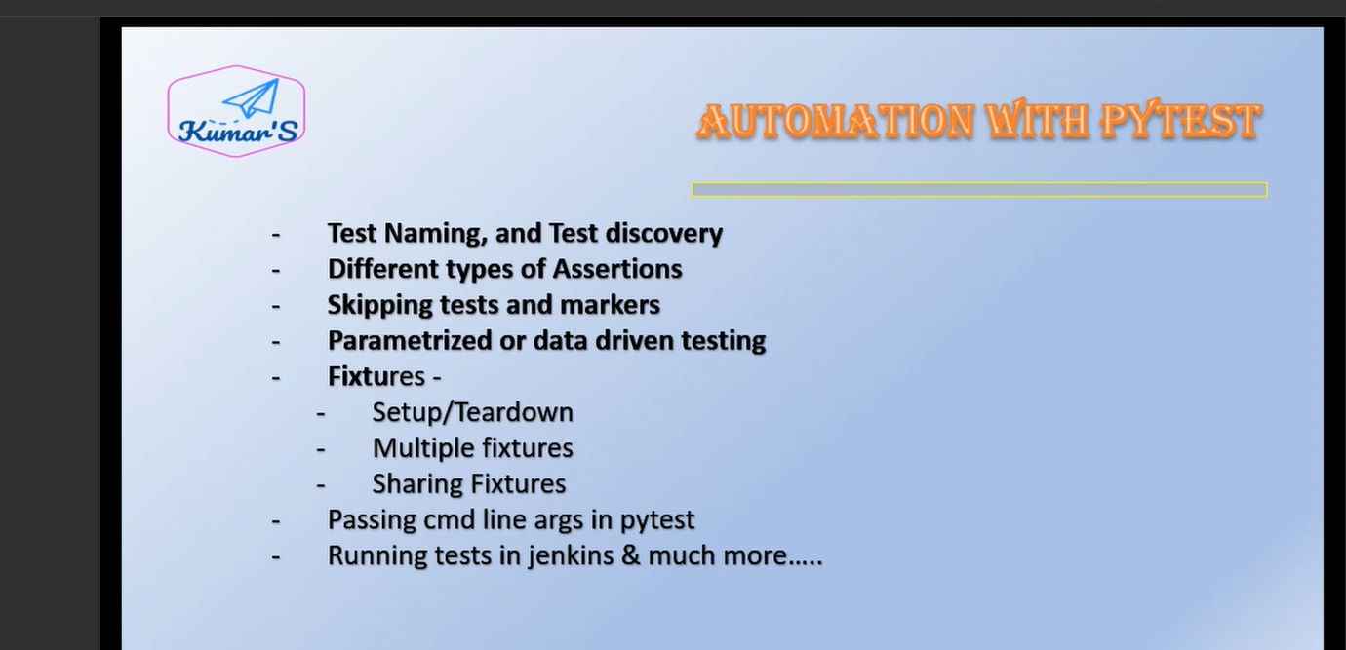

**Why framework:**

* Structure our test
* Added helpful features

**Pytest framework:**

* Test framework based on python language
* Easy to write , execute and generate test reports
* Different types and level of testing

**Good:**

* Ease of use
* Auto detect tests
* Grouping and marking tests
* Uses pythons assert keyword for passing/failing scripts
* Good features – fixtures, parameterization
* Good community support

Pytest command to generate a requirements file which all packages/modules installed in our project

pytest freeze >file_name.txt

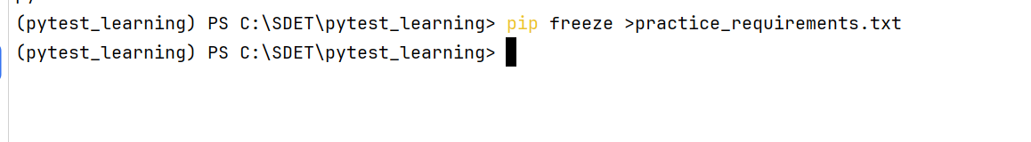

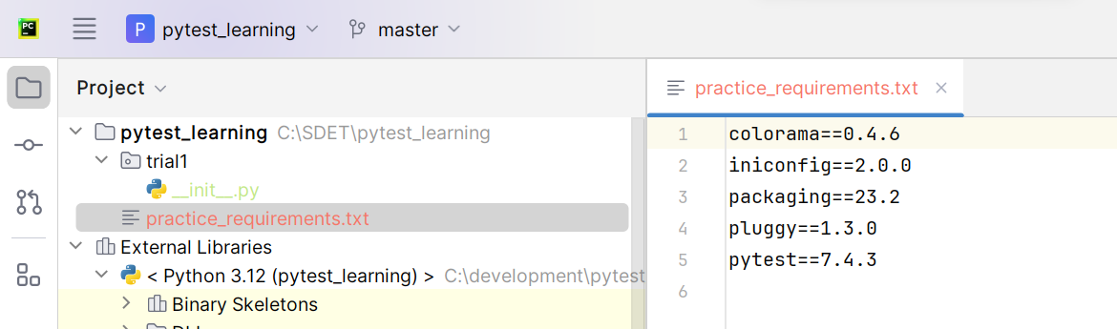

* This statement we used to do whenever we want to share our project with others
* Receivers’ after getting our project if they want to install all packages which is in out requirements file (generated using freeze command) they should use below command
* Pip install –r file_name

# Test File creation:

* While creating test file we should follow naming convention like either file/module should start by test_ or end by _test
* Syntax: test_<somefilename>.py

**Note: Pytest is going to search for the test files, in current directory and sub directories and run those test files**

**Note:Even the class and test methods should be named starting with test (class name with T)**

**Example:**

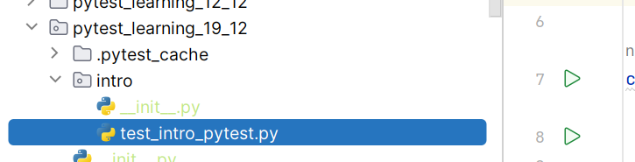

**Creating a class in test file:**

* While creating class in a test file you should create a class with class name as starting with Test_
* Note: (capital T only, **small t not works**)

Example:

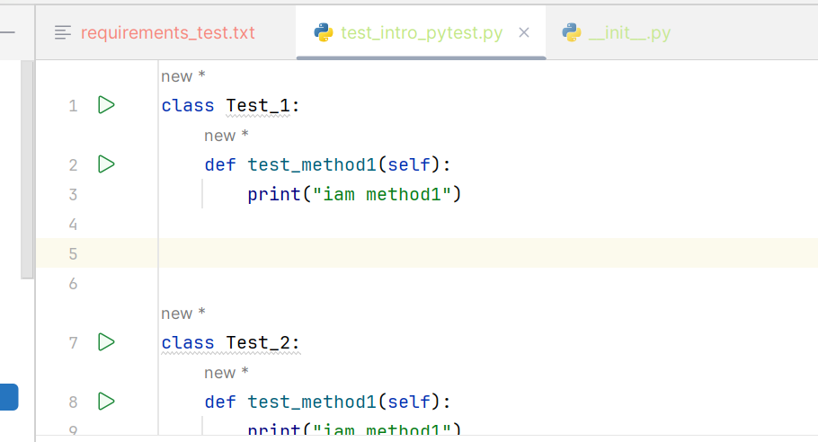

**Creating a method in test class:**

* You need to create a method in test class starts with test_

Example:

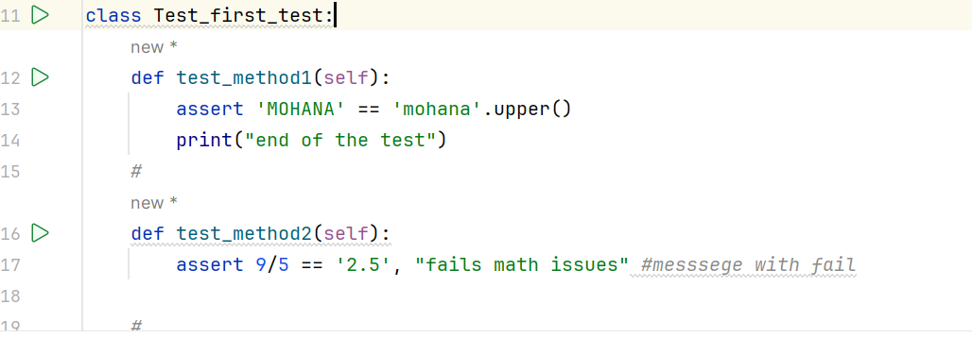

Note: when you followed above conventions then only your test file or class or methods will collected by pytest when you run with pytest commands. And when you follow these conventions then you can see in the terminal console like collecting 0 or 1 or 2. 0 means no test case collected by pytest

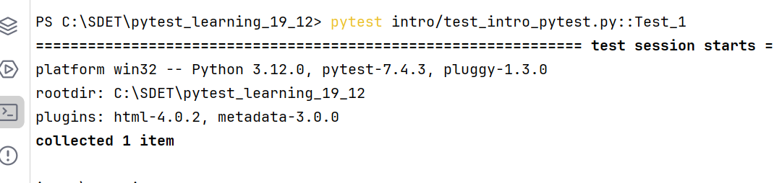

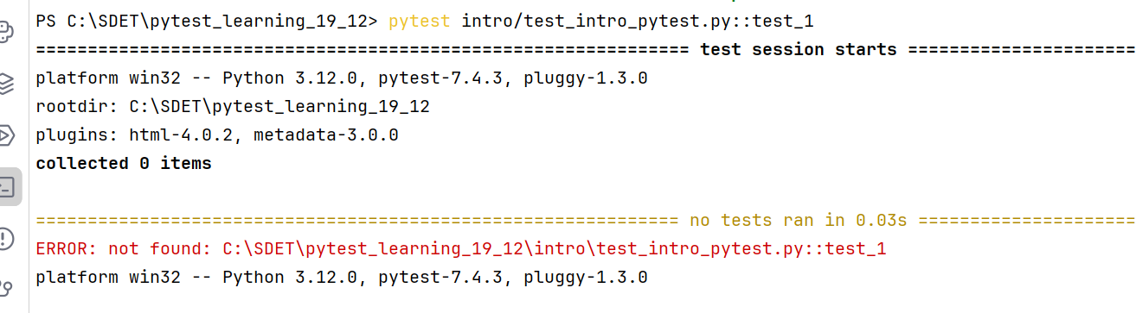

**Printing some failed text if its fails:**

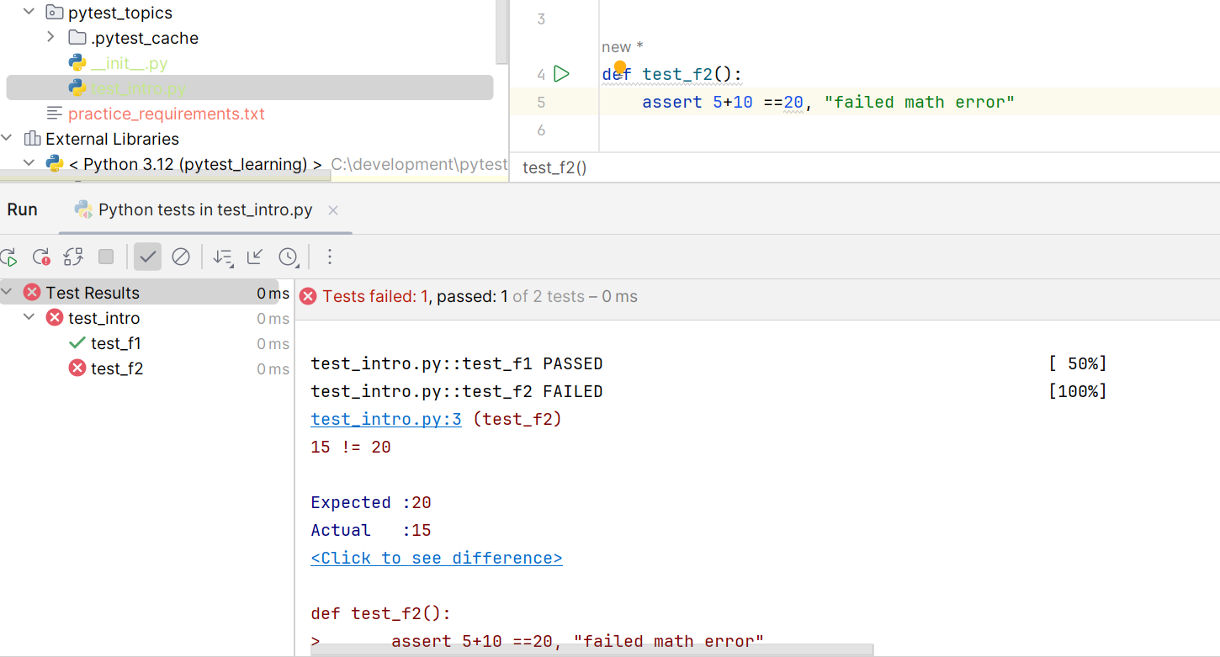

**Verbose mode -v:**

* To represent the **failed test** **cases** **in detailed** in console

Example:”

Without –v:

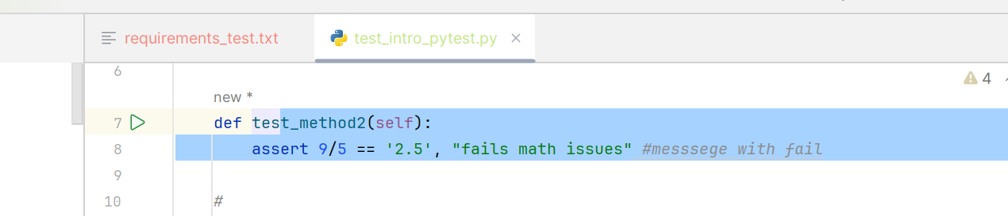

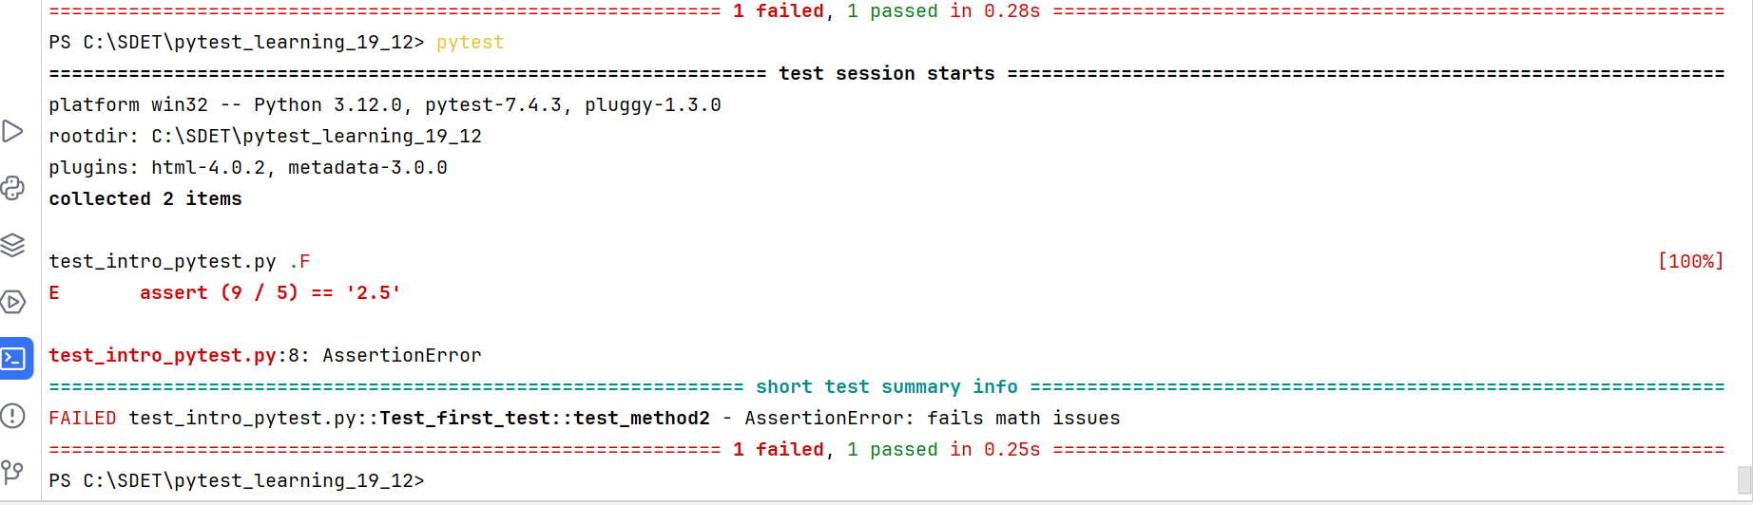

* In above report showing failed messege & how many passed & how many failed not much representation of failed & passed

**With –v in pytest:**

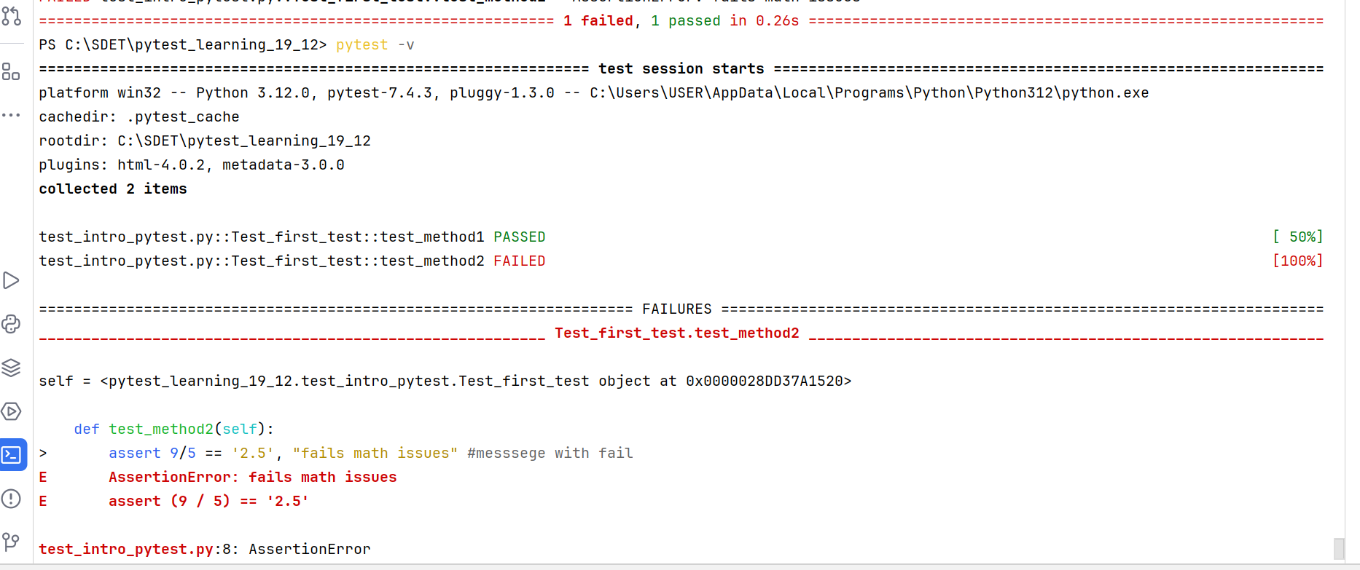

* In –v case you can see for failed & passed both you can have detailed representation in console like error representation in which method exactly failed, how much percentage passed, which method passed, which method failed & with more colours.

**-s mode:**

* this mode is used to log the print statements represented in test methods into the console

With out –s in pytest command:

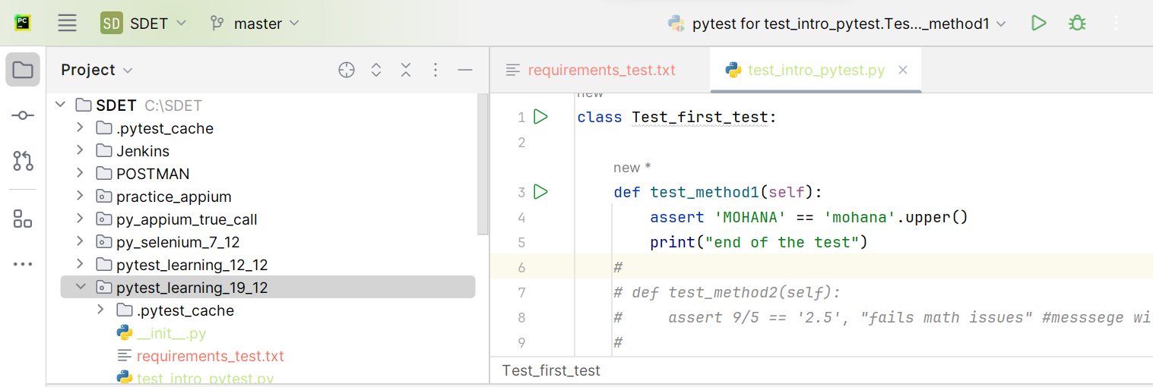

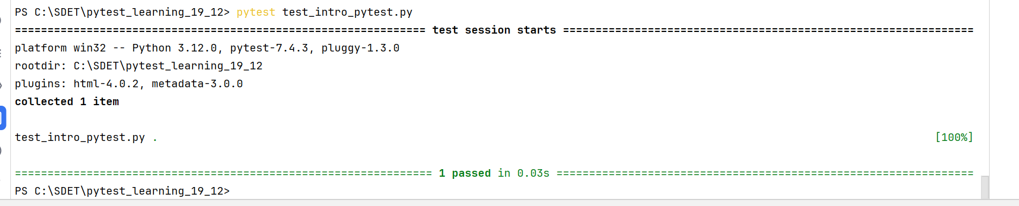

* Here its not printing any of the print statements in the test methods

**With –s in pytest commands:**



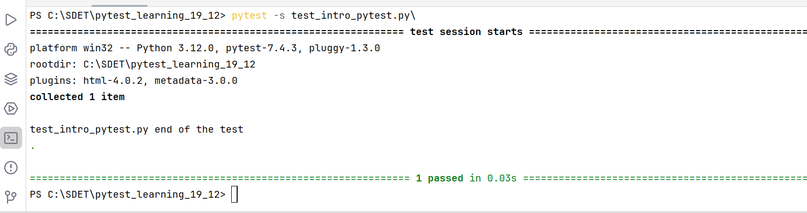

* Here you can see the print statements messages

# Running tests:

## Running test file:

* We can run the file from terminal
* We can run the file by right clicking on it
* We can run it from python console / command prompt

## Running from terminal:

**Running test files in whole folder/package:**

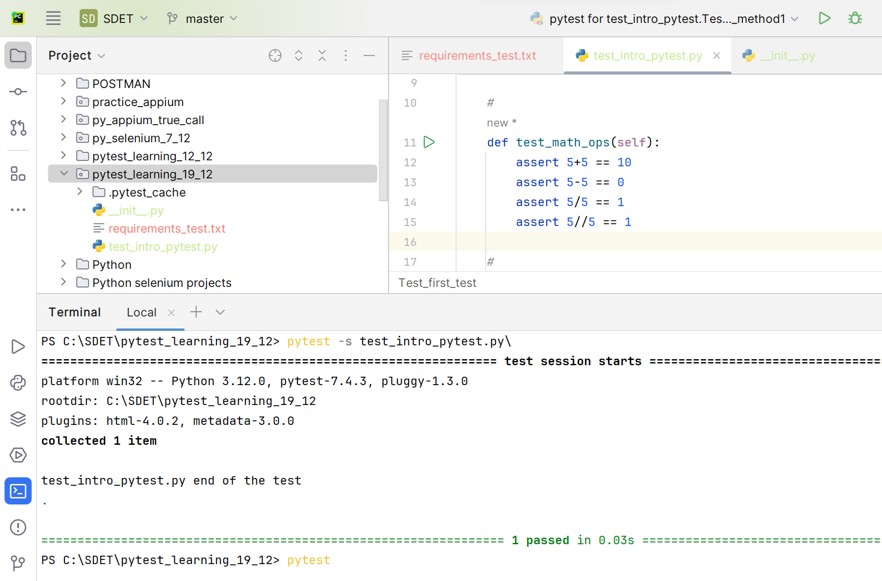

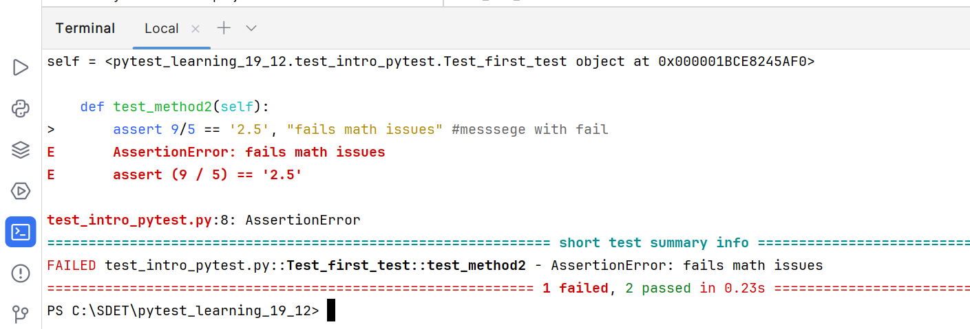

**Running a particular module or test file:**

**Syntax: pytest file_name.py**

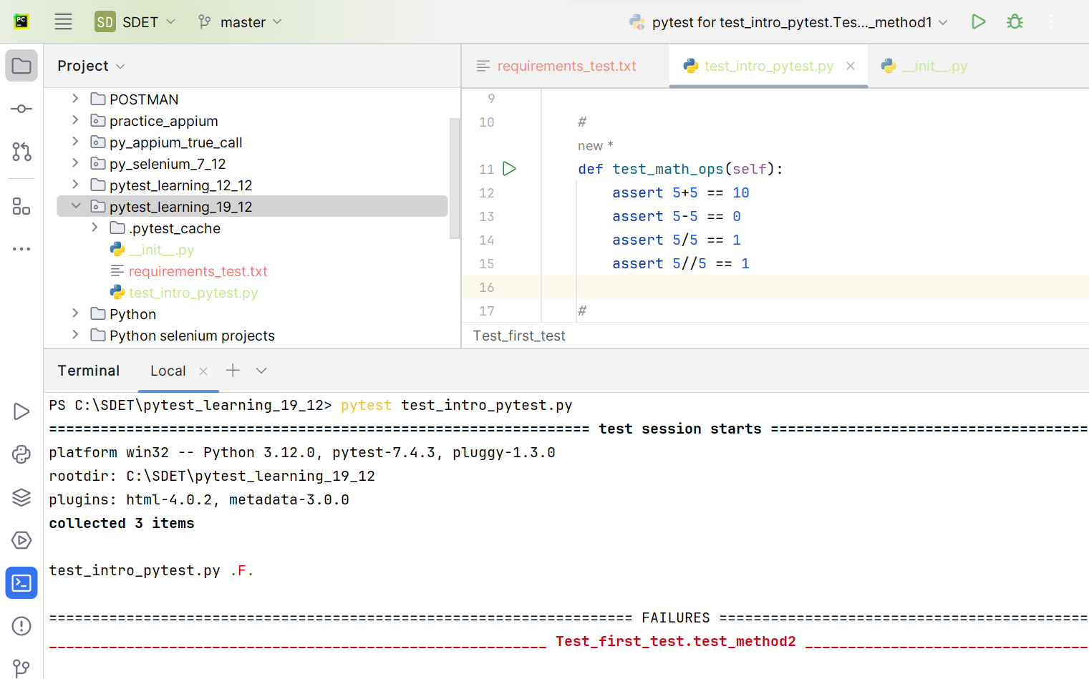

**Running a particular class:**

**Syntax: pytest file_path/file.py::class_name**

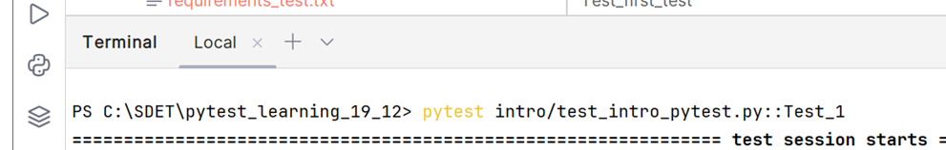

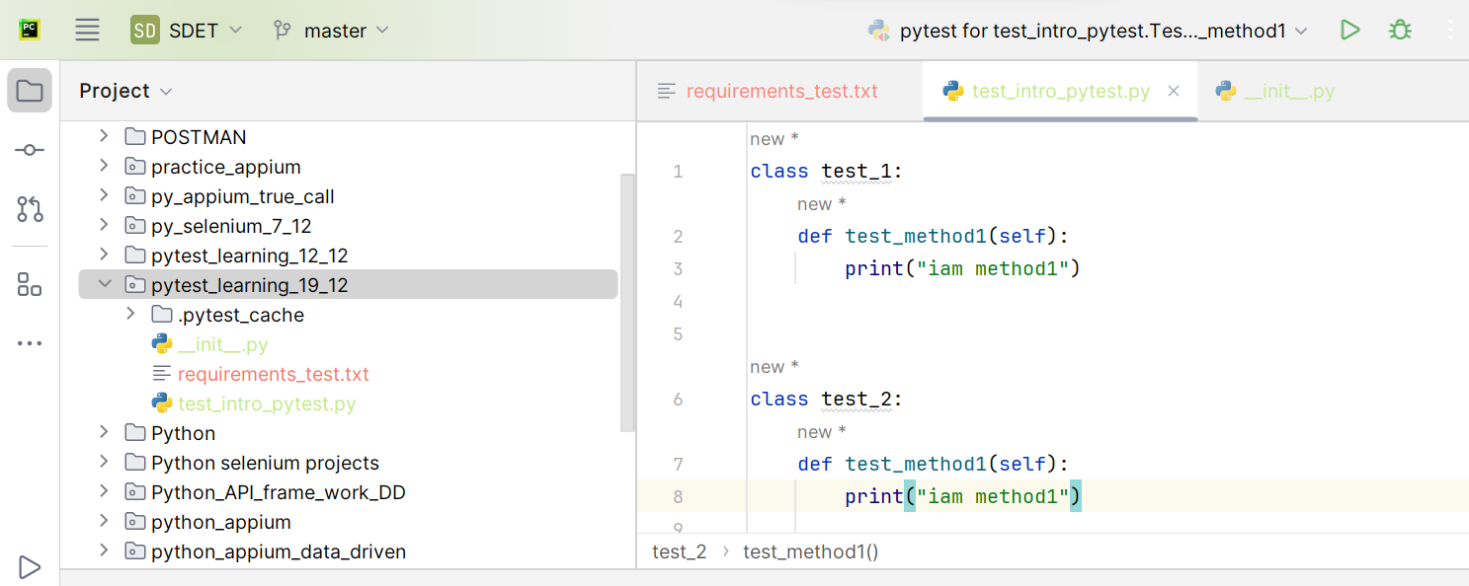

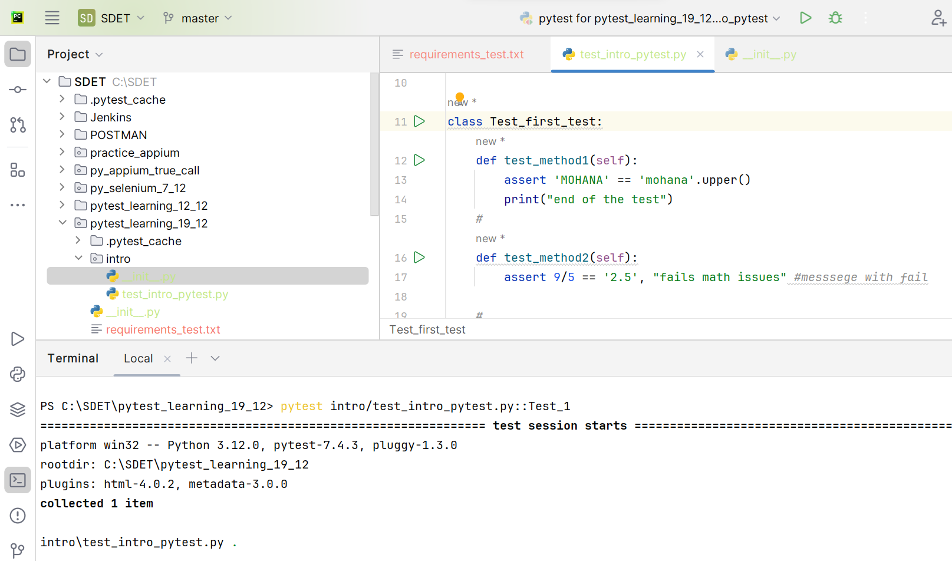

**Running a particular test method from a particular class in a test file:**

* **Syntax : pytest test_file_name.py::class_name::test_method_name**

**Example:**

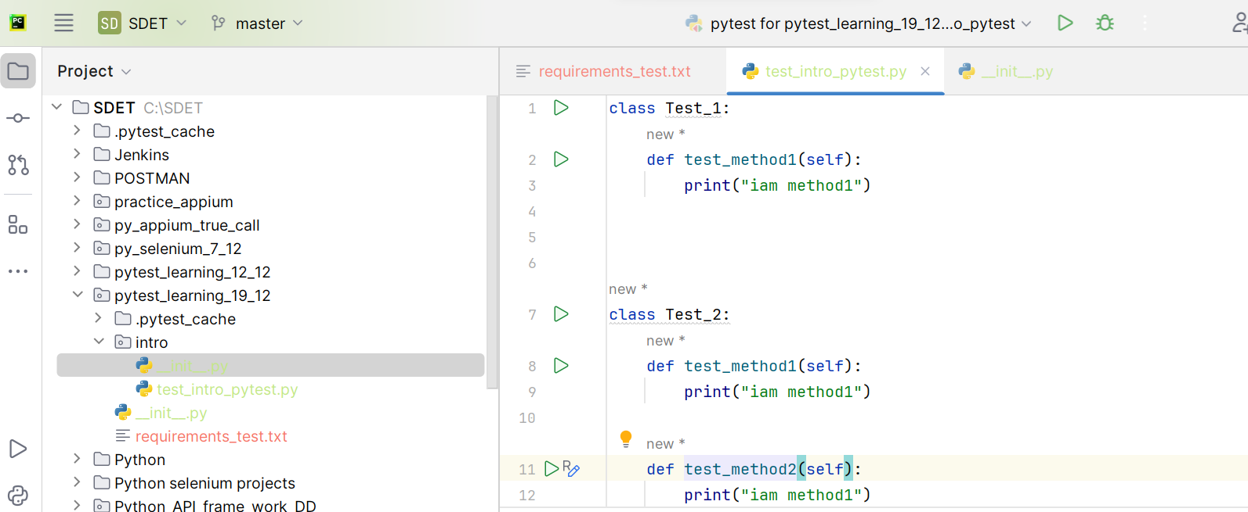



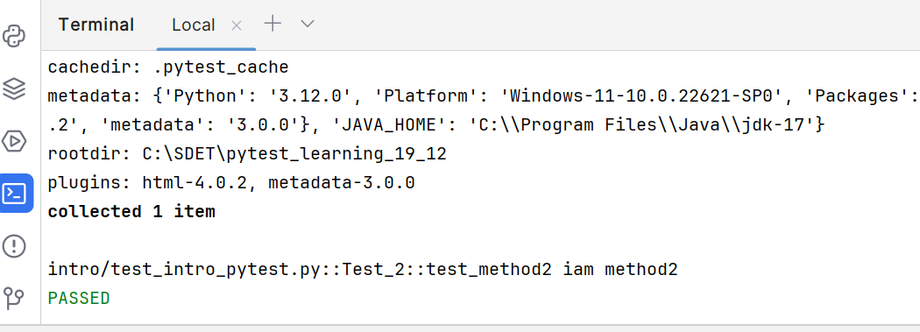

## Running tests directly from pycharm:

## Right clicking on file or method in a class:

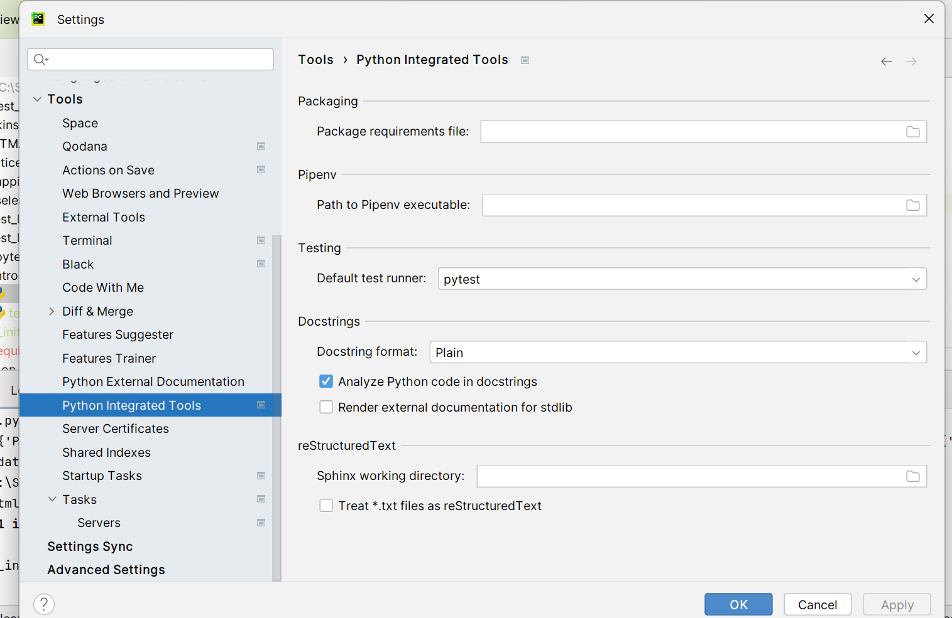

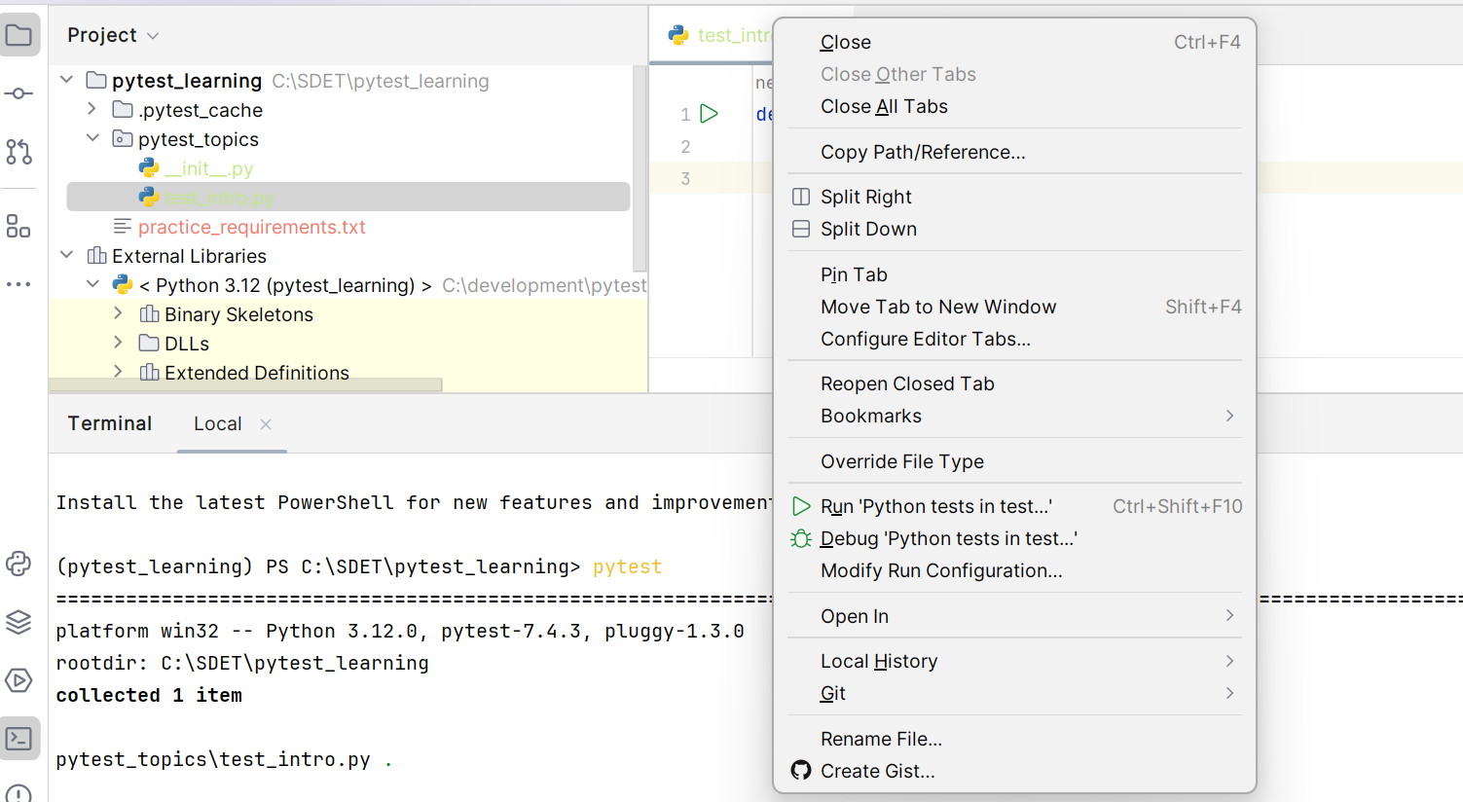

Running a method by right click:

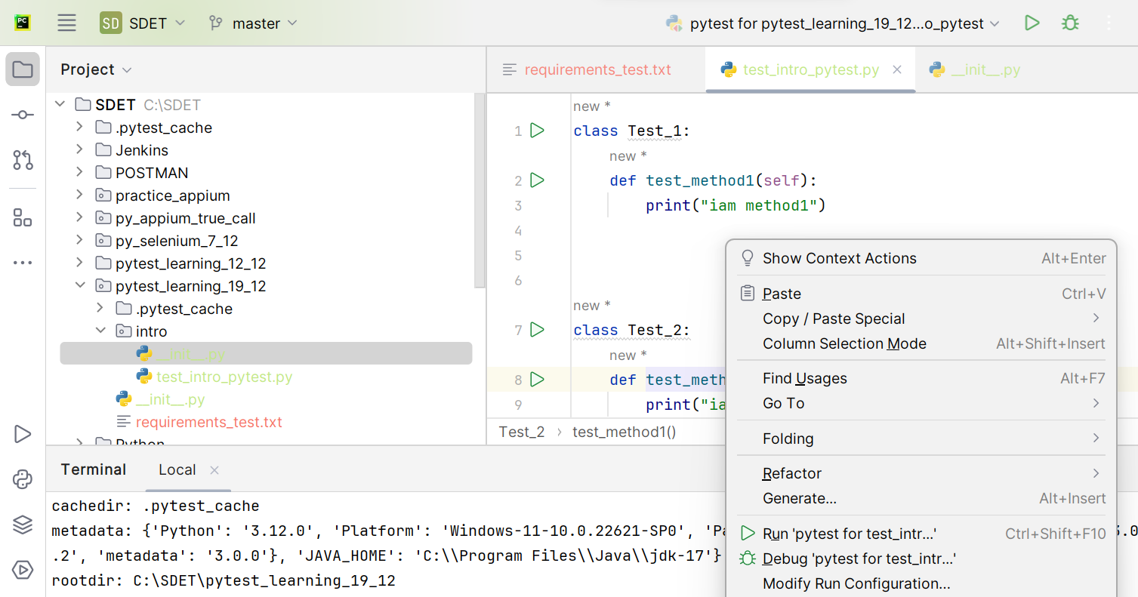

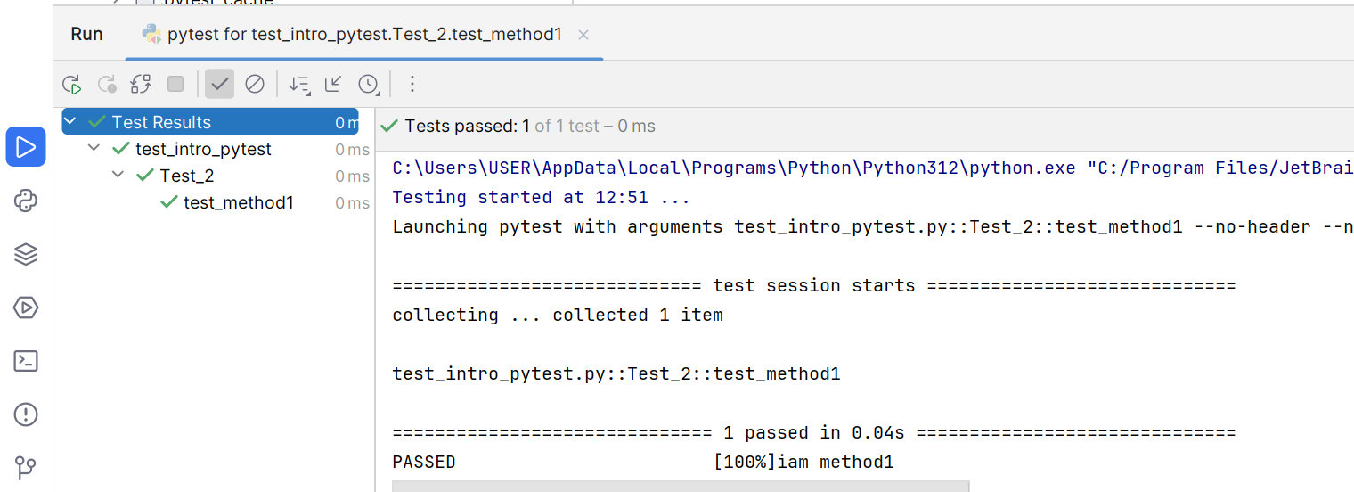

**Run a test files from command prompt:**

* Copy the path of the test directory
* Open cmd in from search
* Change correct directory to copied path
* Run the pytest command which you desired

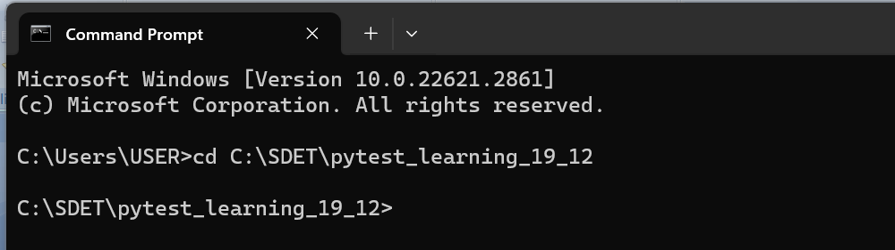

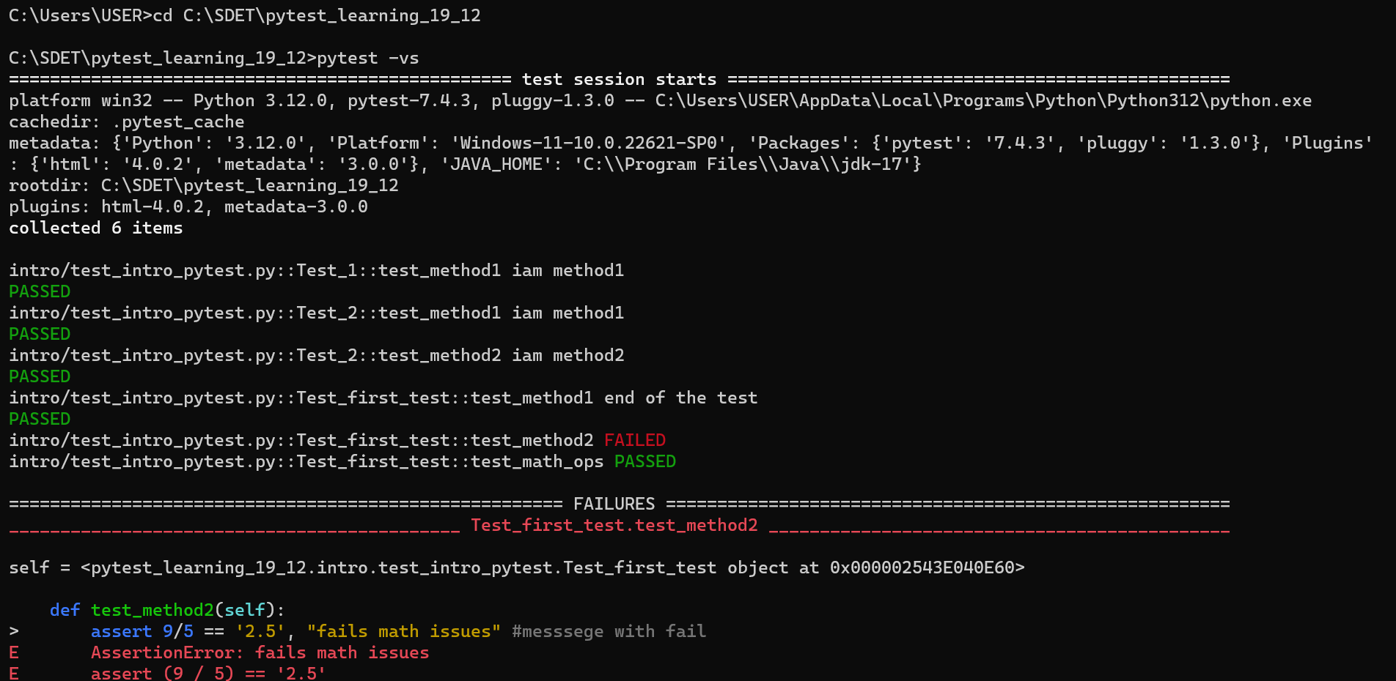

Running a test folder from cmd:

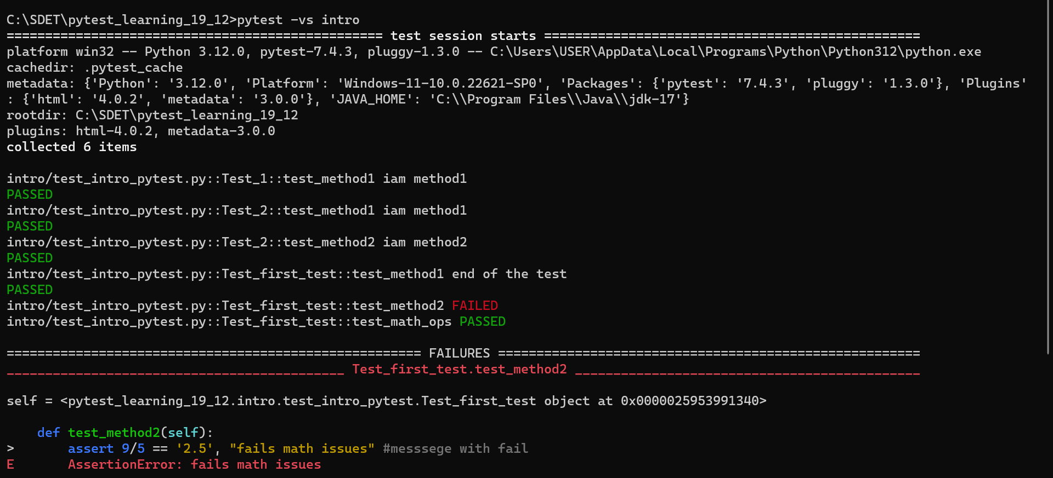

Running a test file from cmd:

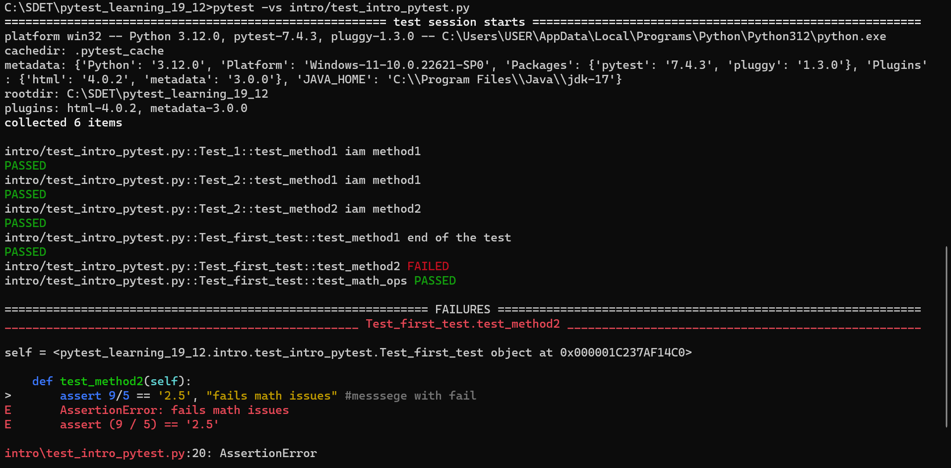

Note: Instead of cd changing to file directory, you can do the same by going to the project directory in file explorer and right click and open cmd

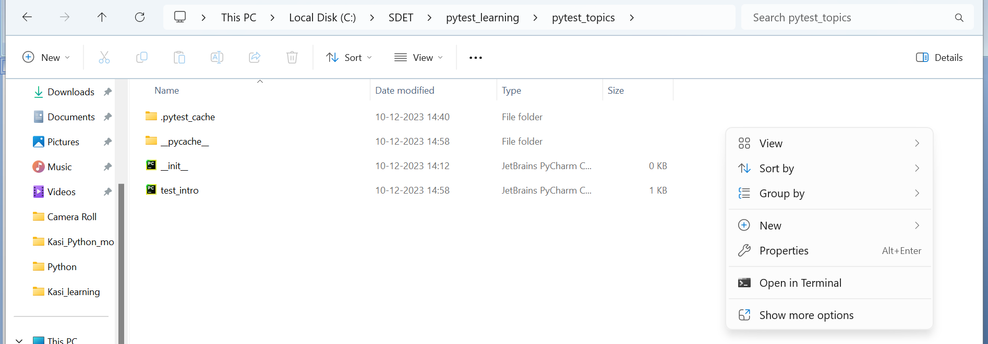

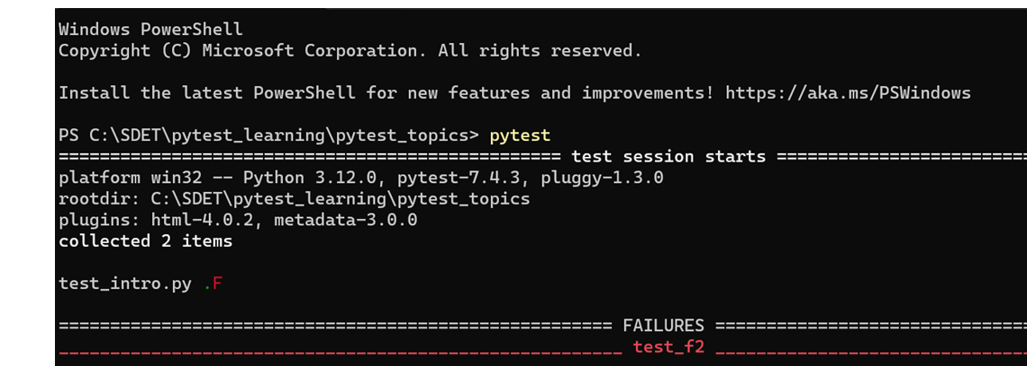

# Pytest cache:

* Cache stores the information about the last run

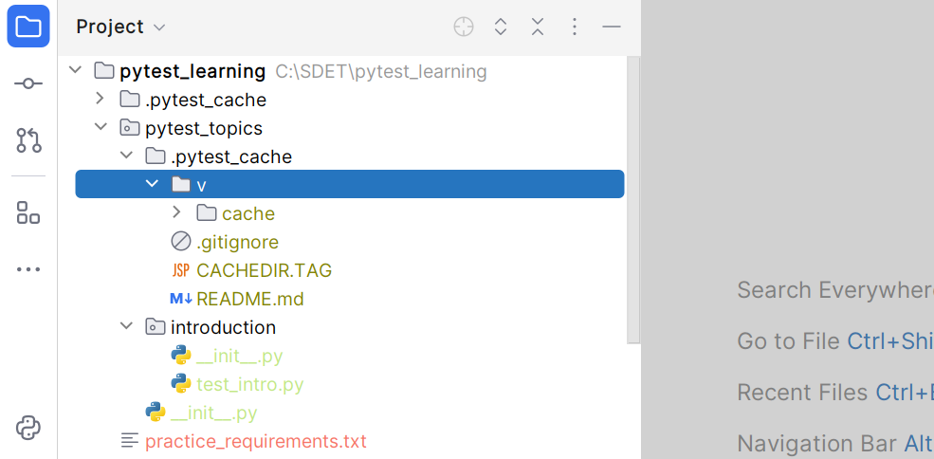

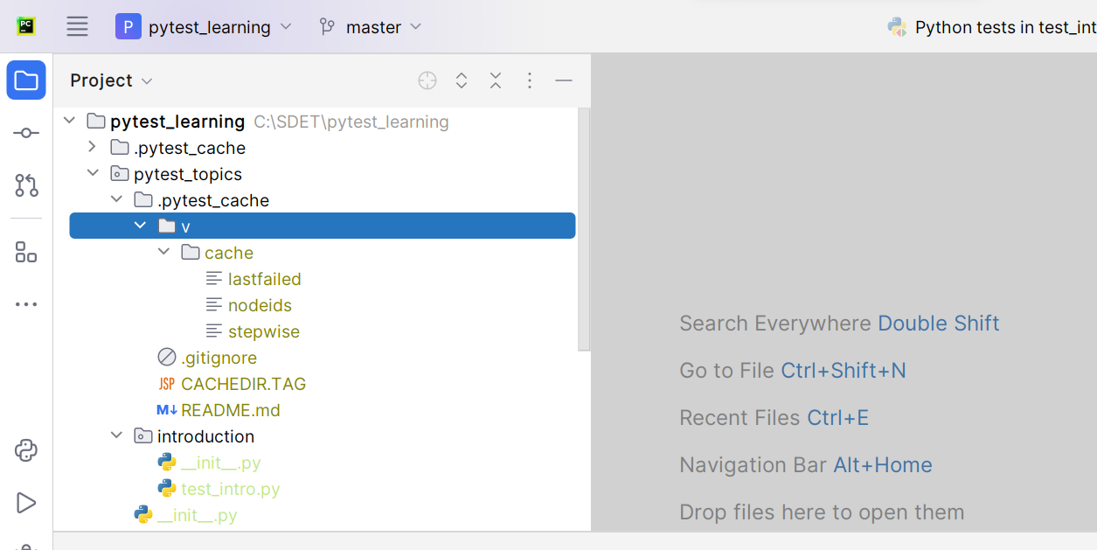

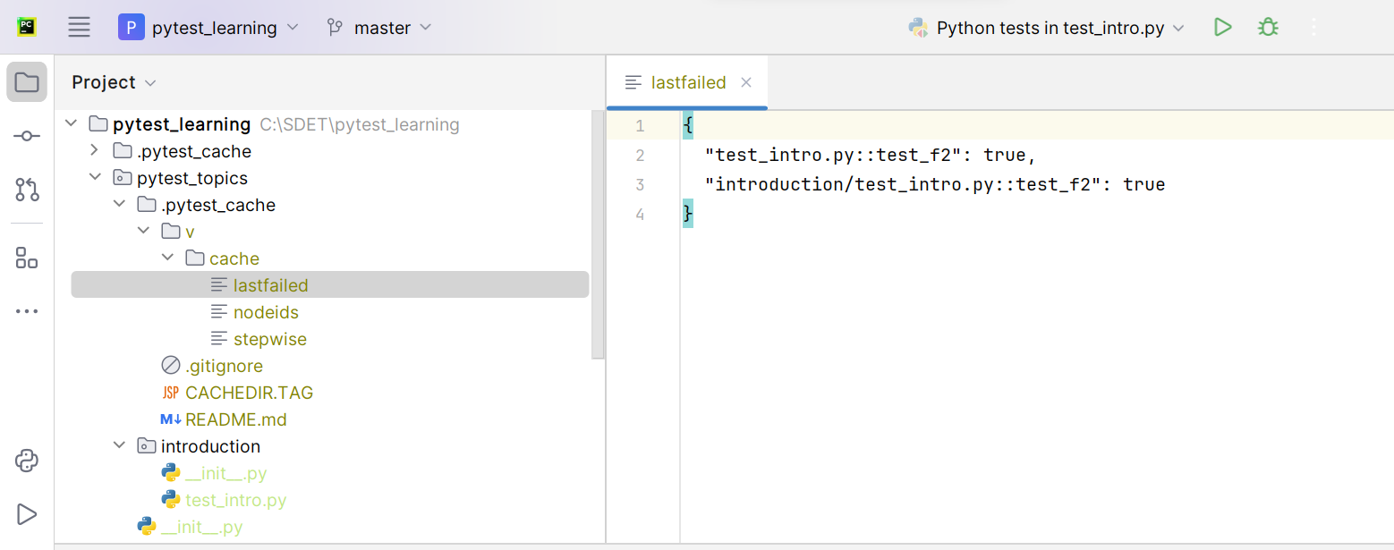

* **Here in last failed file the information about the last failed script is stored**

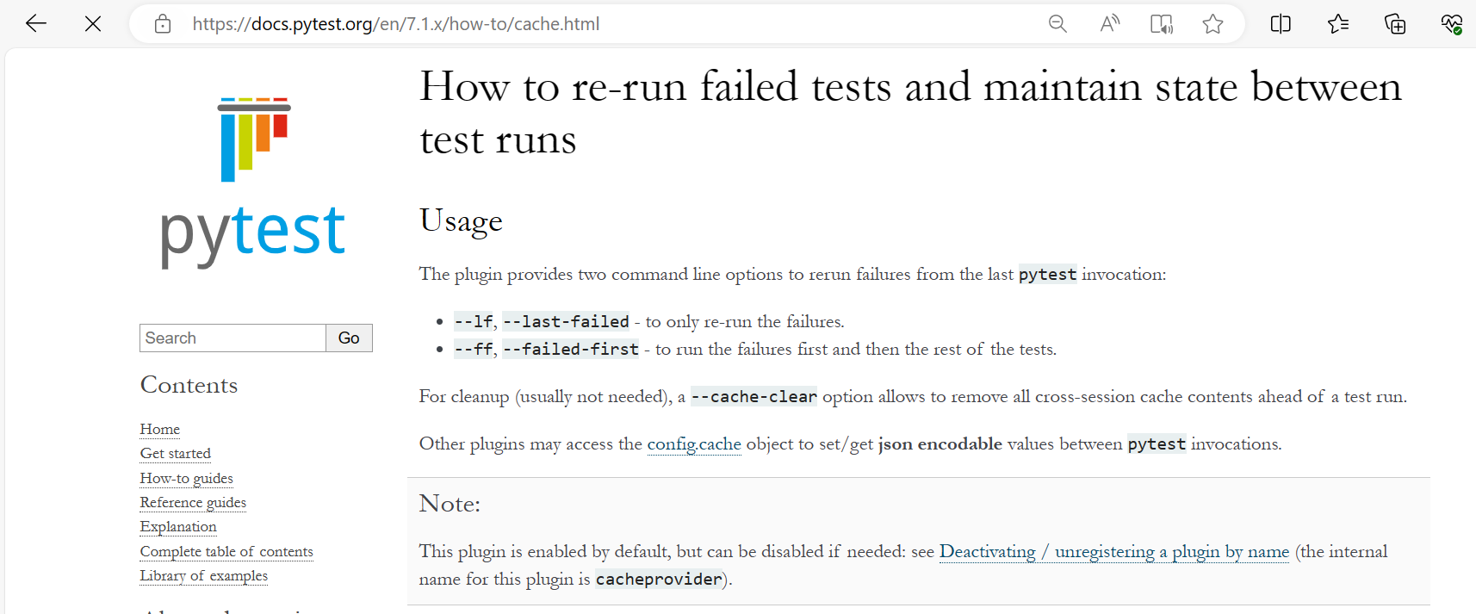

**When you run the –lf or –ff it will take the failed files from the lastfailed file pytestcache**

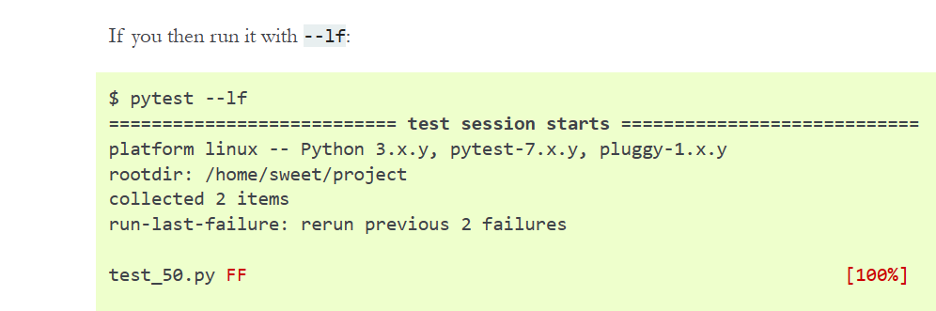

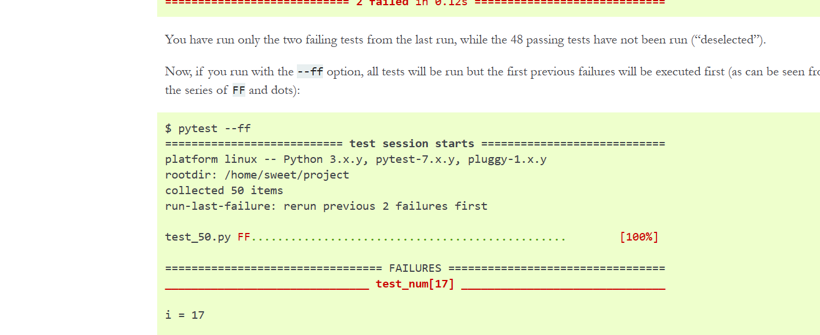**’**

**--lf --last-failed 🡪 it will run the only last failed files**

**--ff --failed-first 🡪 it will run the failed first and remaining files later**

## If you want to see the pytest cache from the terminal instead of from folders:

**Pytest --cache-show**

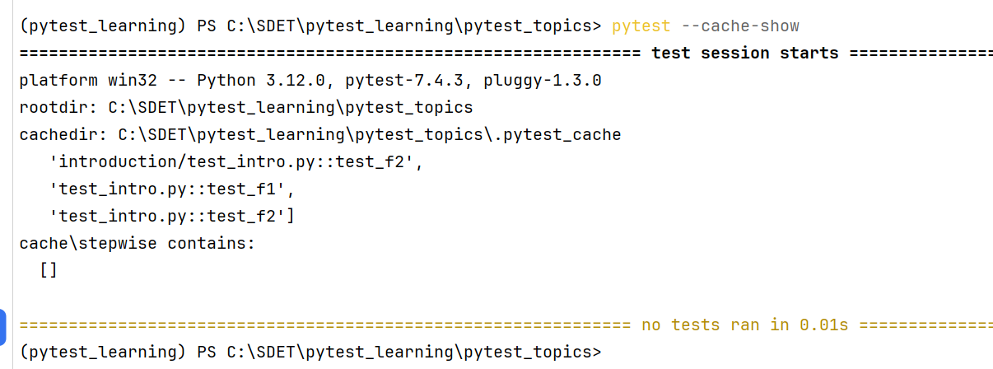

**Clearing cache:**

**Pytest --cache-clear**

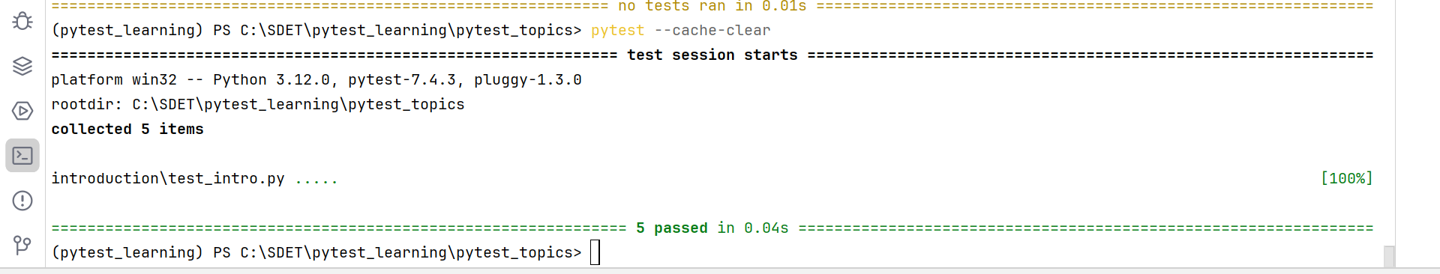

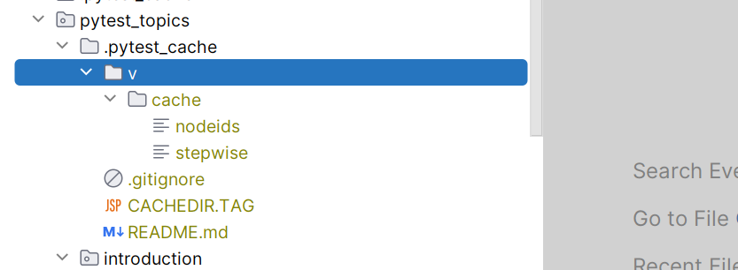

**Assertions:**

* Basically pytest assertions will check for a condition and based on the condition it will fail or pass the test cases

For assertions operation in python we do have assert keyword

## assert:

In Python, the assert statement is used to continue the execute if the given condition evaluates true, if the given condition evaluates to False, then it raises the Assertion Error exception with the specified messege.

Syntax: assert condition [, “Error messege”]

Examples:

def test_a1():  
 assert 5+5 == 10  
  
string1 = 'Mohana'  
def test_f2():  
 assert string1.lower() == 'mohana'  
  
def test_f3():  
 assert 'i' in 'kasi'  
  
def test_f4():  
 assert 1,2 in [1,3,4,2]  
  
def test_f5():  
 assert 4<5

Examples:

def test_m1():  
 assert True  
  
def test_m2():  
 assert True

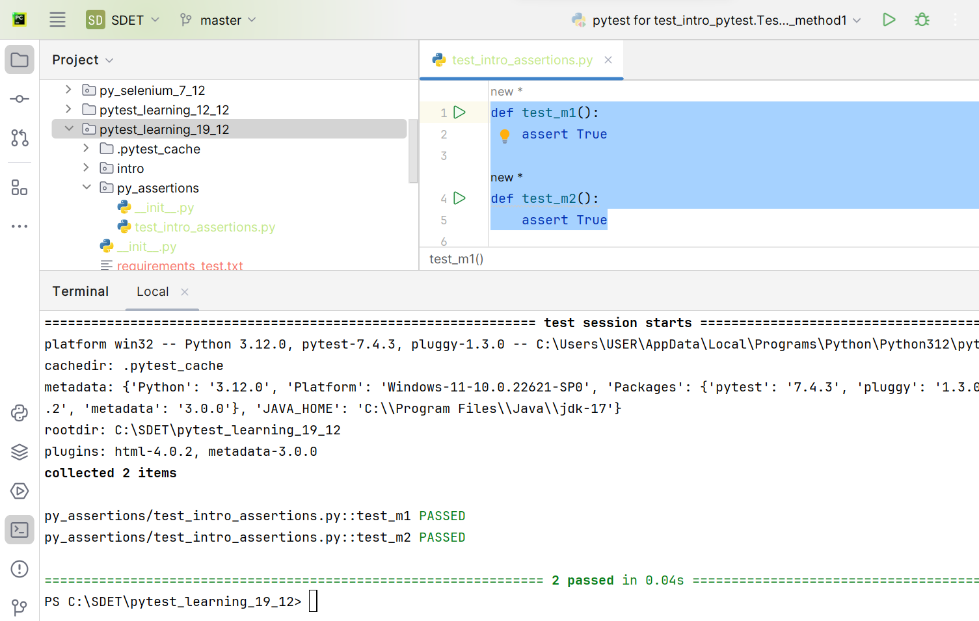

Example2:

def test_m1():  
 assert True  
  
def test_m2():  
 assert True  
  
  
def test_m4():  
 assert 1  
 assert 0  
def test_m5():  
 assert 'kasi'  
 assert '' *#all default data type values will be fails for assert*

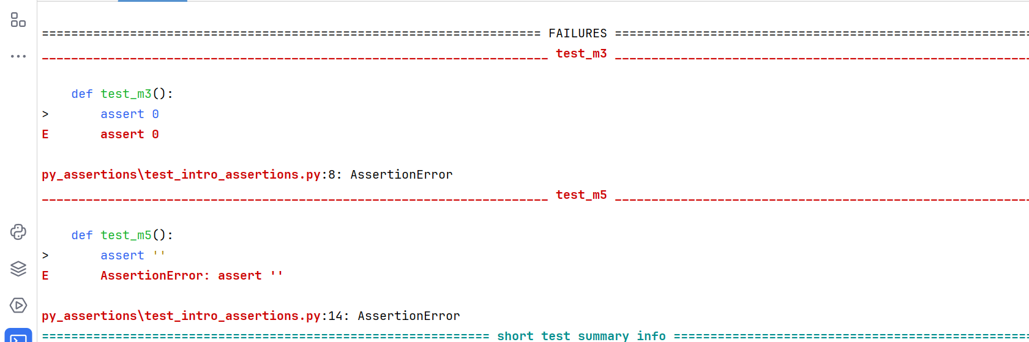

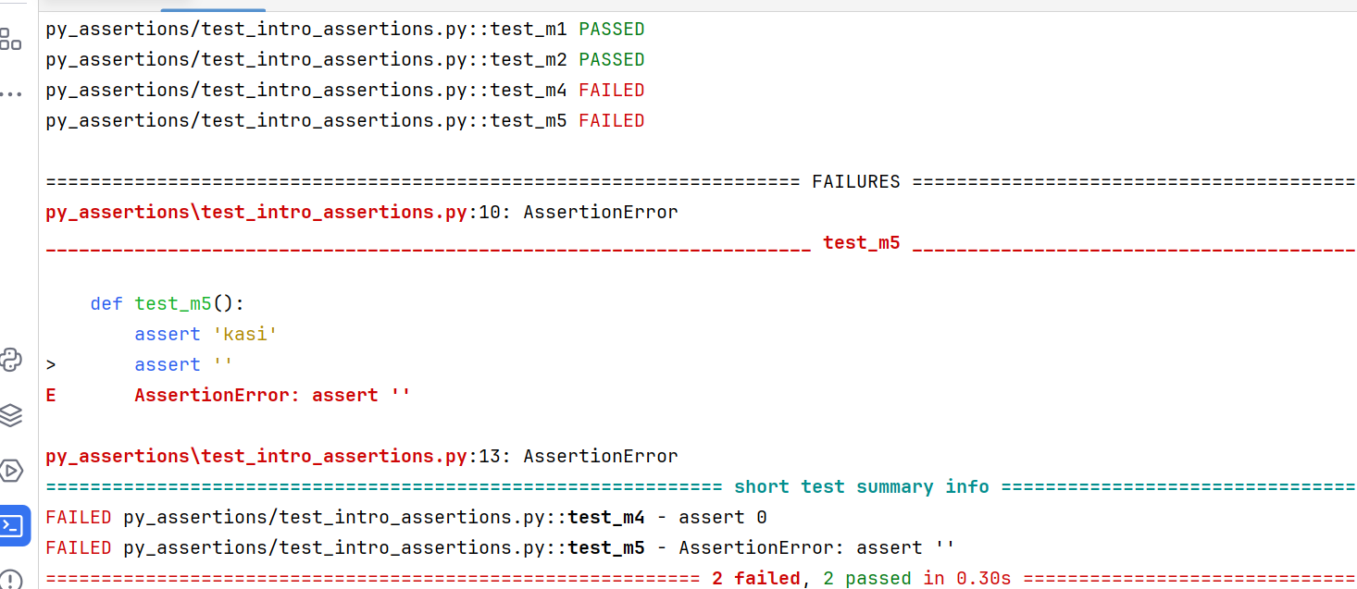

Example3:

def test_file1():  
 assert 'abc' == 'abcd'  
  
def test_file2():  
 assert 'k' in 'kasi'  
  
def test_file3():  
 assert 100 != 120  
  
def test_file4():  
 assert id('kasi') == id('kasi')  
 print(id('kasi'))  
  
def test_file5():  
 assert 'kasi' not in 'this is mohana'

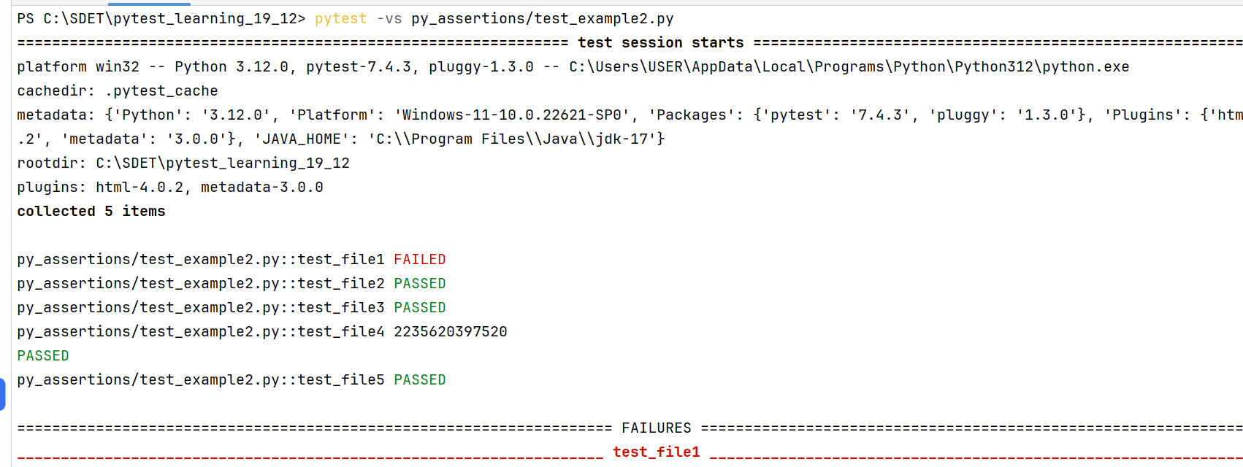

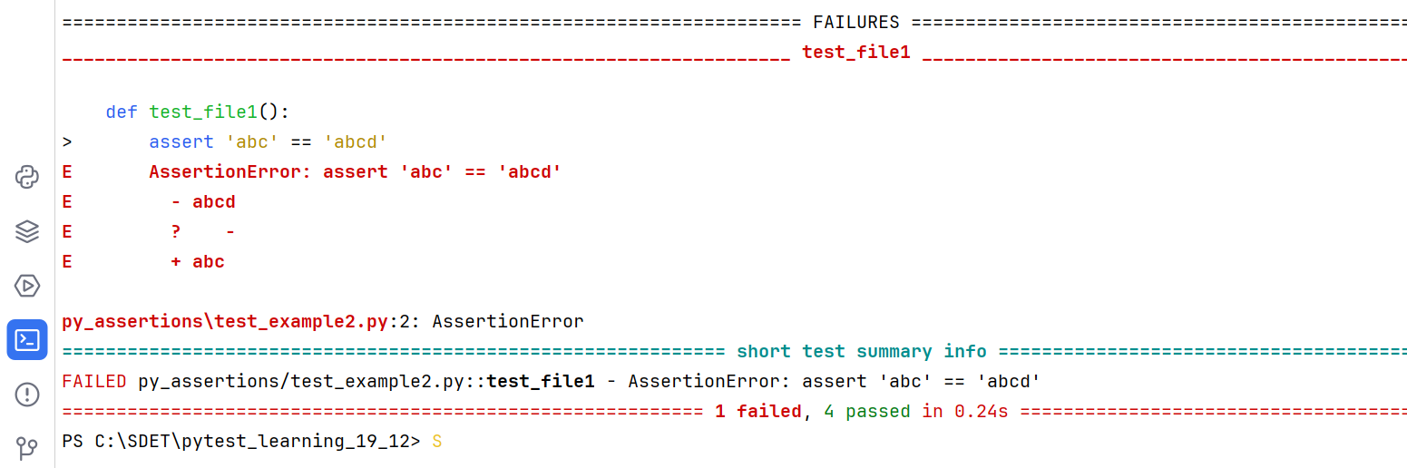

Example3:

def test_file6():  
 assert 100>=101 *#here > & = both not correct so test failes*def test_file7():  
 assert 1000 >=101 *#here not = but its greateer so test pass*def test_file8():  
 assert 100<=105 *#here not = but its less then so test pass*def test_file9():  
 assert 100<=100 *#here not less then but its equal so test pass*

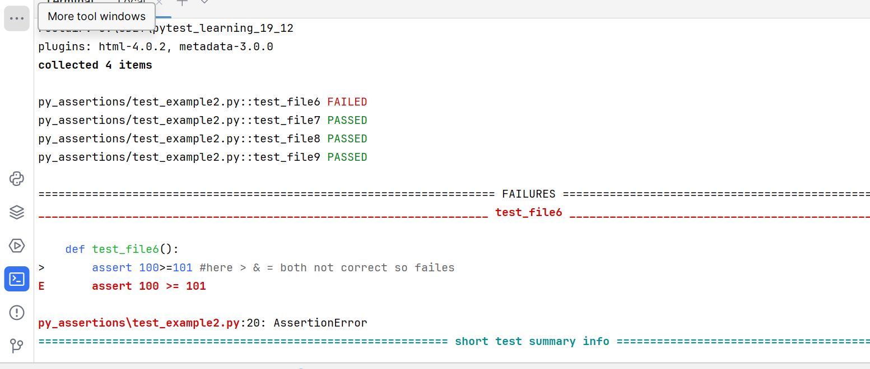

**Test discovery:**

Whenever you run the pytest in the termainl or cmd. Pytest will start searching for the python files with test_ and then in that file it will search for the test function with test_ or test class with Test_ and the test method with test_. So no need to mention the test function or test method name in the command, pytest will auto discover those and run all the test modules or classes implicitly.

If you want to execute any particular module / class you can represent those in pytets command.

* We can run the single directory 🡪 pytest directory name
* We can run the single test module (python file) 🡪 pytest test_file_name.py
* We can run the single class 🡪 pytest test_file_name.py::class_name
* We can run the single method or function 🡪 pytest test_file_name.py::class_name::method_name
* If its is a normal function 🡪 pytest test_file_name.py::function_name

**__init__.py:** It describes the desired folder is a python package and allows us to have duplicate files with same names

**Assertion handling:**

While running the tests using pytest if we know for particular test may get the error we can handle that exception in assertions.

🡪 pytest.raises(eception_name) we can handle the exceptions in assertions

Here if you know the valid exception you can mention exact error name or if you don’t know you can mention default as Exception.

Examples:

#with exception name as Exception

import pytest  
  
  
class Test_intro_pytest_raises:  
 def test_method1(self):  
 with pytest.raises(Exception):  
 assert 1/0

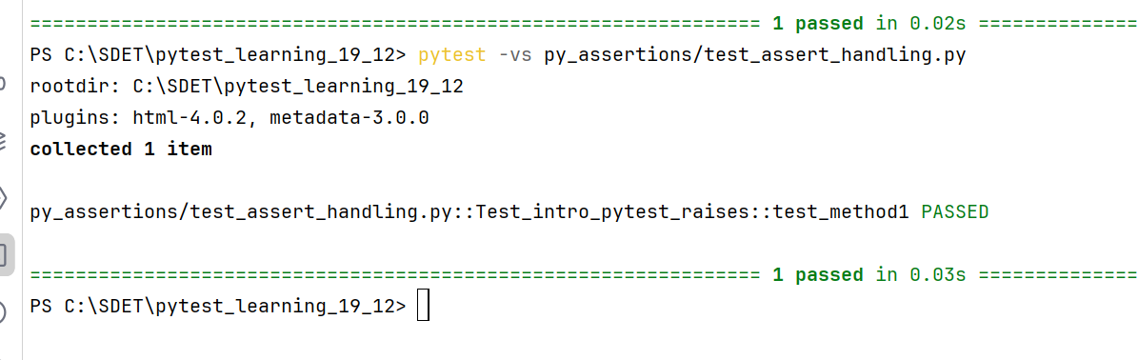

#with proper exception name

import pytest  
  
  
class Test_intro_pytest_raises:  
 def test_method1(self):  
 with pytest.raises(ZeroDivisionError):  
 assert 1/0

Note: you cannot have multiple assertions in the pytest.raises() block while handling exceptions with pytest.raises. only one assert statement should be there in the block. Even though you given 2nd assert statement it will not executes

Example for two assert statements:

import pytest  
  
  
class Test_intro_pytest_raises:  
 def test_method1(self):  
 with pytest.raises(ZeroDivisionError):  
 assert 1/0  
 assert 3<2

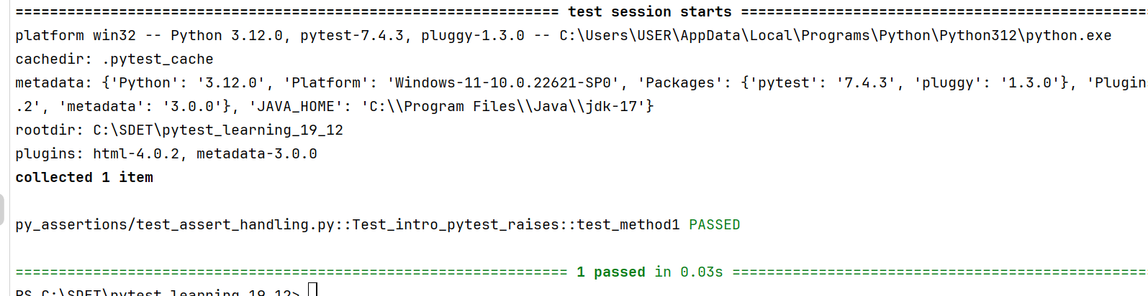

* Here even though 2nd assert statement is wrong its not handling & not executing also

If the assert statement will get error other than Error mentioned in pytest.raises() pytest will through the error, in that case test not will handles

import pytest  
class Test_intro_pytest_raises:  
 def test_method1(self):  
 with pytest.raises(ZeroDivisionError):  
 assert 3<2

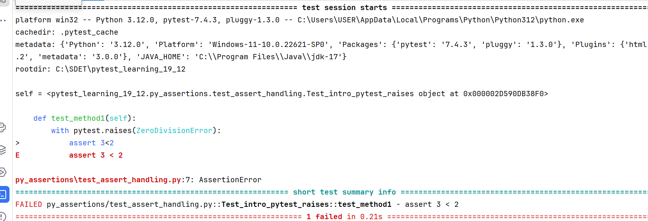

**skipping tests:**

When we don’t want any test case for execution we can skip those test cases using pytest. To achieve this we need to import the skip from the mark which is in the pytest and decorate it to the test method/class.

From pytest.mark import skip

Example:

import pytest  
  
  
def type_check(param):  
 return type(param)  
  
def test_string_rev():  
 res = type_check('Mohana')  
 assert res == str  
  
def test_nums_cjheck():  
 res = type_check(1008)  
 assert res == int  
  
@pytest.mark.skip  
def test_float_check():  
 res = type_check(5/3)  
 assert res == float

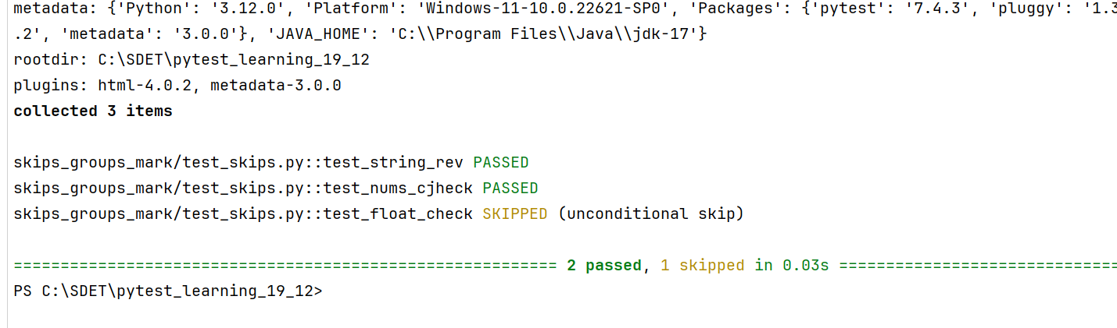

Note: while using skipif you must mention reason in skip statement, if you not mentioning any reason in the console you will get the error as below

**ERROR** **skips/test_skipif.py::test_practice_skips_220 - Failed: Error evaluating 'skipif': you need to specify reason=STRING when using booleans as conditions.**

Example2:

import pytest  
  
  
def type_check(param):  
 return type(param)  
  
def test_string_rev():  
 res = type_check('Mohana')  
 assert res == str  
  
def test_nums_cjheck():  
 res = type_check(1008)  
 assert res == int  
  
@pytest.mark.skip  
def test_float_check():  
 res = type_check(5/3)  
 assert res == float  
  
  
@pytest.mark.skip(reason='skipping the list cases')  
def test_list_type():  
 res = type_check('this is Mohana'.split())  
 assert res == list

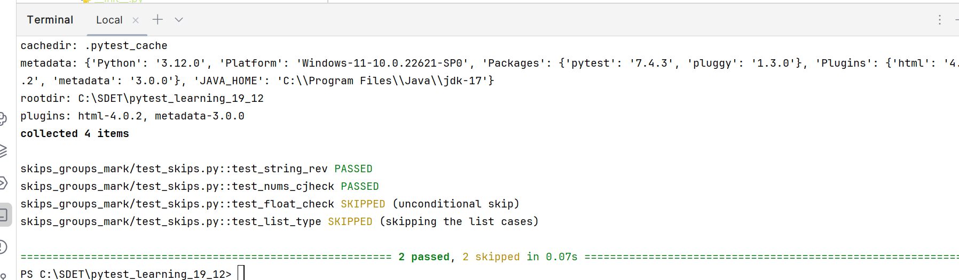

We can skip the test cases based on the conditions also

import sys  
import pytest  
  
@pytest.mark.skipif(sys.version_info < (3,5), reason='skipping as low version installed')  
def test_low_python_version_validate():  
 print("proper python version")  
  
  
@pytest.mark.skipif(sys.version_info > (3,5), reason='not required for higher versions')  
def test_high_python_version_validate():  
 print("least python version")

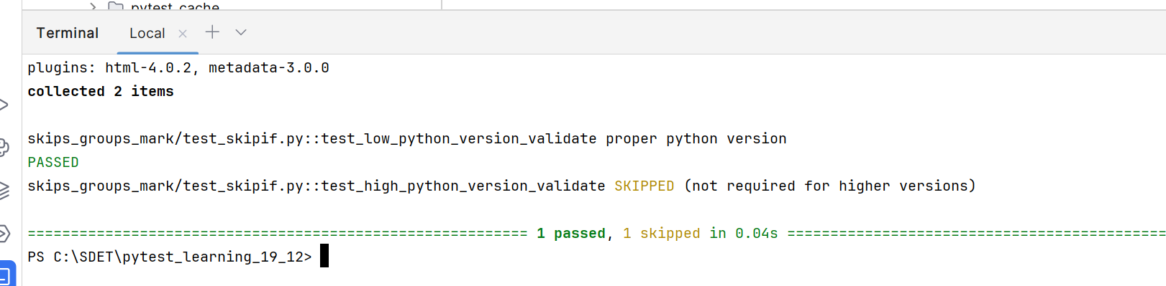

**Skipping entire module:**

We can skip the entire module by giving a condition using global variable called pytestmark. Either you can metion one skip or multiple skip conditions inside a list

**Note: Here pytestmark is a global variable. Pytest will detect that variable and if you given the skip statements to it pytest will imlicitly skips entire module**

Example:

import pytest  
import sys  
  
*# pytestmark = pytest.mark.skipif(sys.platform == 'win32', reason="run only on ios")*pytestmark = [pytest.mark.skipif(sys.platform == 'win32', reason="run only on ios"), pytest.mark.skipif(pytest.__version__ > '7.4.3', reason='not rquire for latest python versions')] 🡪 multiple skips  
def test_sanity1():  
 print(sys.platform)  
 print(pytest.__version__)  
 print("set1 test cases")  
  
  
def test_sanity2():  
 print("set2 test cases")  
  
def test_sanity3():  
 print("sanity3 test cases")

python versions validate with skipif:

*#cheecking for latest python version*@pytest.mark.skipif(pytest.__version__ <'7.4.3', reason='old python version installed')  
def test_py_version_check():  
 print("latest pytest version")  
  
  
*#checking for old python version*@pytest.mark.skipif(pytest.__version__ > '7.4.3', reason='not rquire for latest python versions')  
def test_py_version_check():  
 print("old python version only installed")

**Grouping tests:**

In pytest we can group few test cases with the name and we can run particular group of test cases using pytest without specifying directory or file_names. We can achieve this functionality by using mark in pytest.

**The good in markers is when your test needed same names for multiple test cases when you decorated with markers then using particular marker name you can execute that particular test case only. If you did it without marker when you run it with test case name, pytest will run the latest overrided test case.**

**Syntax: pytest.mark.marker_name**

Examples:

import pytest  
  
@pytest.mark.strings_sanity  
def test_merging_strings():  
 return "mohana"+"kasi"  
  
@pytest.mark.lists  
def test_string_first_letter_check():  
 list_ = ['Mohana', 'mac', 'bhavani', 'lokitha']  
 list_2 = []  
 for string_ in list_:  
 if 'a'<=string_[0].lower()<='s':  
 list_2.append(string_)  
  
@pytest.mark.lists  
def test_unpacking_list_items():  
 data1,data2 = ['Mohana', 'guntur']  
 print(data1, data2)  
  
@pytest.mark.strings_sanity  
def test_string_even_check():  
 string_ = 'this is mohana'  
 if len(string_) %2 == 0:  
 return True  
  
@pytest.mark.strings_sanity  
def test_string_revrse():  
 list_ = [1089, 'bengaluru', {'kasi'}]  
 for item in list_:  
 if isinstance(item, str):  
 print(item[::-1])

Run:

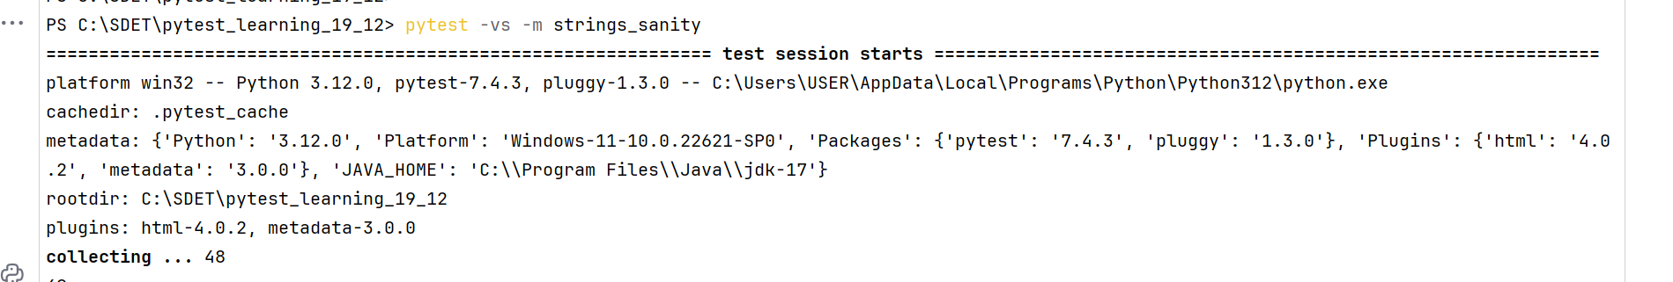

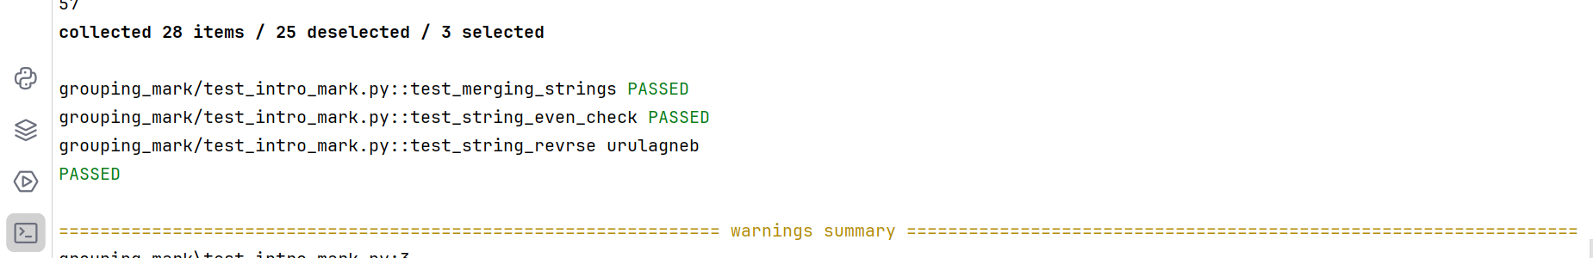

We can skip the markers which not needed using not in pytest command

Example:

pytest -vs -m "lists and not strings_sanity"

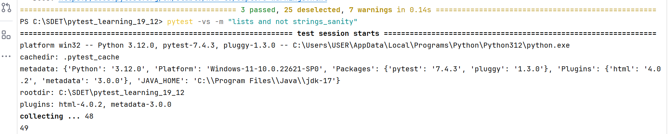

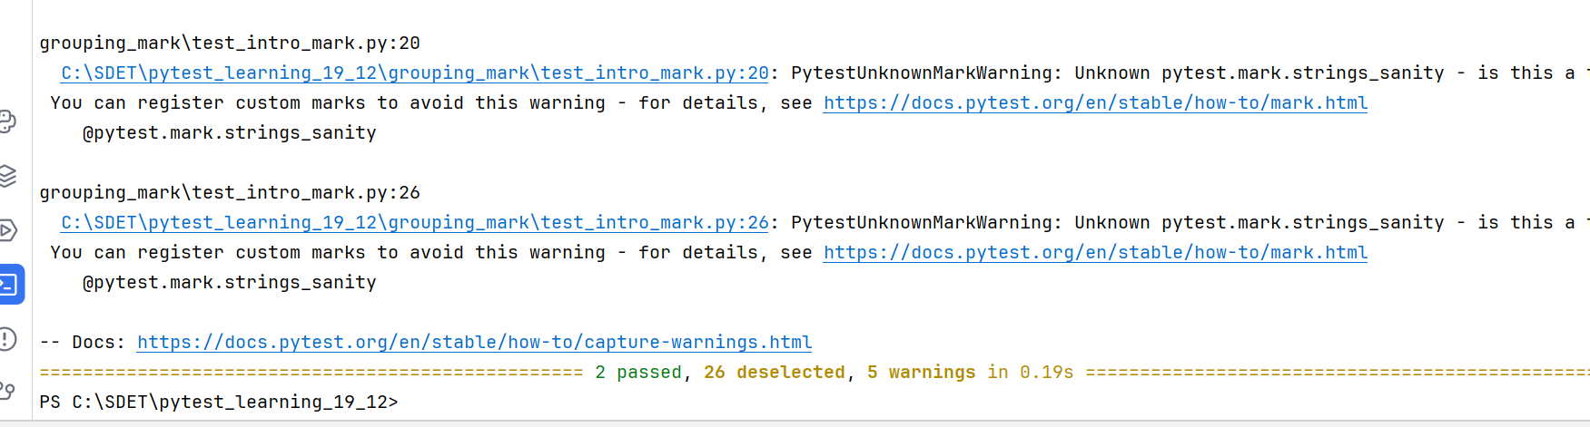

**Ignoring particular marker in a module:**

**pytest -vs -m "not strings_sanity" grouping_mark/test_intro_mark.py**

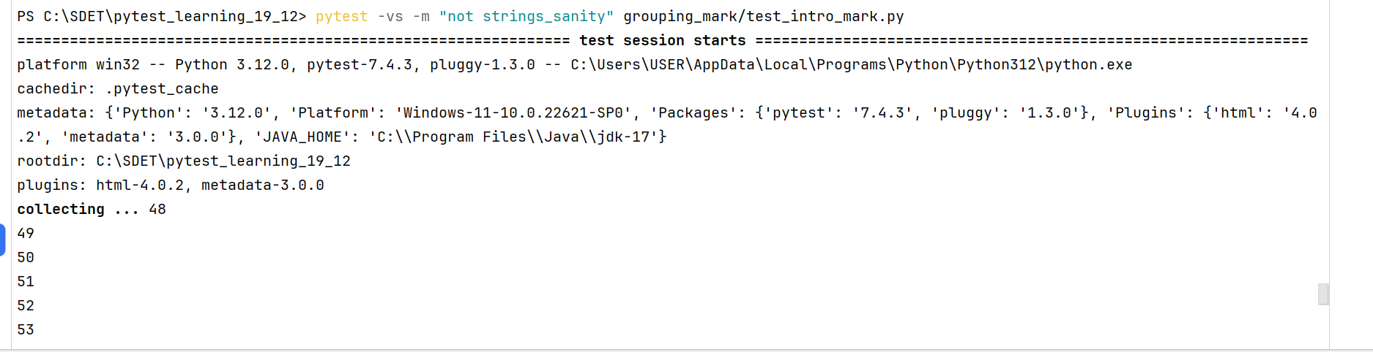

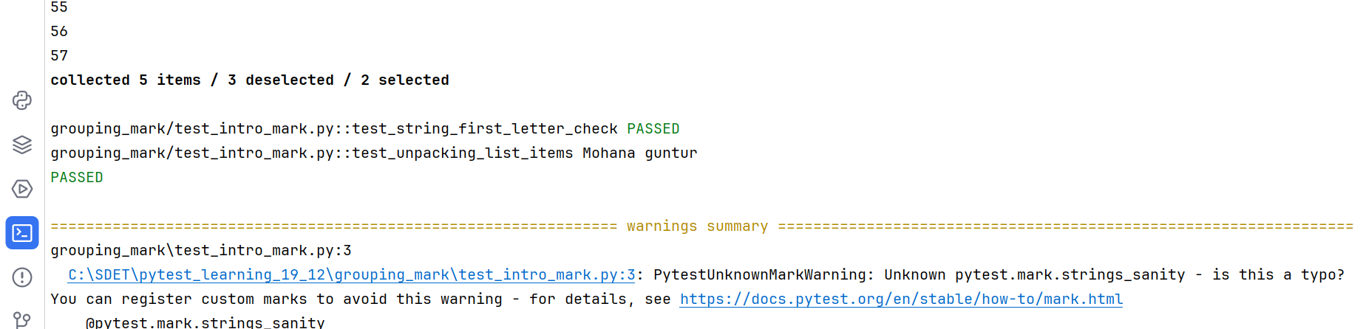

**Applying mark at module level:**

We can apply markers at module level also. To achieve that we need to use a global variable called **pytestmark**

Then we need to create a mark and assign to that variable. If you want to create multiple markers we need to create in a list and assign to that global variable.

Syntax: pytestmark = pytest.mark.marker_name #single marker

Pytestmark = [pytest.mark.marker1, pytest.mark.marker2] #for multiple markers

**Note: Here pytest is a global variable. Pytest will detect that variable and if you given the mark statements to it pytest will imlicitly apply markers at module level**

**Example:**

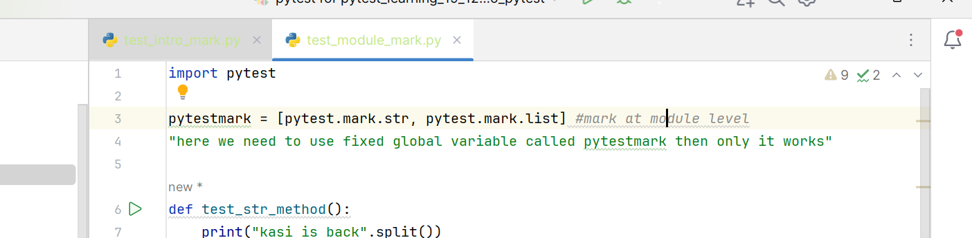

import pytest  
  
pytestmark = [pytest.mark.str, pytest.mark.list] *#mark at module level*"here we need to use fixed global variable called pytestmark then only it works"  
  
def test_str_method():  
 print("kasi is back".split())  
  
def test_str_method_upper():  
 print("python is a language".upper())  
  
def test_list_reverse():  
 print([109, 'kasi', 1.56, True][::-1])  
  
def test_list_merge():  
 print(['kasi']+['Mohana'])  
  
def test_list_dict_pick():  
 list_ = []

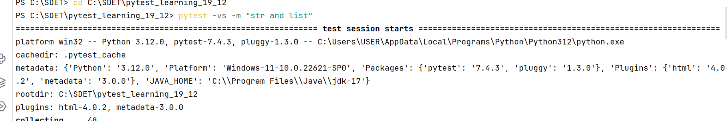

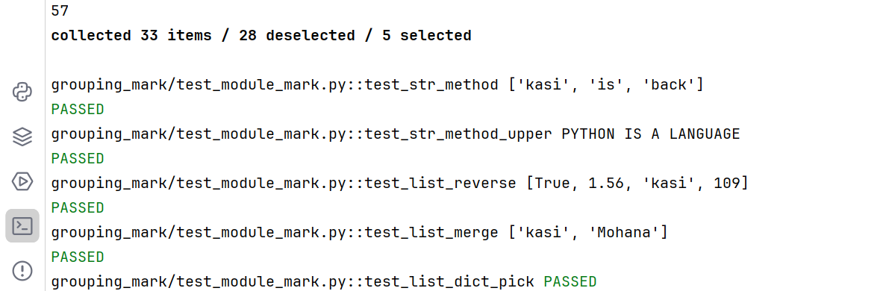



# Xfail:

Xfail is a **another way handling the exceptions** in assertions using markers. To apply the xfail to a particular test we need decorate it to the test.

Synatax: @pytest.mark.xfail

Note: after applying xfail to the test, if the test fails in console it will show as xfailed. If its passed it will show as the xfail passed. You can mention the reason while creating xfail for the test.

Here reason for documentation purpose only when the test is passed also it will show the reason in console

It will just show xfail if the test failed, and it will show xpass if the test passed. Instead of getting error exceptions and not executing other tests, it will handle it, remaining tests will executes as normal.

Examples:

import pytest  
  
class Test_xfail_practice:  
  
 @pytest.mark.xfail(reason='its not a proper index to fetch')  
 def test_get_car_str_index(self):  
 string_ = 'its a beutiful day'  
 assert string_[18]  
  
 @pytest.mark.xfail(reason='its not a proper index to fetch')  
 def test_get_car_str_type2(self):  
 string_ = 'its a beutiful day'  
 assert string_[2]  
  
 @pytest.mark.xfail(reason='you can not conctinate different data type')  
 def test_str_num_concatinate(self):  
 name = 'Mohana kasi'  
 id = 1008  
 assert name+id

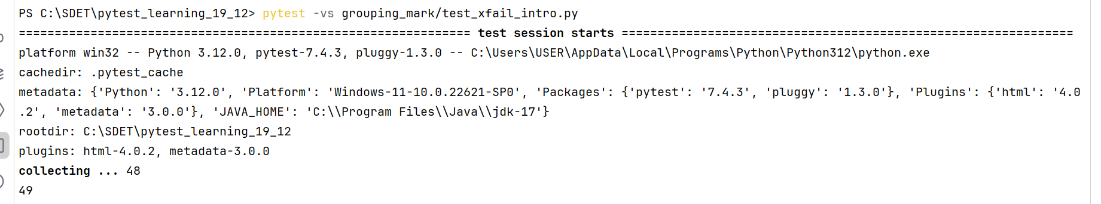

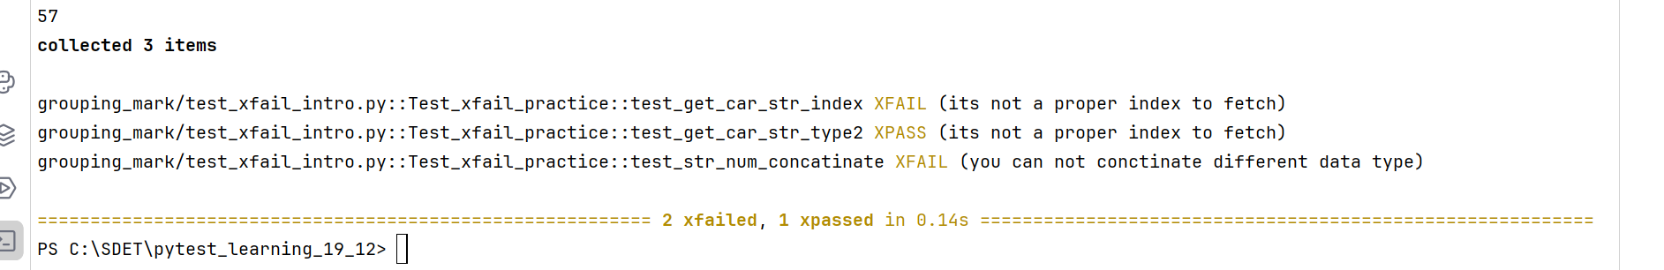

**Xfail with conditions:**

We can pass the negative scenarios by putting a condition in the xfail. If the condition is satisfied then the negative scenario passed. If its fails then it will gives as failed test case.

For item checking in collection with assert statement will through assertion error

Raises is for error validations only

You need to mention reason must when you doing conditions in xfail or else it will through below error

**_ ERROR at setup of test_method_xfail_cond**

**Error evaluating 'xfail': you need to specify reason=STRING when using booleans as conditions.**

If you want to declare any other validations, you can directly mention it, no parameter needed

@pytest.mark.never_work  
@pytest.mark.xfail(raises=TypeError)  
def test_method_xfail_220():  
 assert {1, 324, 234}[0]

Examples:

import sys  
  
import pytest

@pytest.mark.never_work  
@pytest.mark.xfail(raises=TypeError)  
def test_method_xfail_220():  
 assert {1, 324, 234}[0]

@pytest.mark.xfail(raises=IndexError, reason='index is out of the range')  
*#other than index error it will fails the test case*def test_char_fetch():  
 string_ = 'python is full of puzle codes'  
 assert string_[25]  
  
@pytest.mark.xfail(raises=IndexError, reason='index is out of the range')  
def test_char_fetch():  
 string_ = 'python is full of puzle codes'  
 assert string_+1  
  
@pytest.mark.xfail(sys.platform == 'win32', reason='its work in linux only')  
def test_platform_check():  
 print("in linux version")  
  
@pytest.mark.xfail(sys.platform == 'linux', reason='its work in windows only')  
def test_wind_platform_check():  
 print("in windows version")

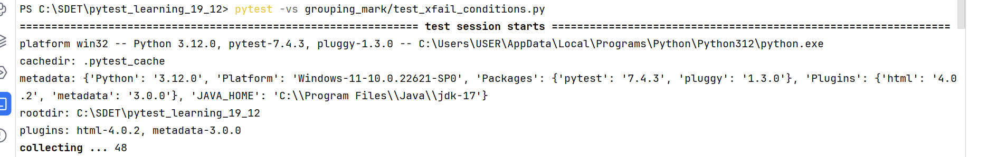

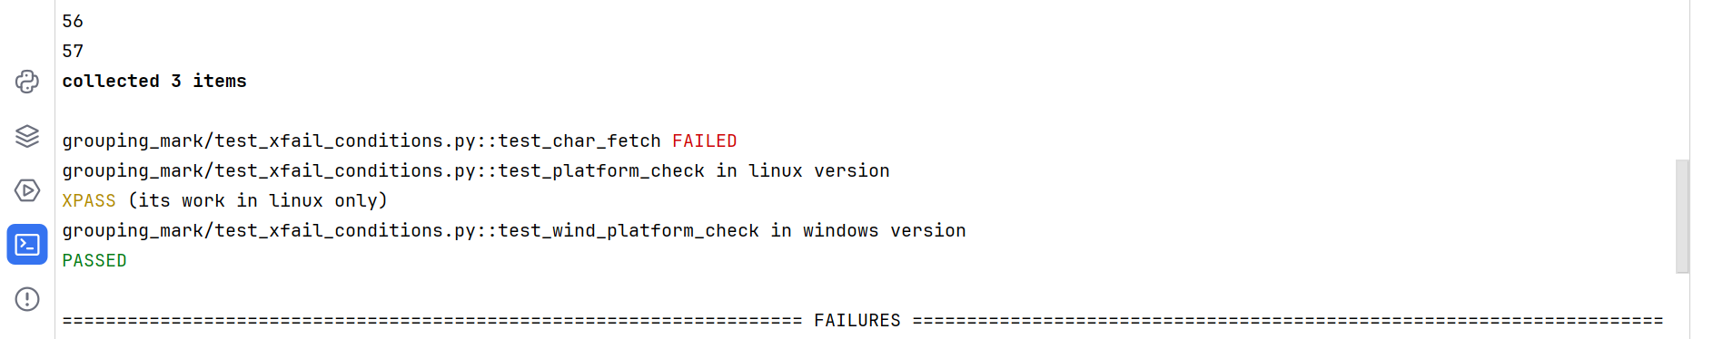

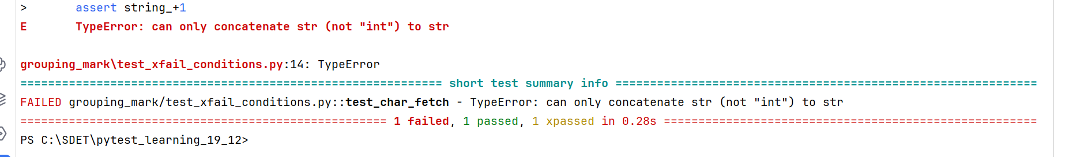

**Running the tests using test names: (-k)**

It is used to run the particular test module/function/class. Basically this –k used to filter out the test module/functions. While running with –k no need to specify the module names or path. Pytest will auto detects for test modul/class names with the given text.

Examples:

**Running with partial text of method names:**

**If you given partial text it will run all matched test cases.**

**Example1:**

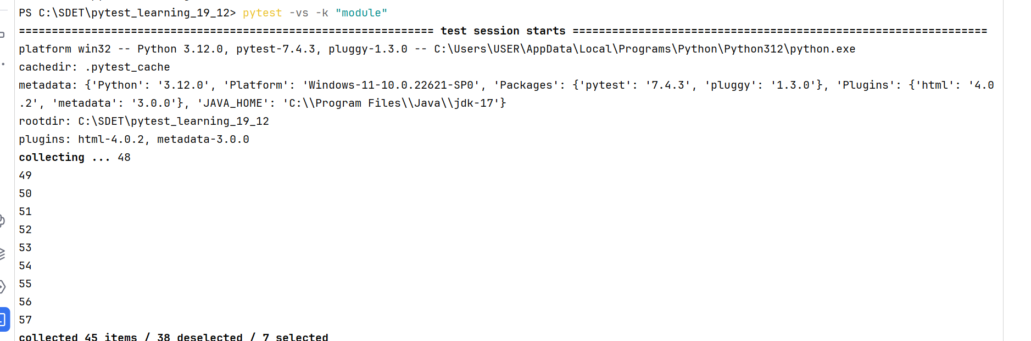

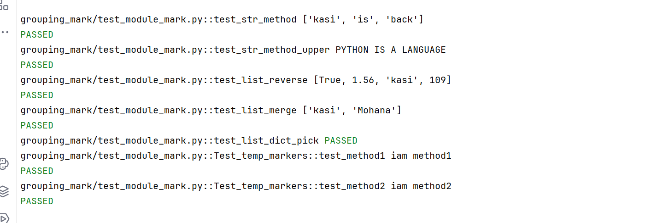

*here it is detected the class names with module text

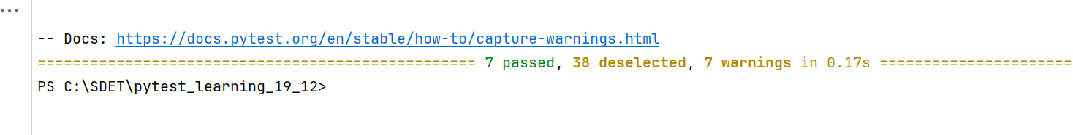

Example2:

**If your test method name is unique and if you given full test method name in pytest command, even though you not given the module name, pytest will detects and run it**.

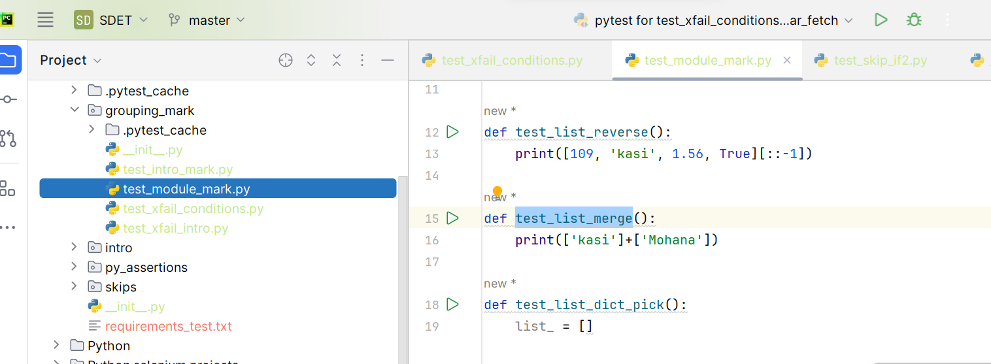

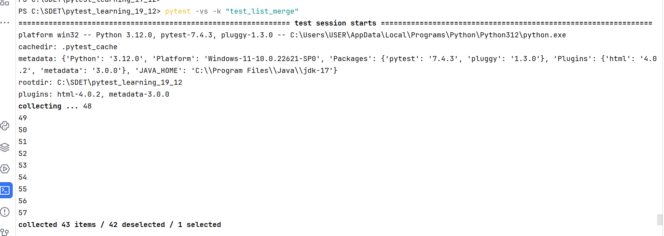

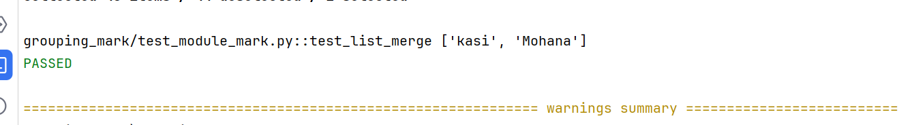

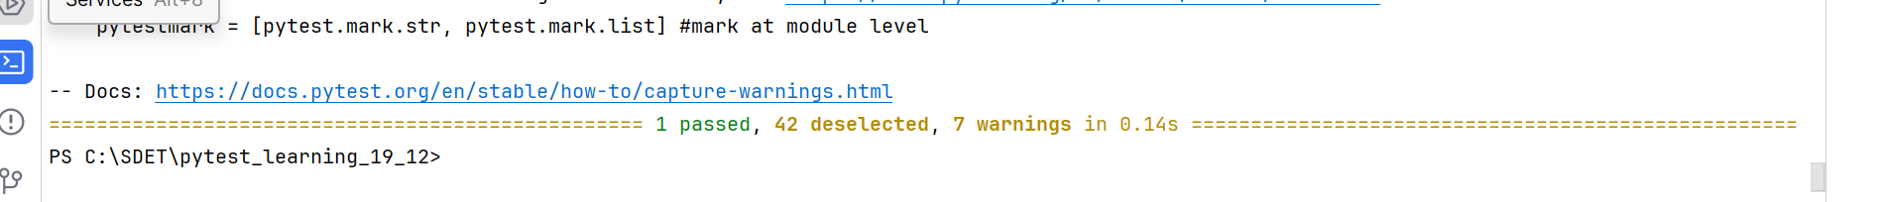

Example3:

**Running the test classes using –k option:**

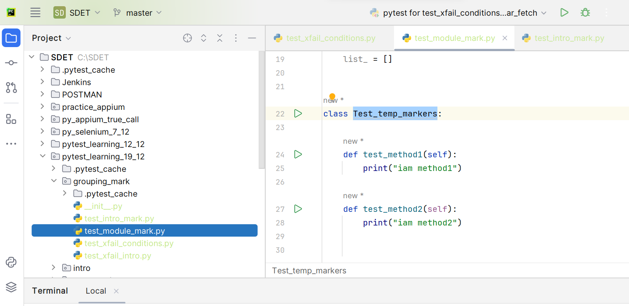

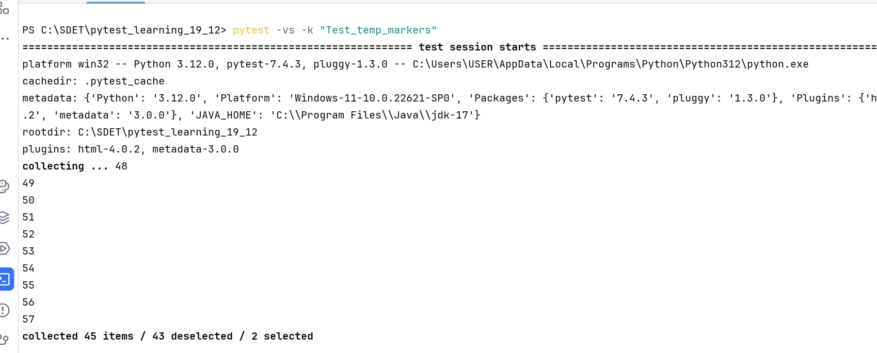

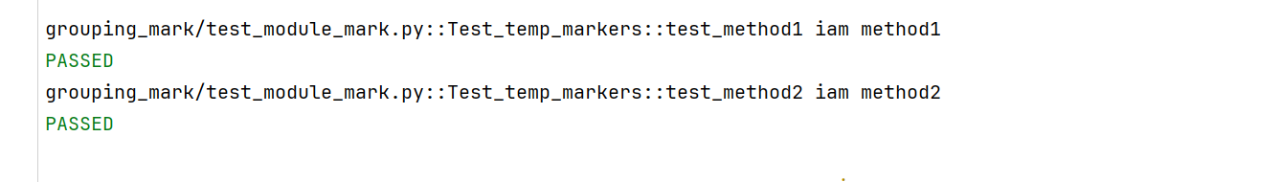

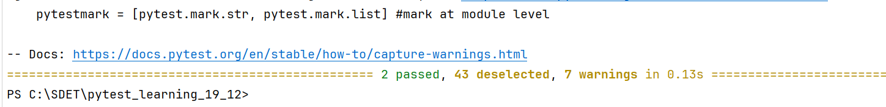

**Note: you can use the and or statements while declaring the test method**

**Example:**

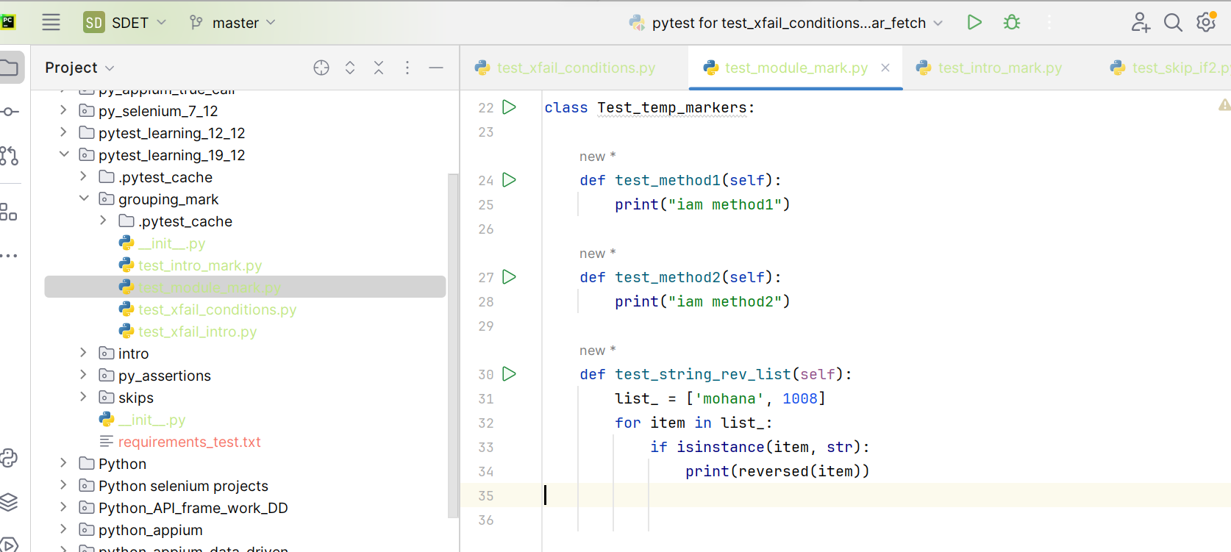

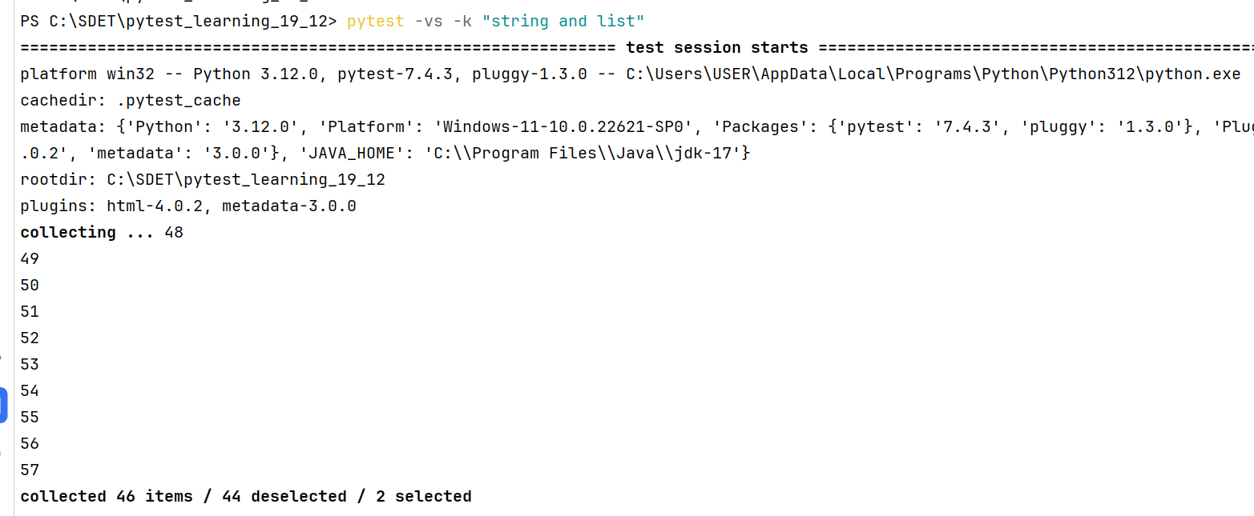

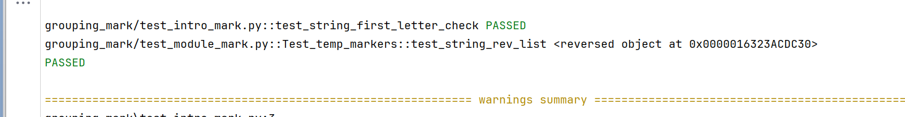

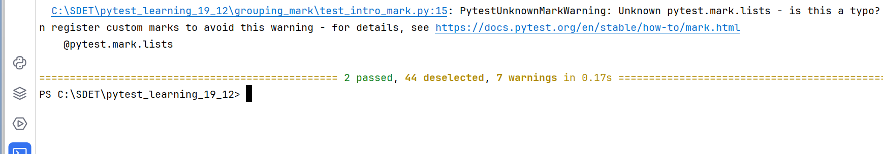

**Or:**



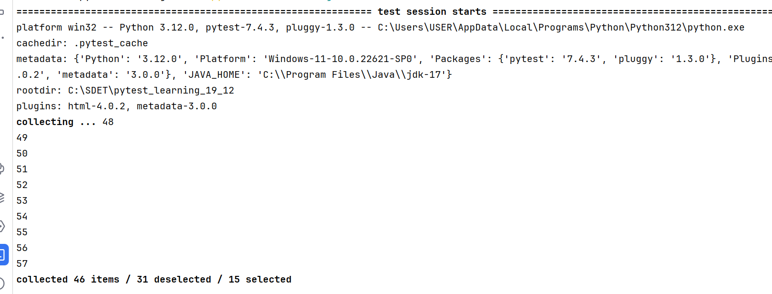

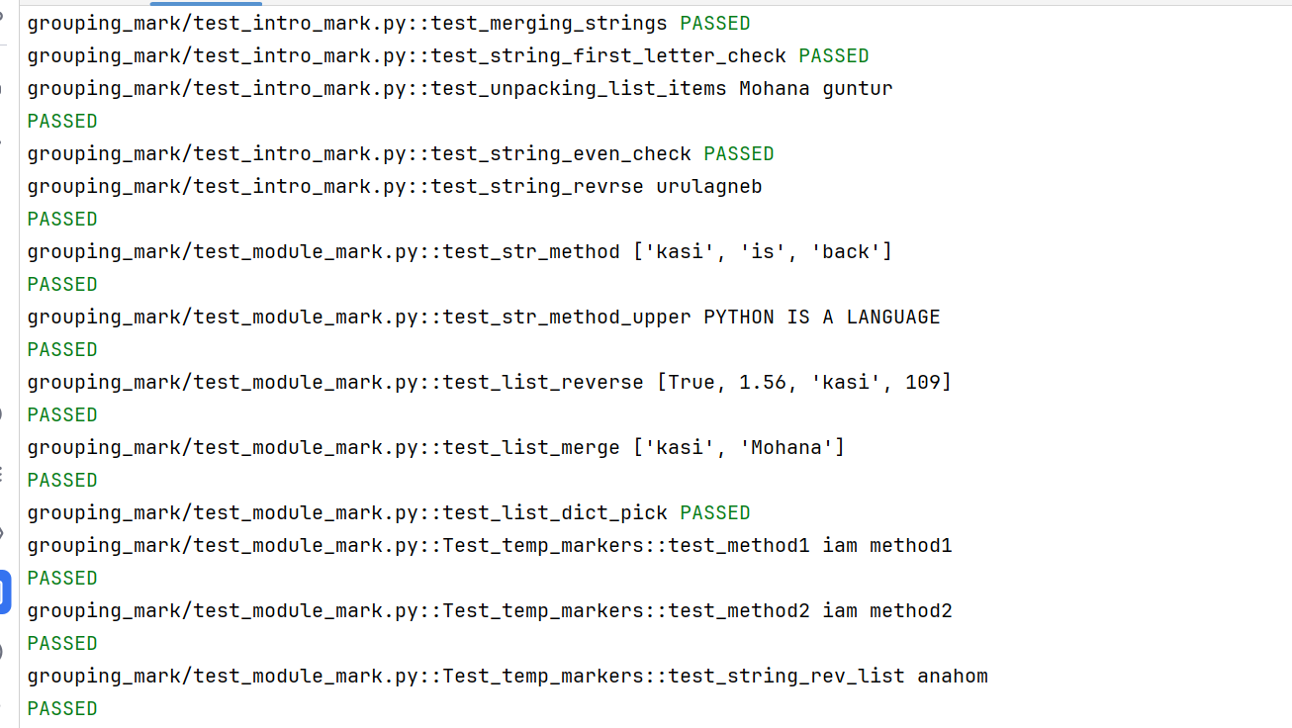

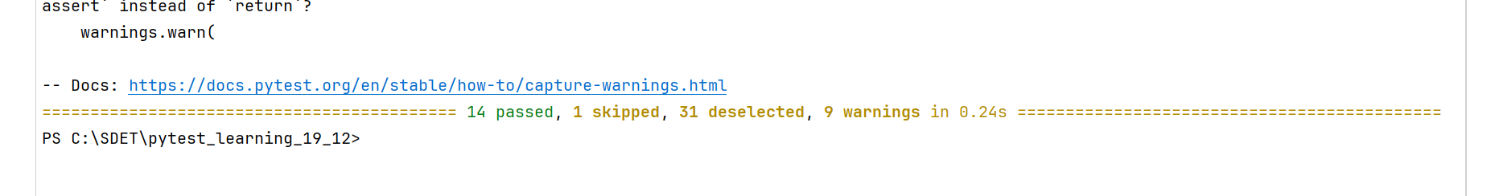

**--tb: (tb means traceback)**

Used to specify if any test cases is failing and want short output, at that case we will use –tb=no, then it will provide the short output. It will specify the pass/fail only not detailed error report for failed ones.

Examples:

Without –tb:

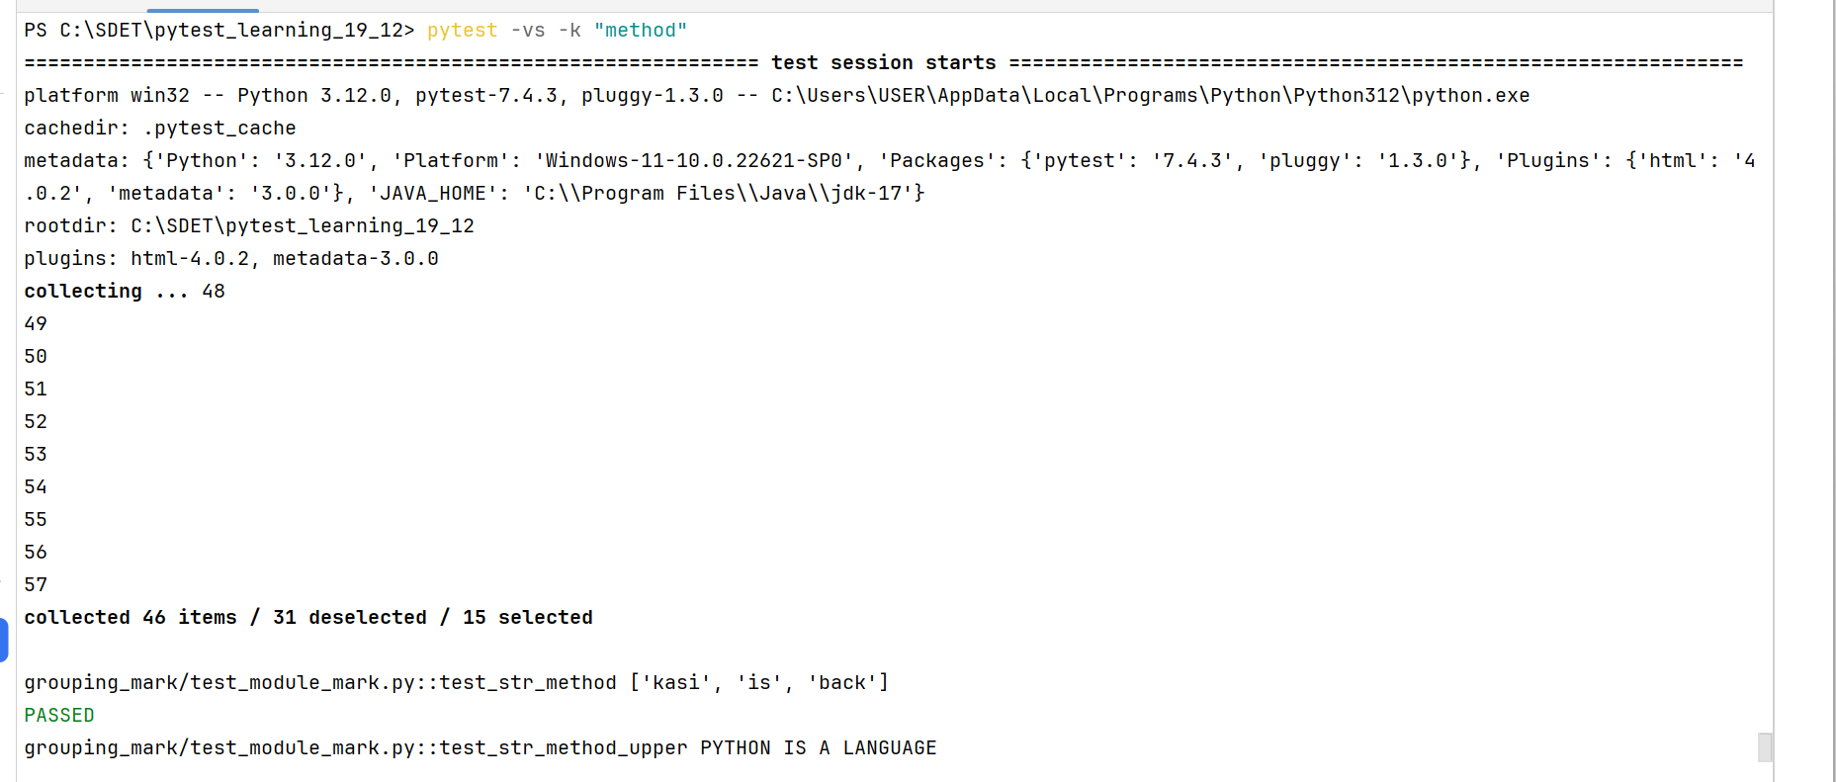 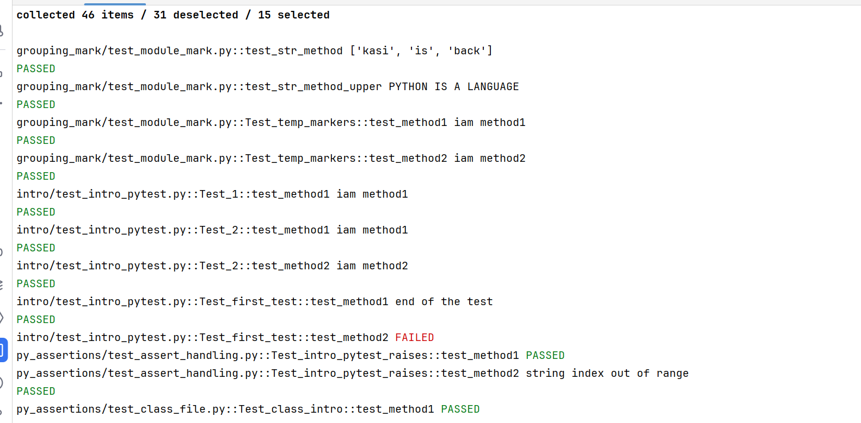

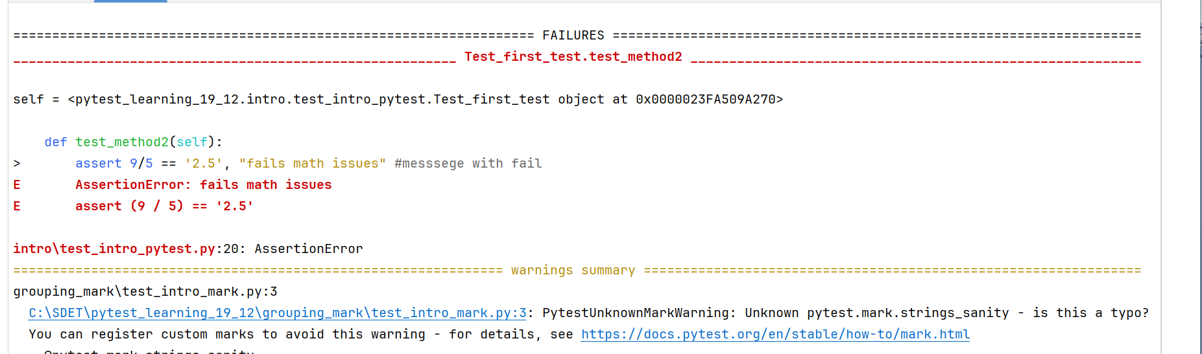

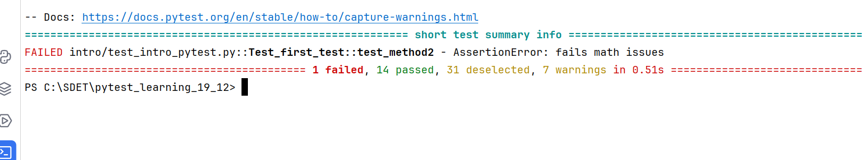

With –tb=no:

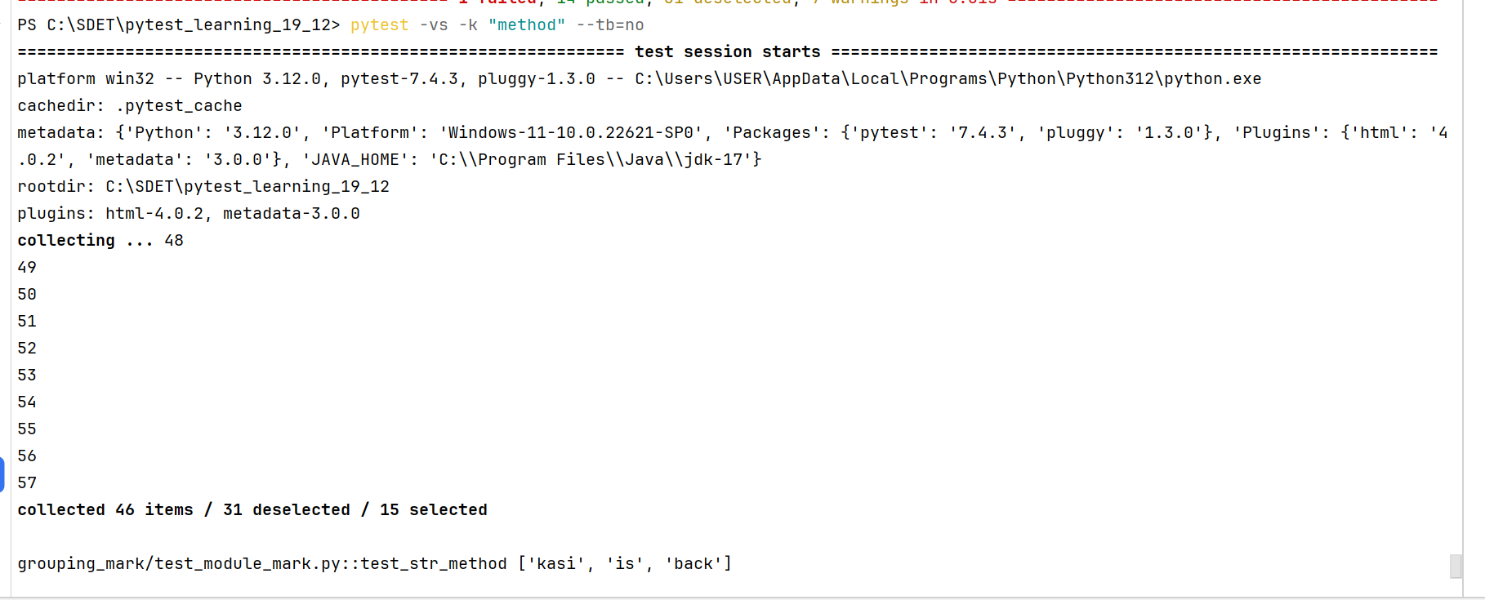

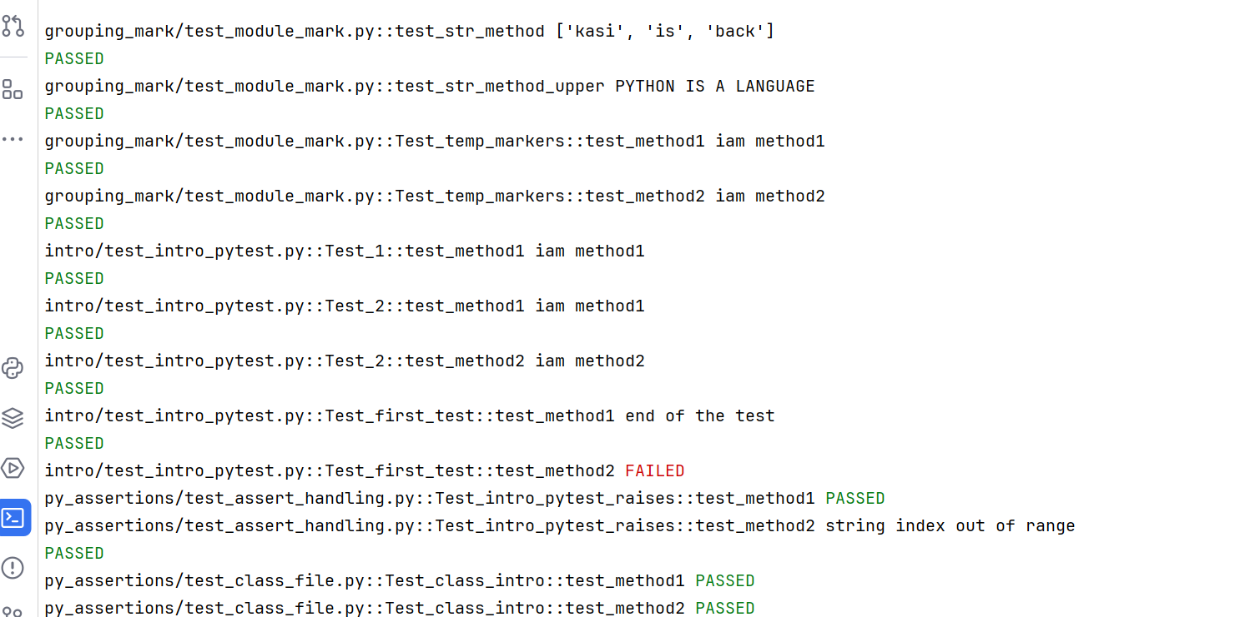

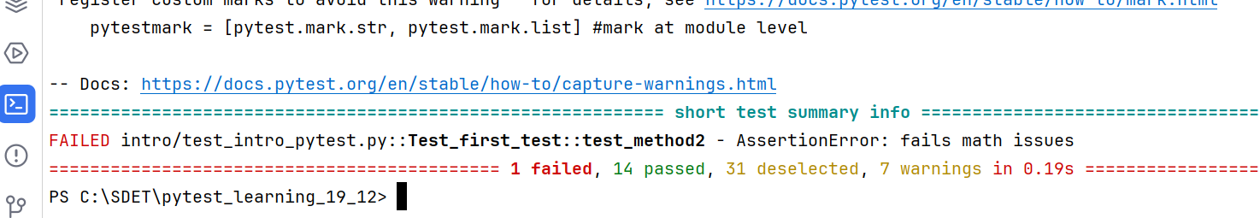

-x:

Whenever any test failed it will not allow running remaining test cases. It will stop execution there it self.

Without –x:

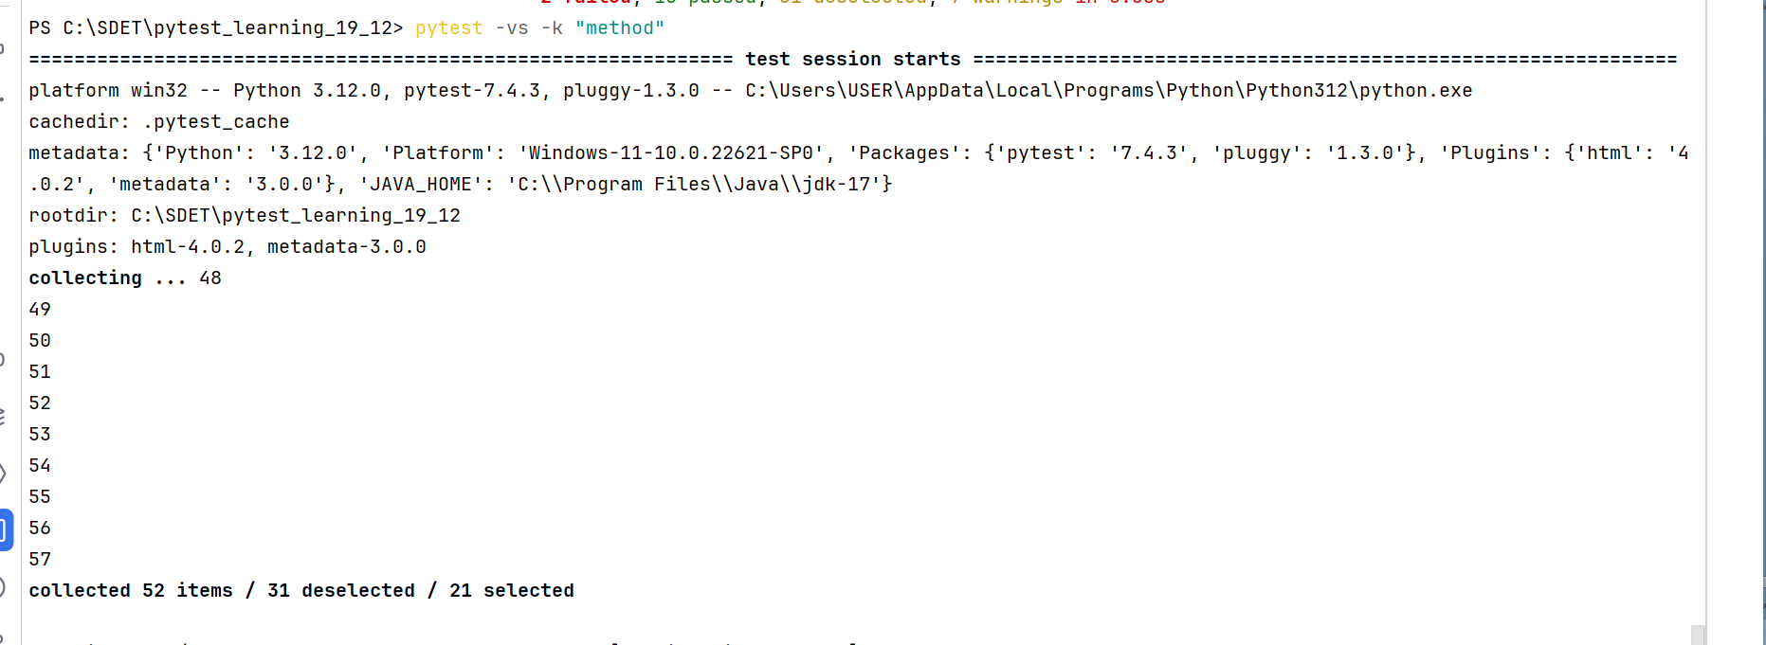

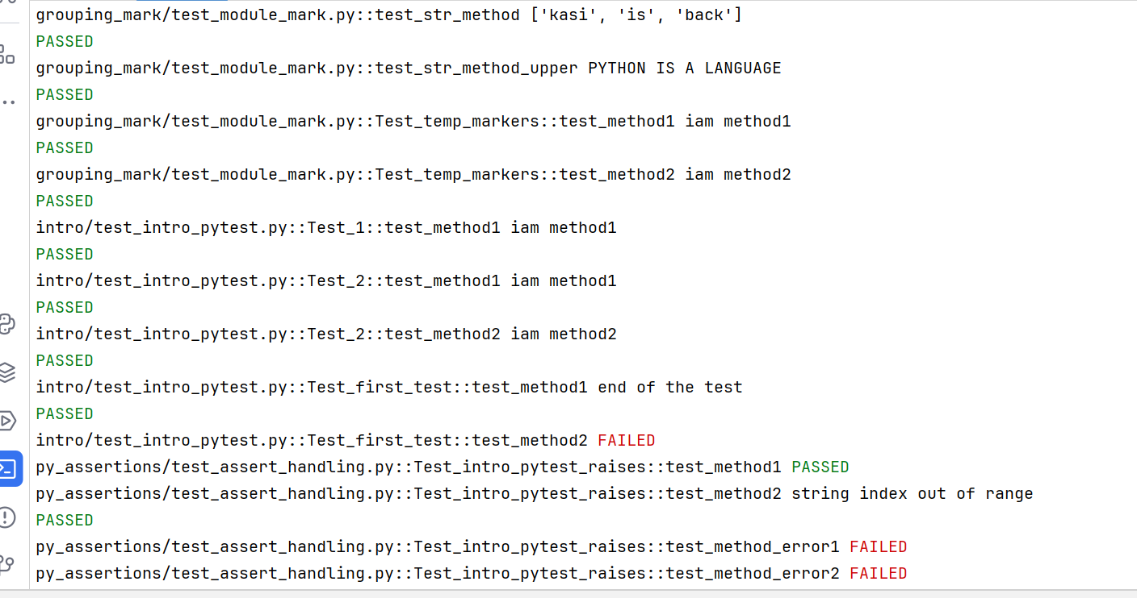

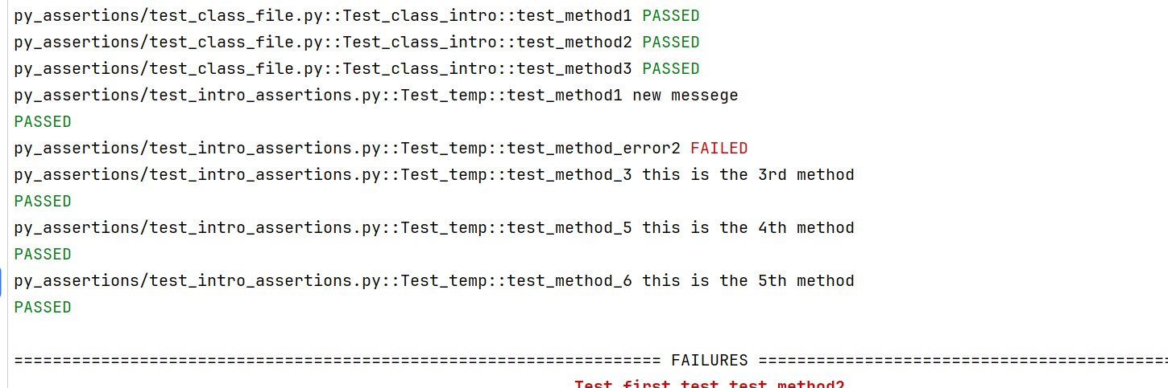

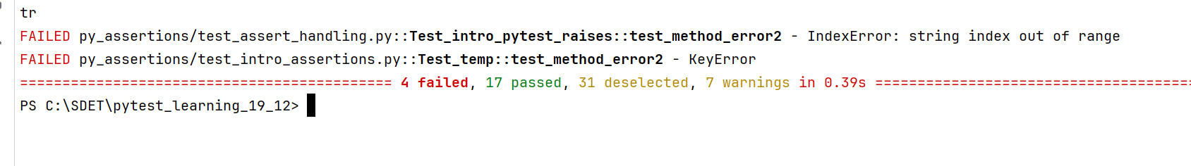

* here you can see the concurrent executions of pass/fail whenever a test case is failed.

**With –x option in pytest command:**

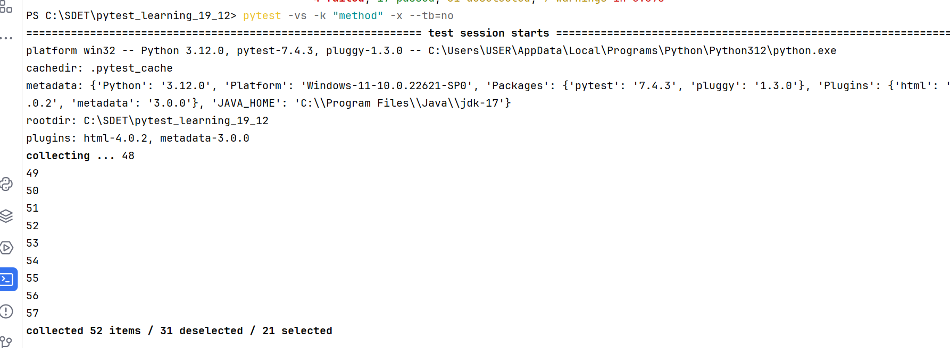

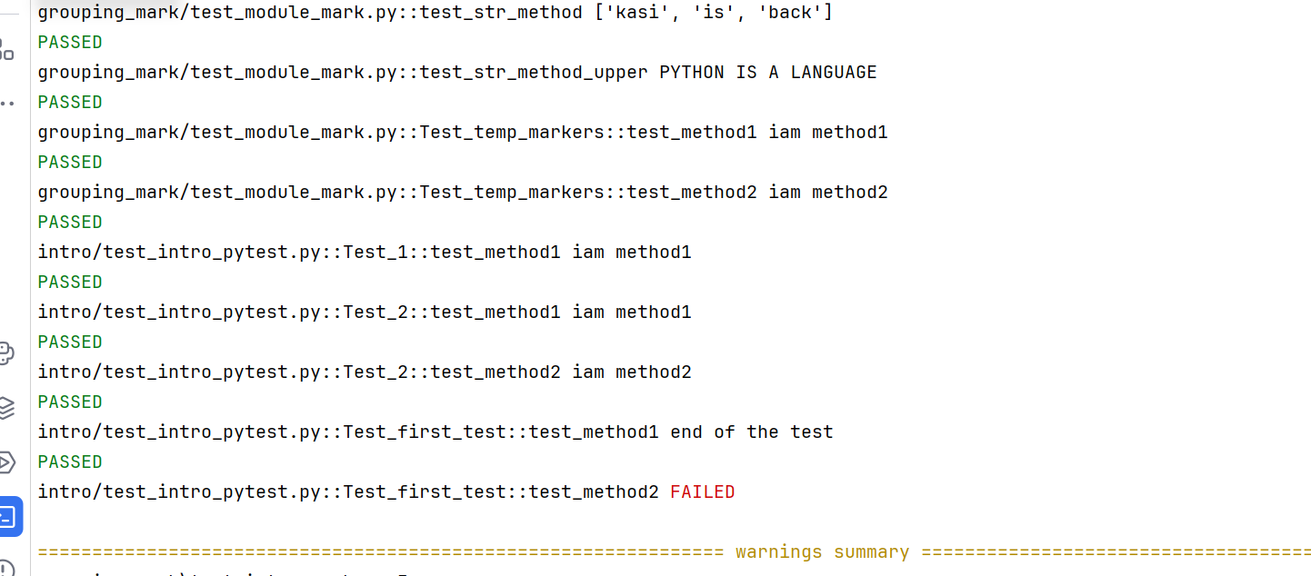

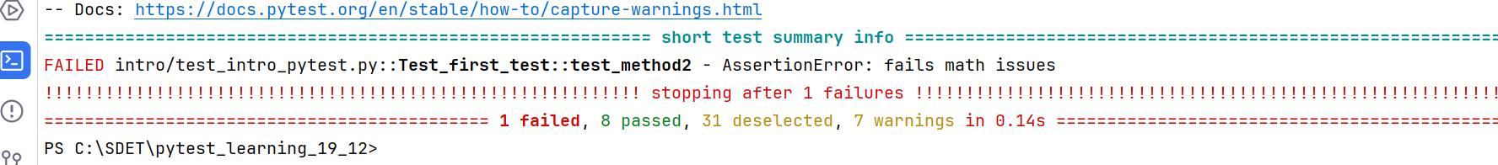

* here you can see any of the test case is executed(pass/fail) once a test case is failed

--maxfail:

* Used to stop the execution flow whenever the failed cases reached the specified number. In this way you can stop the execution whenever failing reached desired number

Without –maxfail:

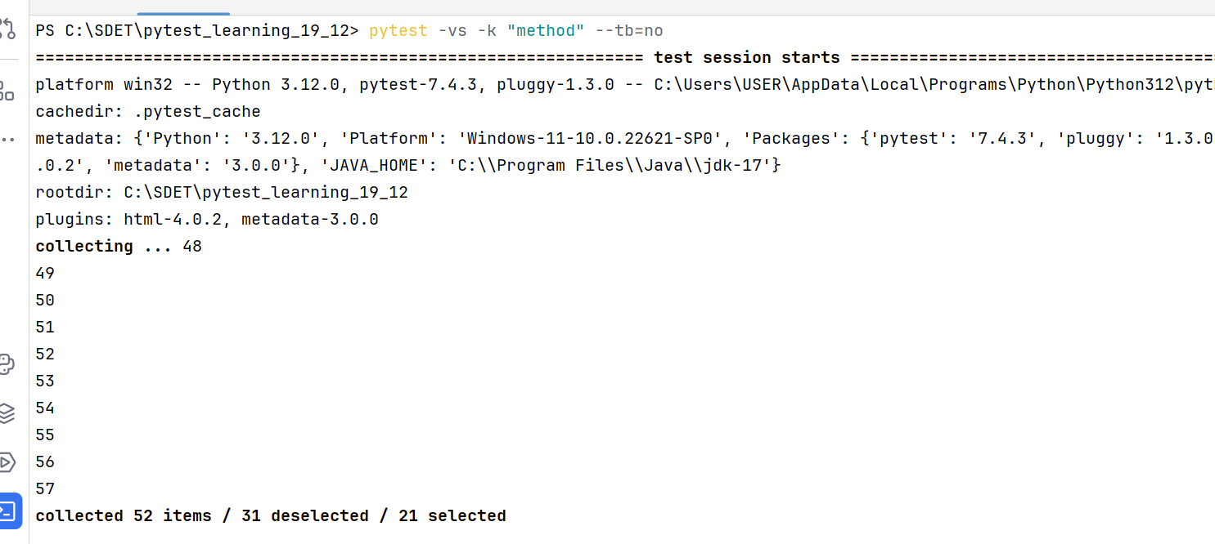

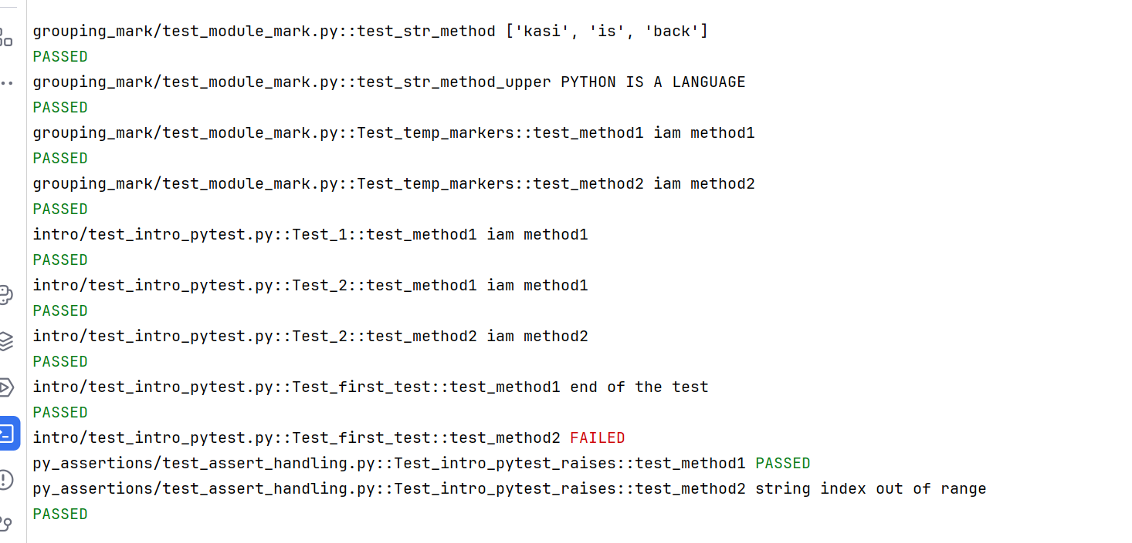

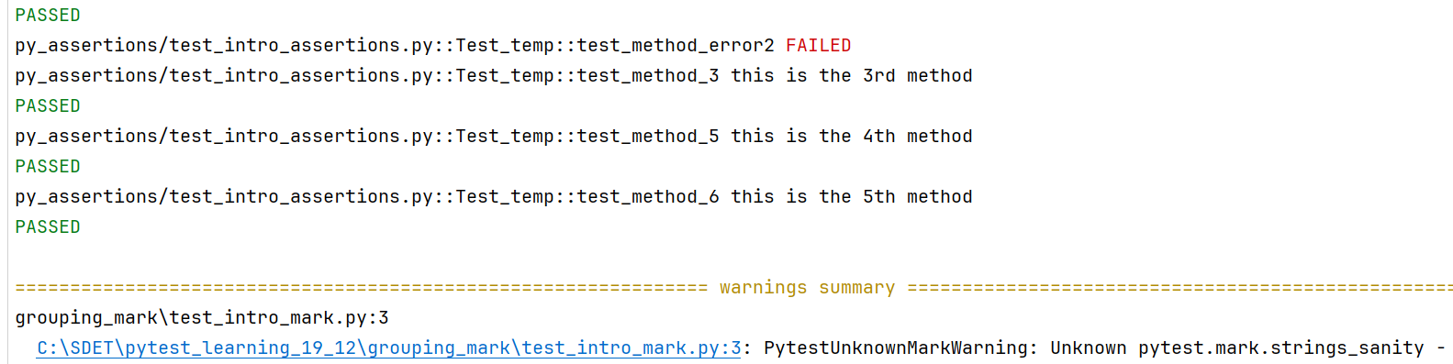

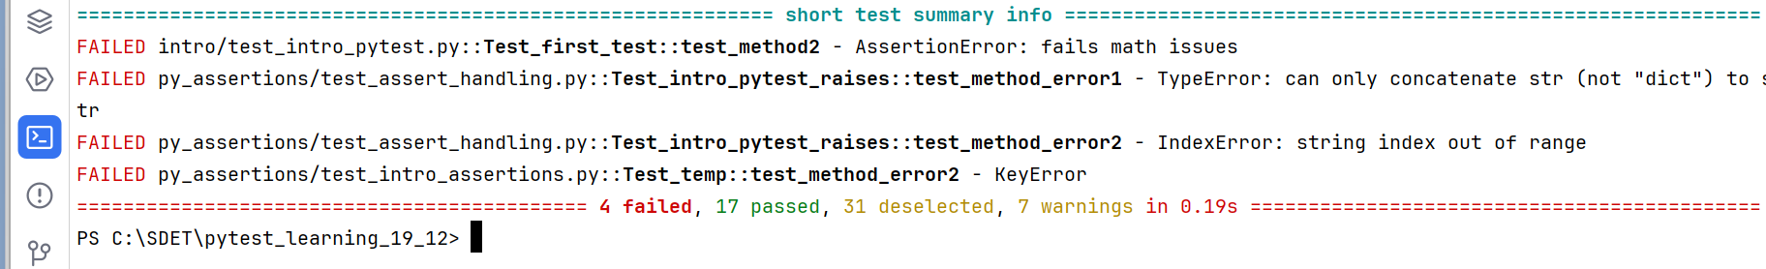

Using –maxfail:

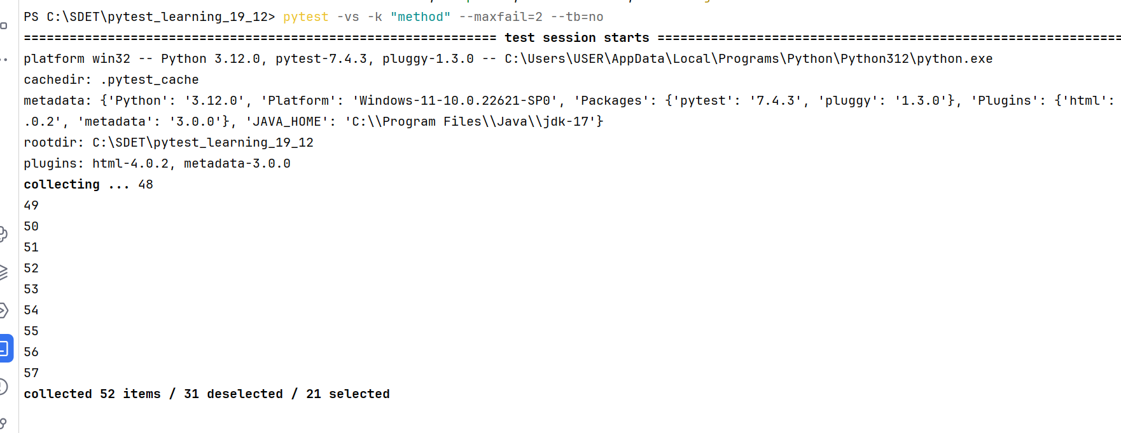

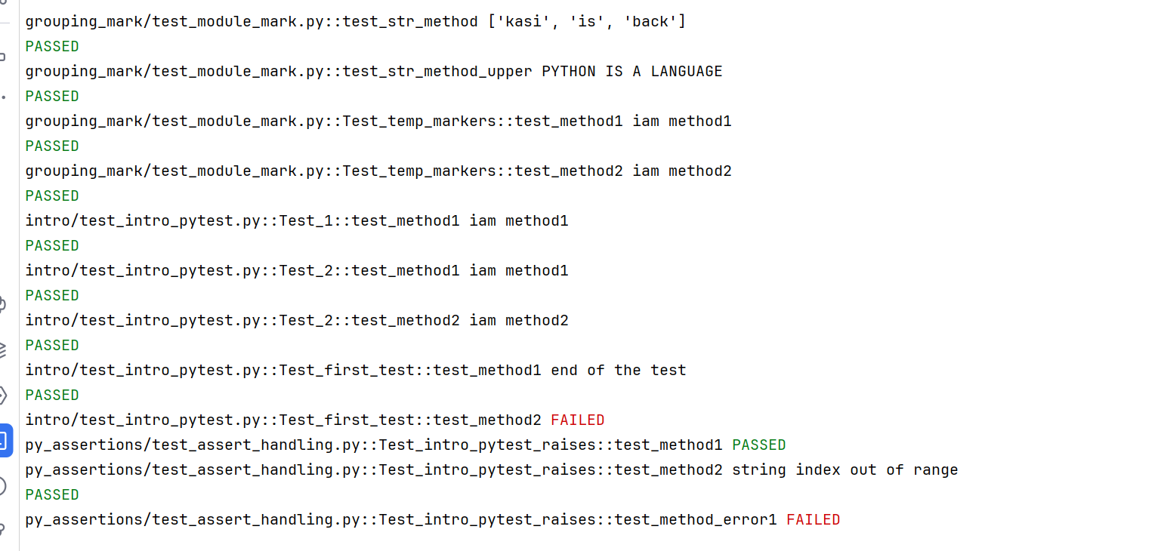

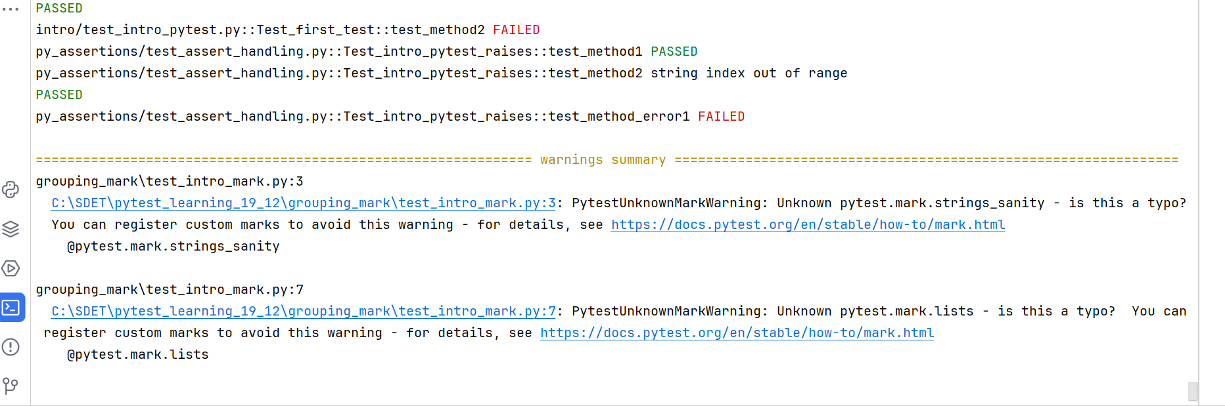

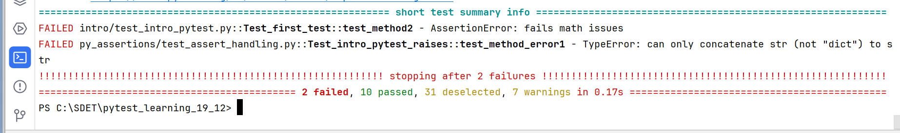

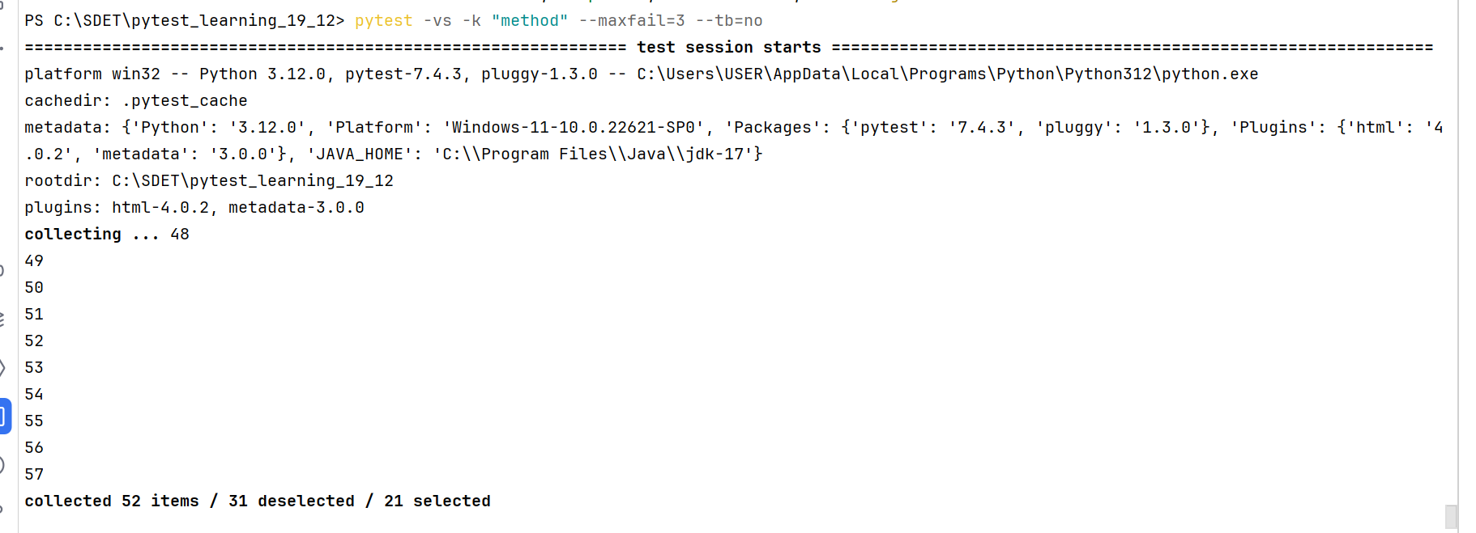

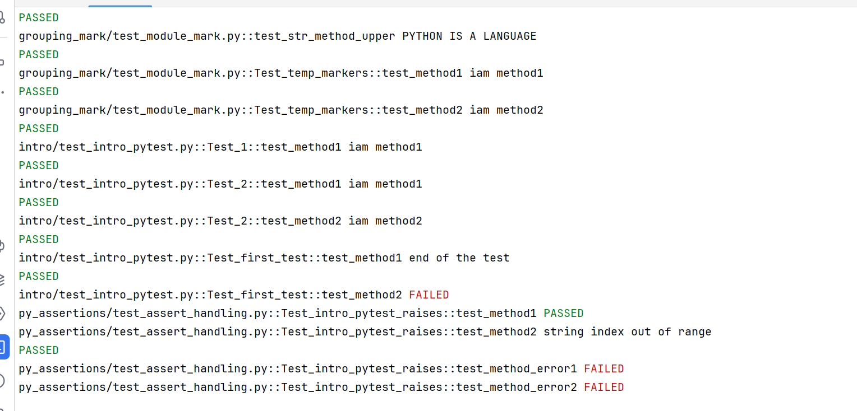

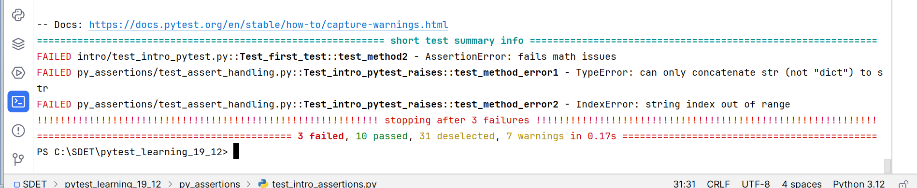

-q option:

Used to decrease verbosity. Used particularly when running in Jenkins servers. It will reduce the logs

--collect-only:

* Used to collect only all desired/matched test cases no to run it.

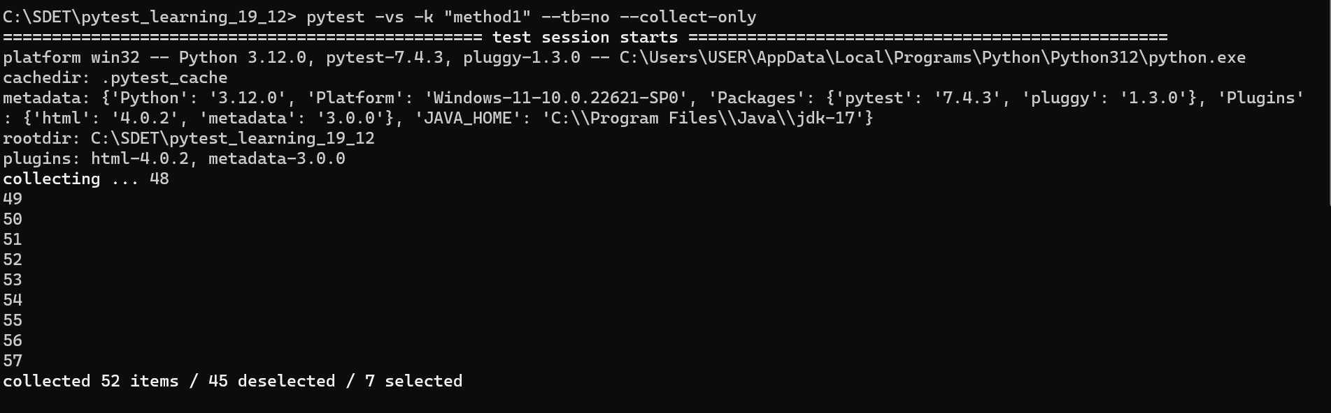

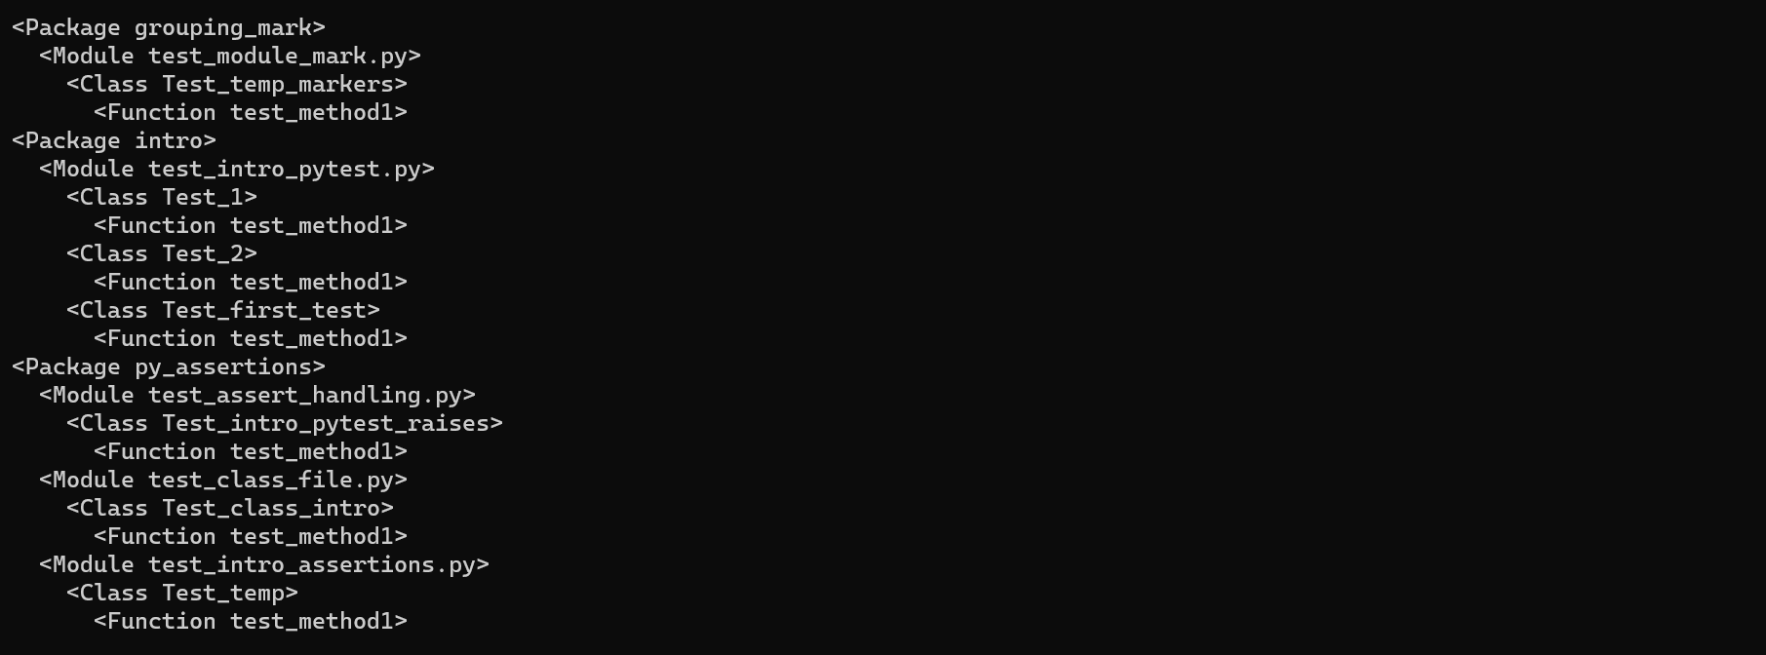

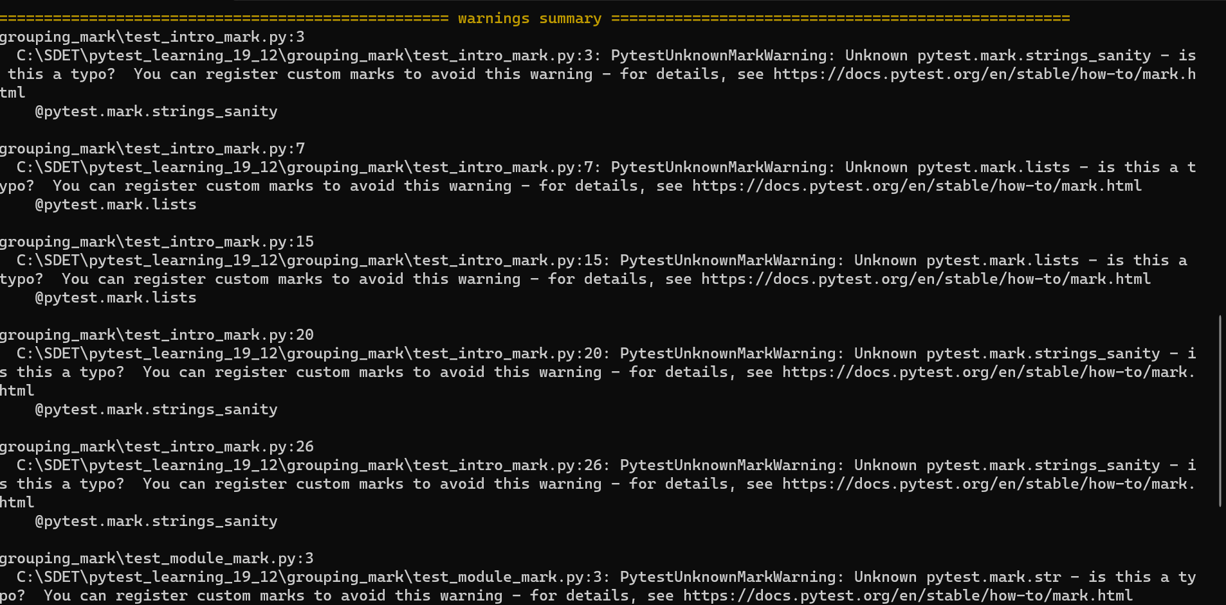

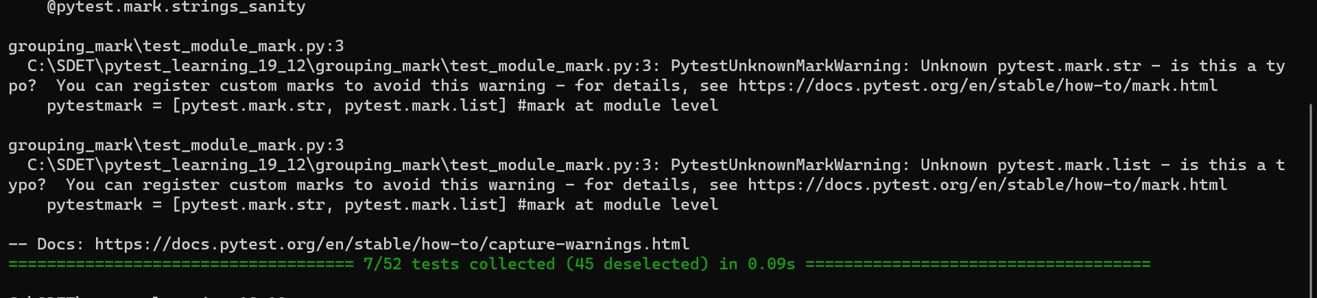

--lf:

* Used to run the failed test cases only. It will run the last failed test cases which will take from the pytest cache.

Example:

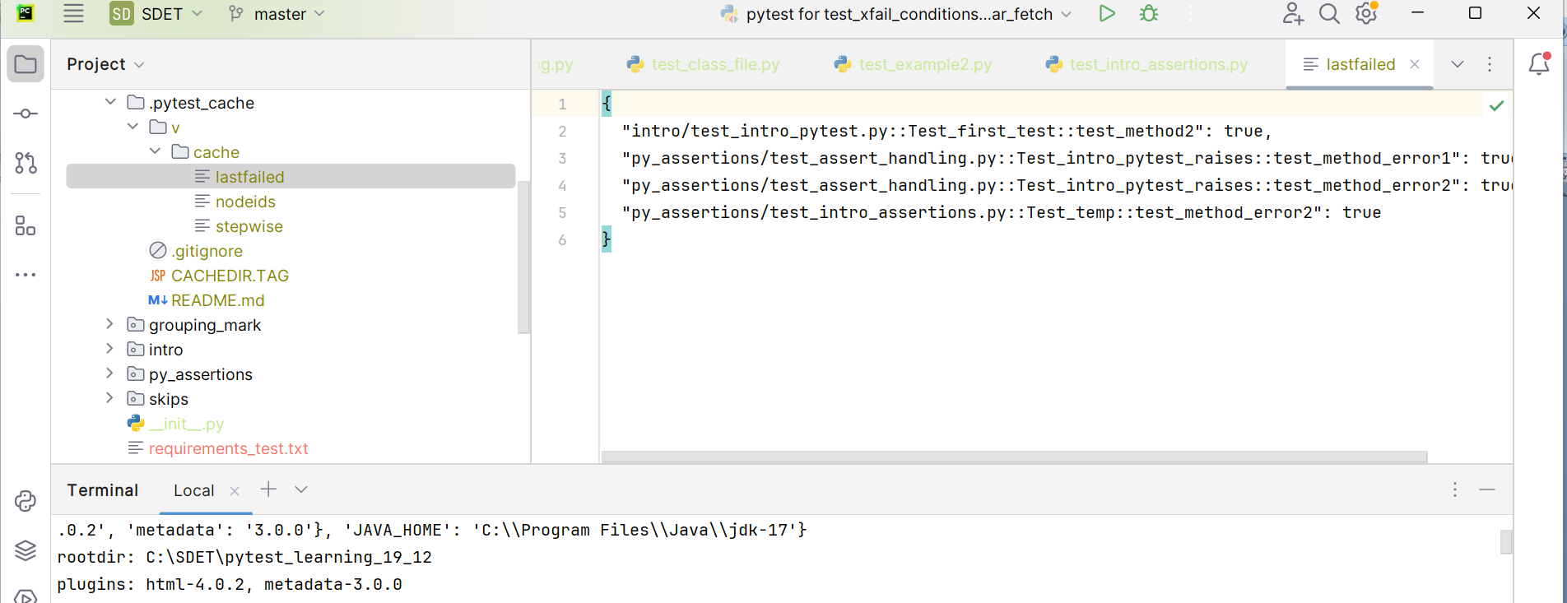

* In pytet cache having failed test cases of 4

Now trying to run the pytest command with –lf

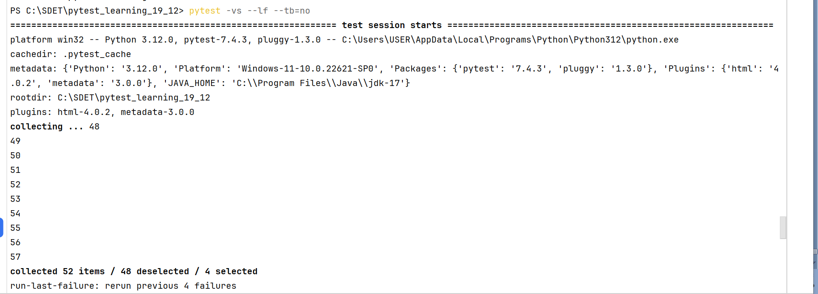

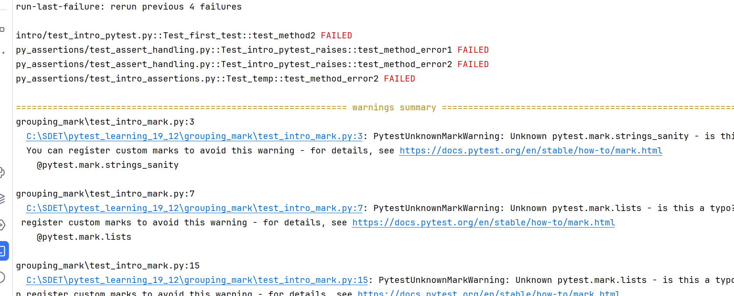

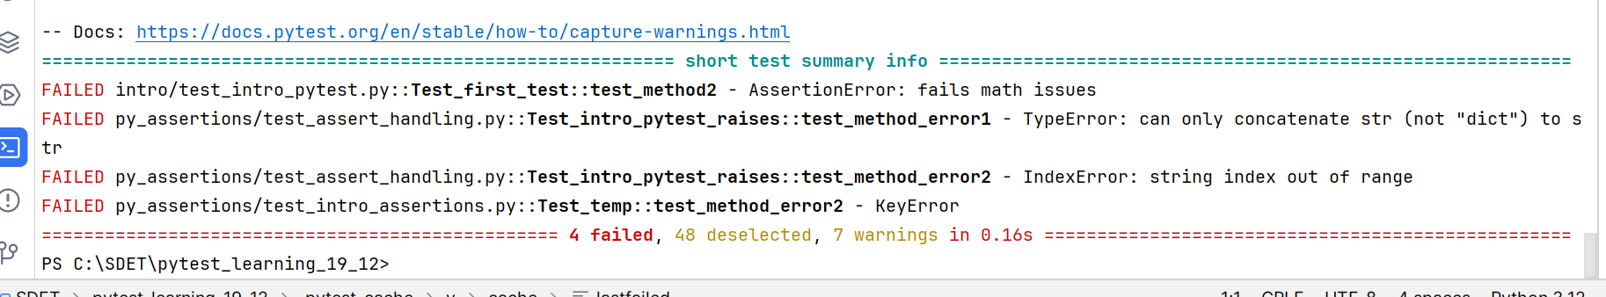

--ff:

* It will run the failed test cases first and later it will runs the remaining test cases

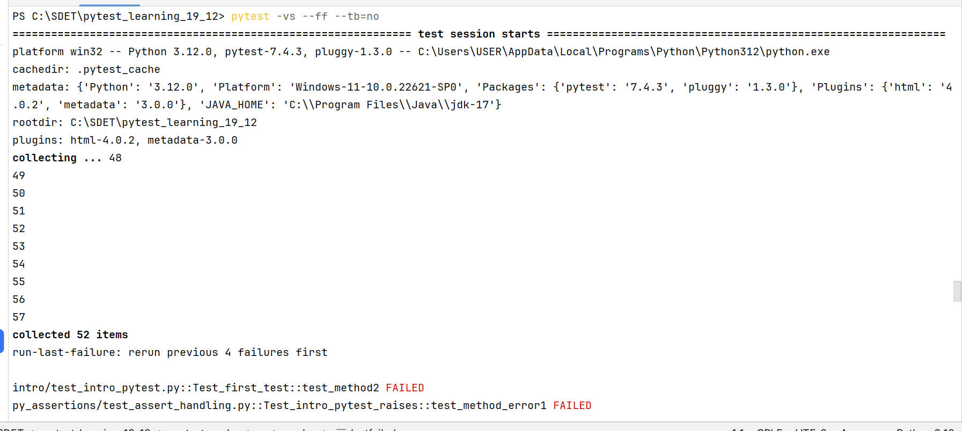

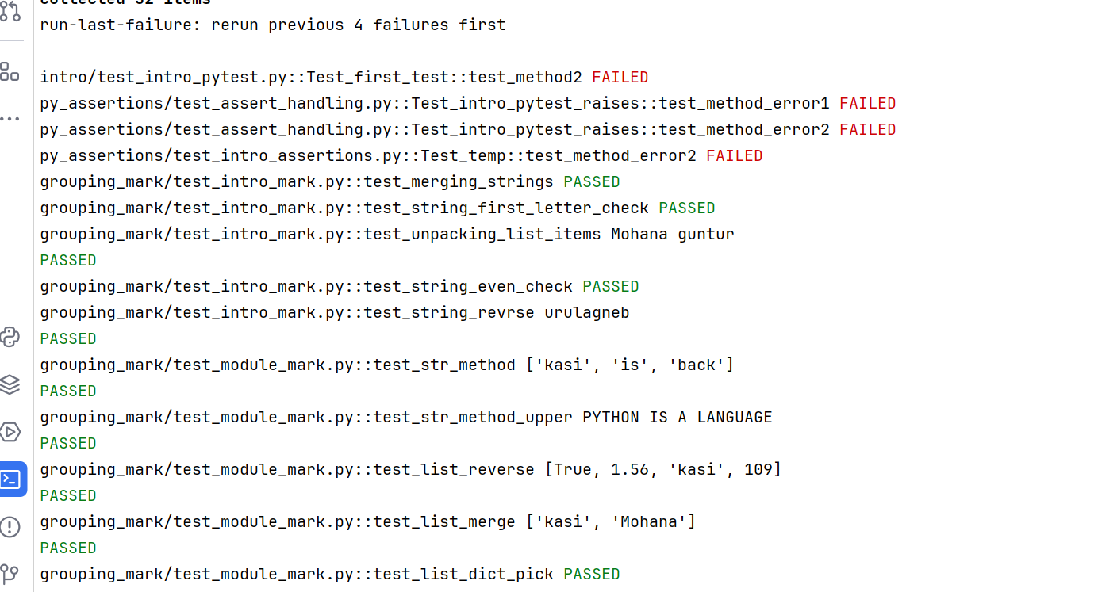

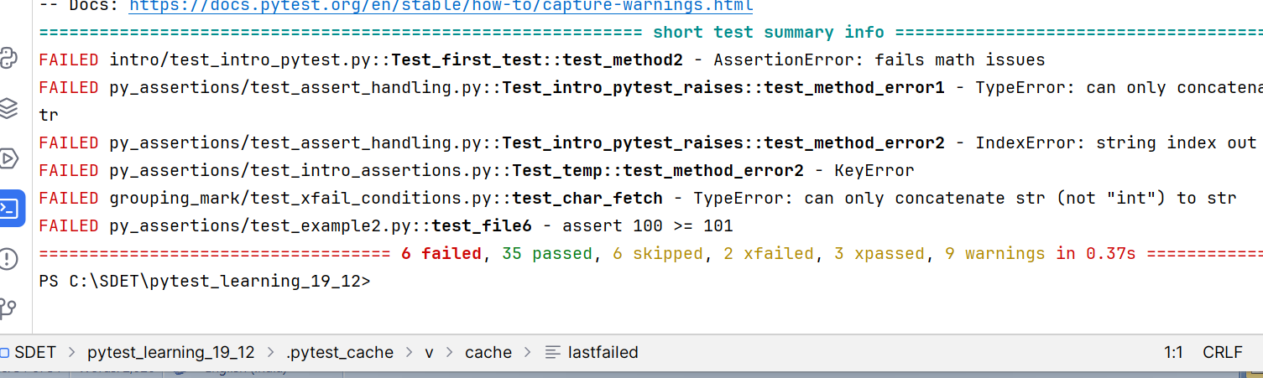

--help:

* Used to get the different commands in pytest

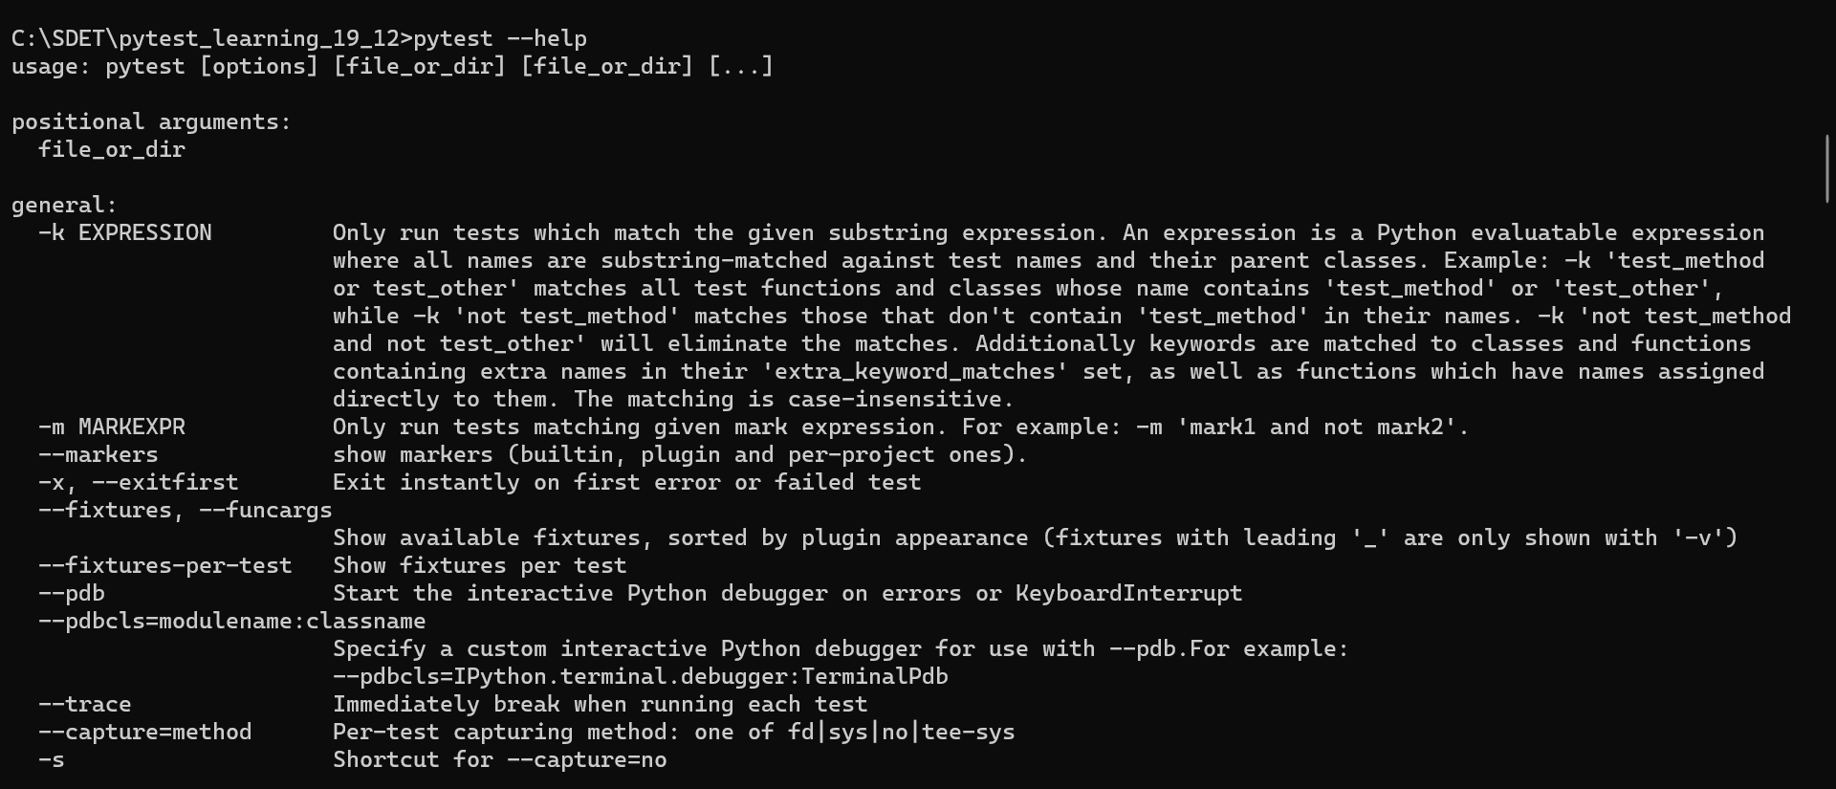

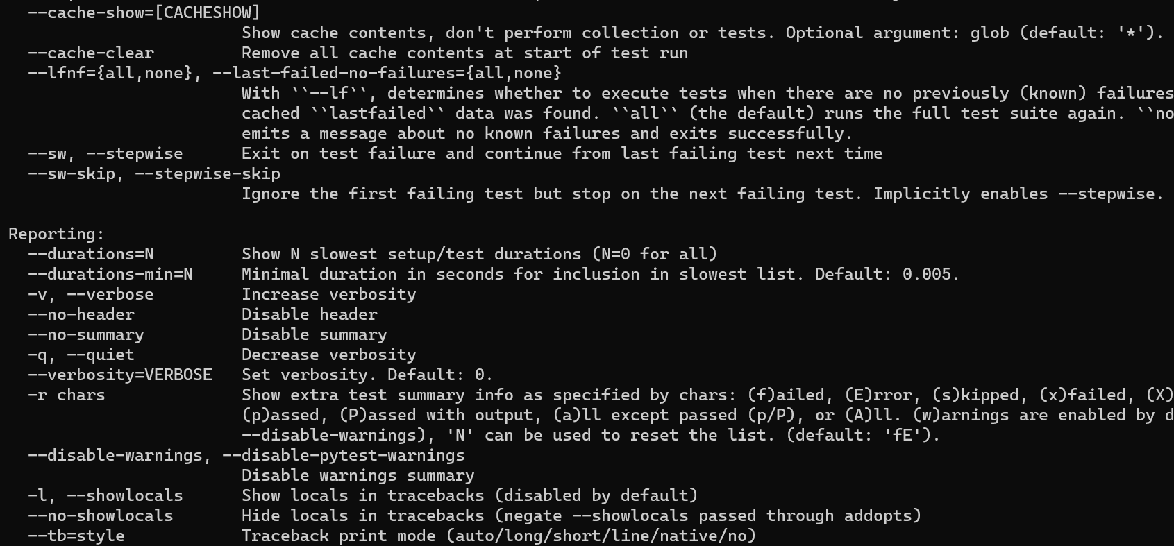

**--version:**

* To list the python versions



**Some validations of the pytest:**

PASSED: Test ran successfully

Failed: Test did not run successfully

SKIPPED: The test was skipped

Xfail: The test was not supposed to pass, ran and failed.

Xpass: The test was not supposed to pass, ran and passed

Error: An exception happened outside of the test function

**Parametrize:**

To make a test method to run with the different set of data like data driven then we will use parameterize which is available in pytest.mark

Pytest will provide the data to the test method each time like a iteration which will take from the given data list and inputs into the variable decalred

Example:

import pytest  
  
@pytest.mark.parametrize("user_name", ['Mohana', 'kasi', 'Rao'])  
def test_trial1(user_name):  
 print(user_name)

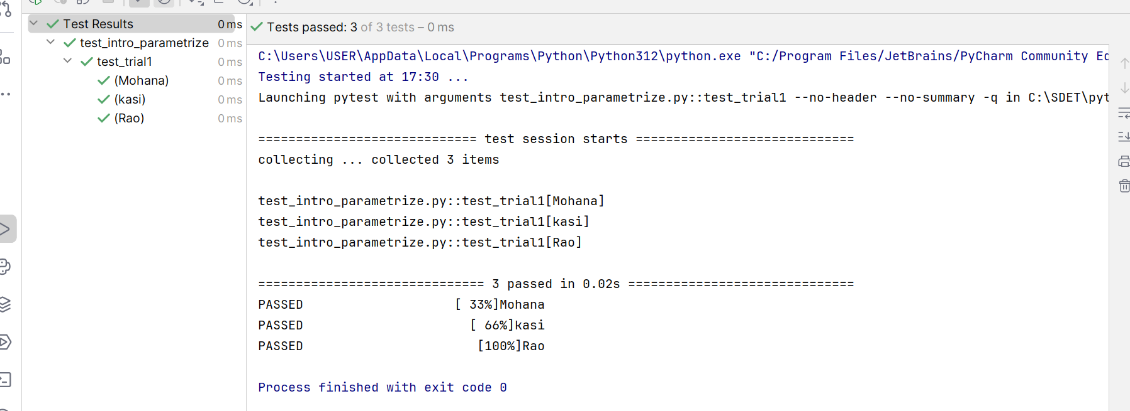

* Here each value in the given list taken and passed to test method by pytest using declared variable called user_name. means it is running like a iteration loop by providing a data at every iteration.

**Example2: numbers**

import pytest

@pytest.mark.nums_check  
@pytest.mark.parametrize("number", [109, 84, 45, 289])  
def test_numbers_check(number):  
 assert number > 100

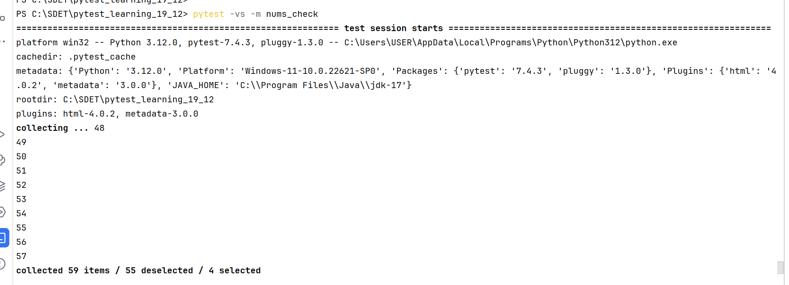

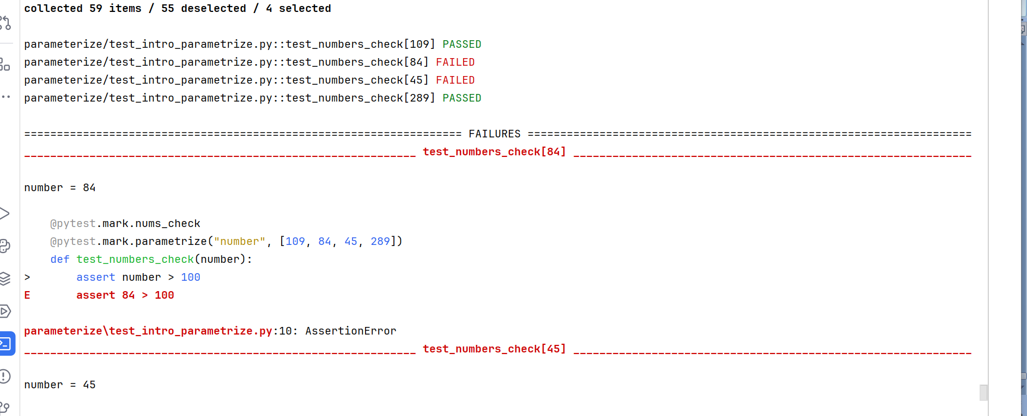

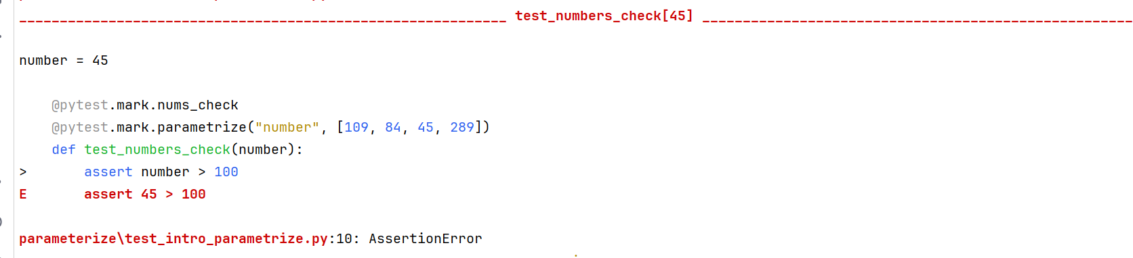

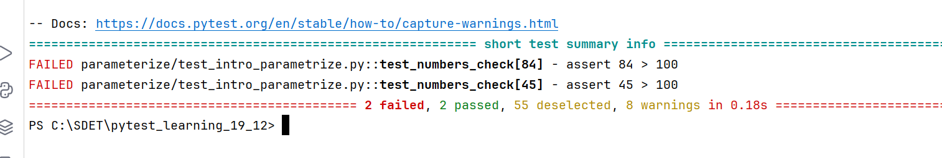

**Defining more than one variable in test method:**

@pytest.mark.user_pass_word  
@pytest.mark.parametrize("user_name, pass_word", [('Mohana', 123), ('kasi', 4560), ('Rao', 789)])  
def test_trial1(user_name, pass_word):  
 assert isinstance(user_name, str)  
 assert isinstance(pass_word, int)

* Here each value is associated with one more value, so test cases will be 3 only

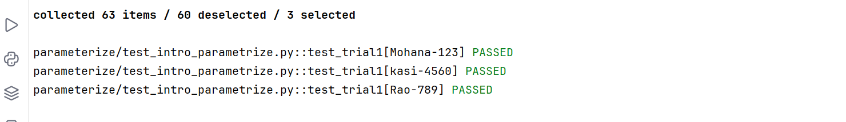

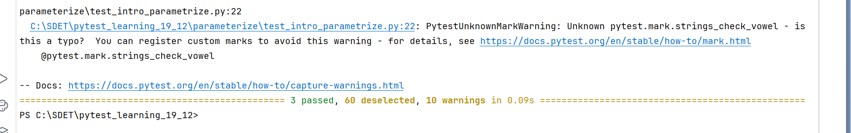

**Example3: with strings**

@pytest.mark.strings_check_vowel  
@pytest.mark.parametrize("string", ['integrate', 'Mohana', 'python', 'user_name'])  
def test_vowels_check(string):  
 assert string[0].lower() in 'aeiou'

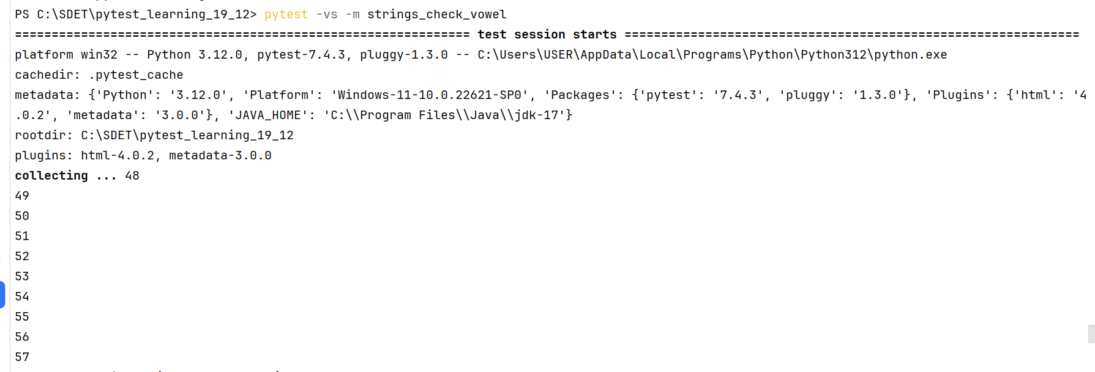

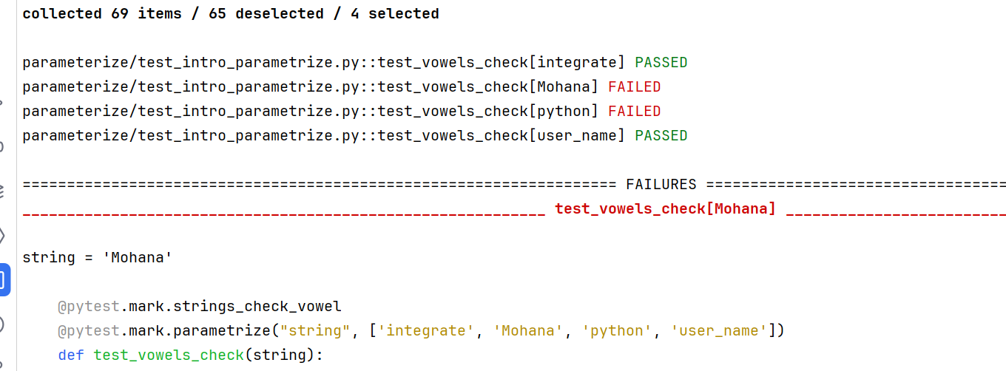

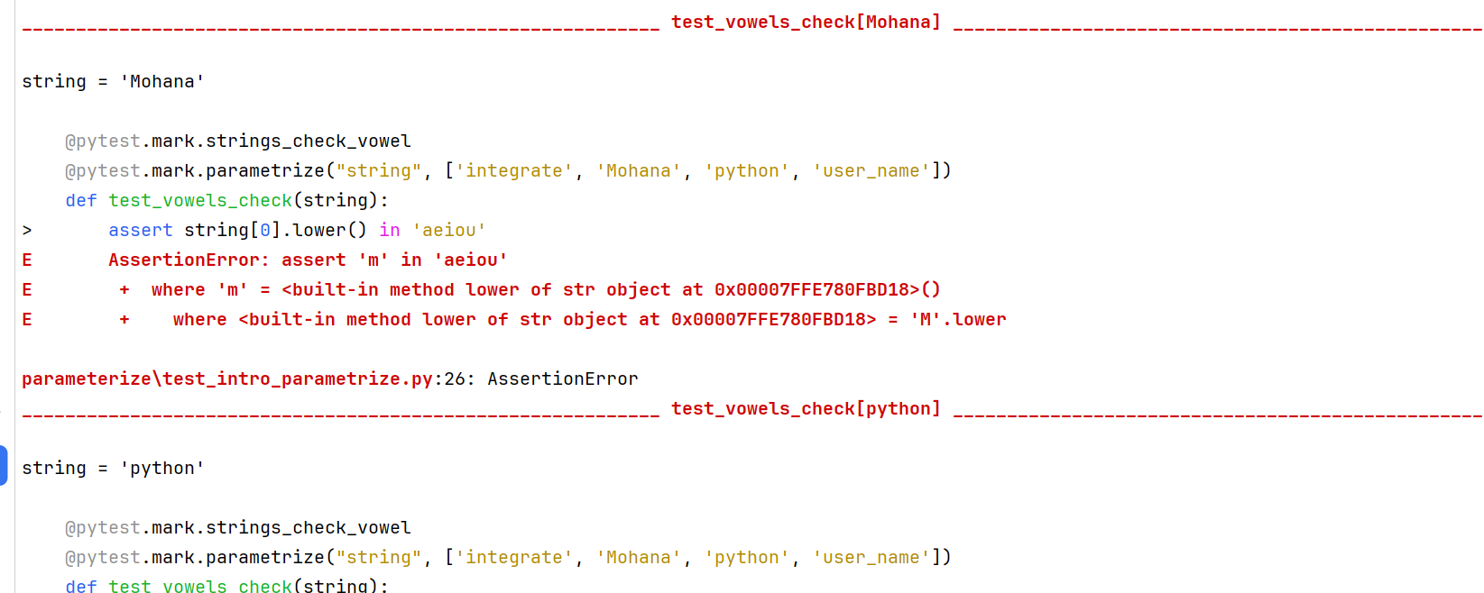

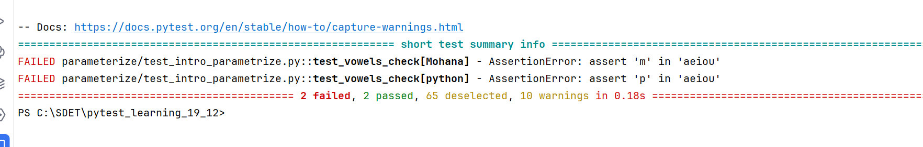

Another way of testing with multiple data:

**Test method with multiple parametrization variables:**

import pytest

@pytest.mark.user_pass_word  
@pytest.mark.parametrize("user_name", ['Mohana', 'kasi', 'Rao'])  
@pytest.mark.parametrize("pass_word", [123, 456, 789])  
def test_trial1(user_name, pass_word):  
 assert isinstance(user_name, str)  
 assert isinstance(pass_word, int)

* Here total number of tests will be totl_data In first parameterize * total data in 2nd parameterize
* Like first parameterize total data items is 3
* 2nd parameterize total data is 3
* So 3*3 = 9 test cases should execute

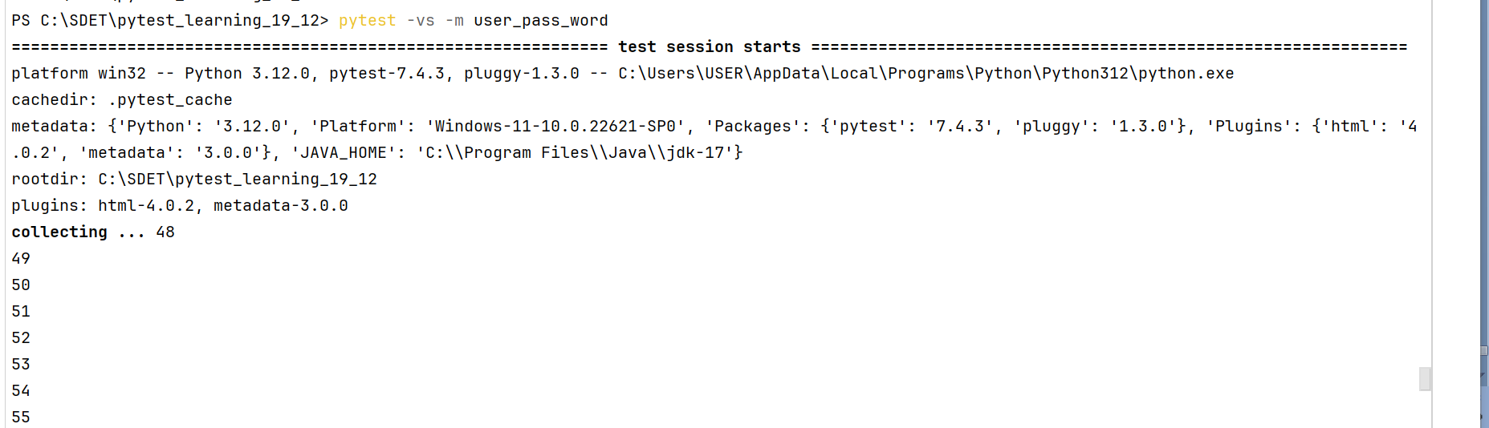

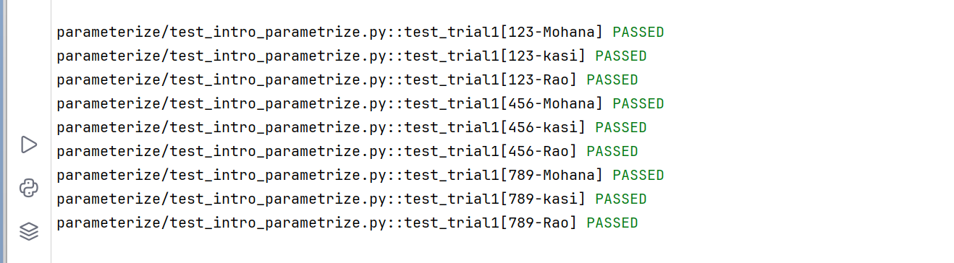

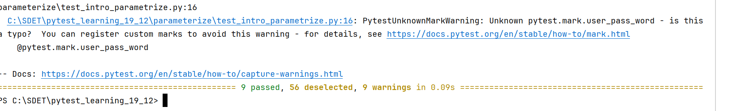

Example 4: with multiplication

@pytest.mark.multiplication  
@pytest.mark.parametrize('input, output', [(2, 4), (8, 64), (45, 3458)])  
def test_multiplication_validation(input, output):  
 assert (input * input == output)

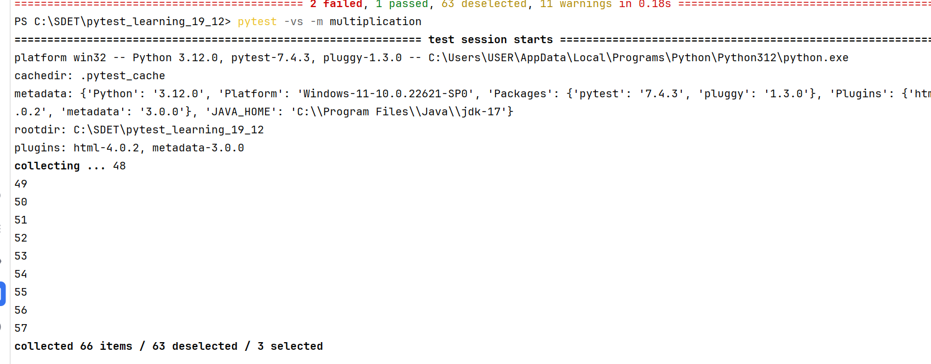

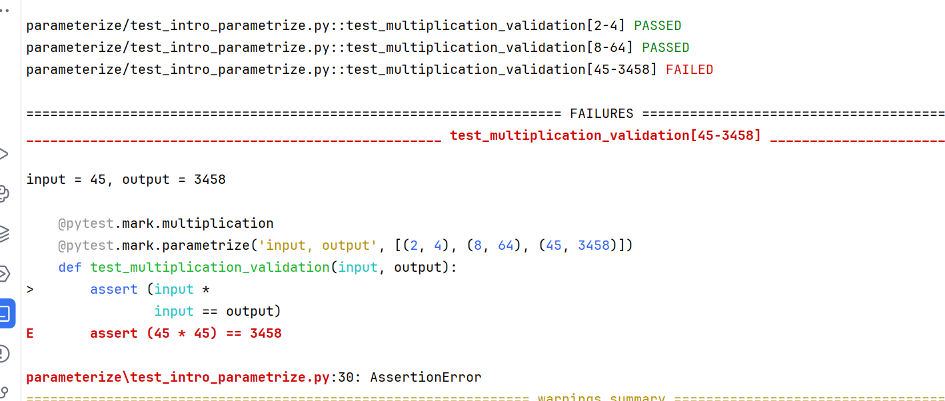

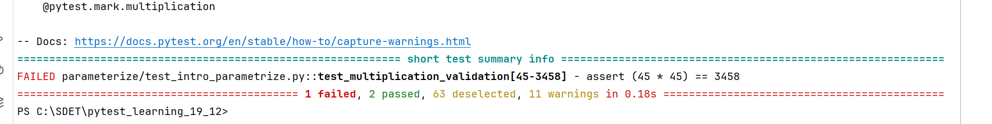

Example: maths ops

import math  
  
import pytest  
  
data = [([1,9,25], 'sum', 35),  
 ([1,5,6], 'prod', 30)]  
  
@pytest.mark.test1_maths  
@pytest.mark.parametrize("nums_list, opration, value", data)  
def test_maths_ops(nums_list, opration, value):  
 if opration == 'sum':  
 assert sum(nums_list) == value  
  
 elif opration == 'prod':  
 assert math.prod(nums_list) == value

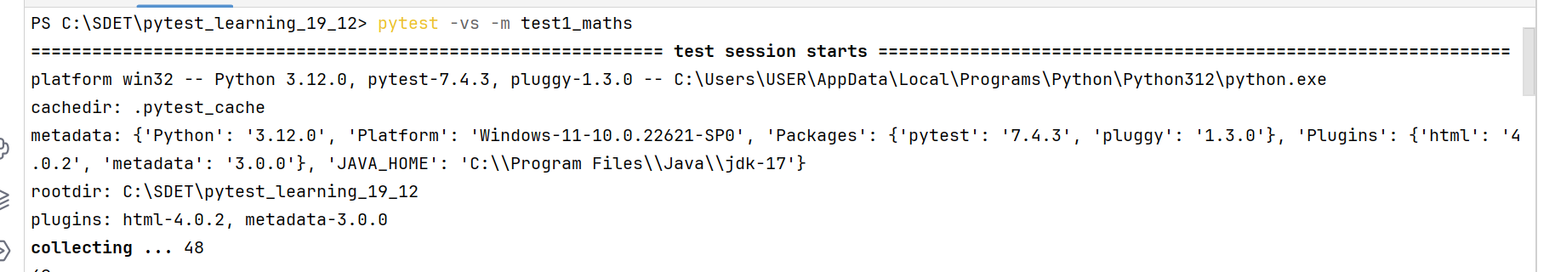

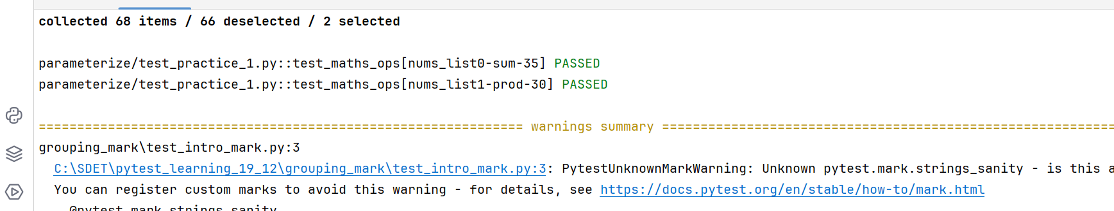

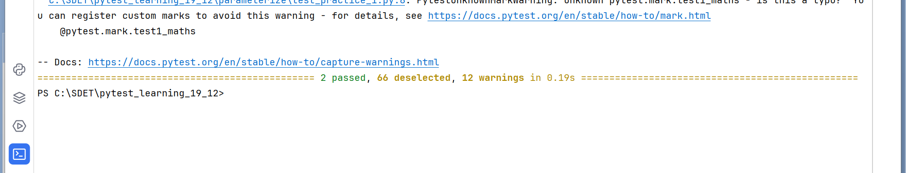

**Fixtures:**

Getting setup ready for actual tests

**It’s a way to define reusable code for tests**

These are the functions run by the pytest before (and sometimes after) the actual test functions which will setup the things and returning the data for the tests.

Examples: setup DB connection, initializing webdriver, opening files, etc….

The fixtures can be written directly in test files if needed. Or pytest inbuilt function called conftest.py also you can write the fixtures which is available for the multiple test files.

**Examples:**

import pytest  
  
@pytest.fixture  
def setup_city():  
 print("\nthis is the starting of fixtuer")  
 print("\nbeeing called by pytest, not you")  
 cities = ['guntur', 'bangalore', 'mumbai']  
 return cities  
  
  
@pytest.mark.fixture_cities  
def test_city_process(setup_city):  
 print(setup_city[1:2])  
 assert setup_city[0] == 'guntur'  
  
  
def reverse_list(list):  
 res = []  
 for item in list:  
 res = [item] + res  
 return res  
  
def test_exam2(setup_city):  
 assert setup_city[::-2] == ['mumbai','guntur']  
 assert setup_city[::-1] == reverse_list(setup_city)

**Using fixtures in test function by decorating with markers:**

In mark we have a function called usefixtures, we can decorate it with the test function. Usefixtures will takes the fixture name as input with in the stirng. While using usefiuxtures the fixture should not have return statement.

Synatax: @pytest.mark.usefixtures(“fixture_name”)

Examples:

*#using fixtures by decorating with mark*@pytest.mark.usefixtures("setup_city")  
*#while using usefixtures the fixture function should not have return statment*def test_method1():  
 print(setup_city[::-1])

#handling the failure of using fixture with the xfail in marker  
@pytest.mark.xfail(reason="known reason, test with use fixtuere, the fixture should not have return statement")  
@pytest.mark.usefixtures("setup_city")  
*#while using usefixtures the fixture function should not have return statment*def test_method1():  
 print(setup_city[::-1])  
  
  
@pytest.mark.usefixtures("setup_city")  
def test_method2():  
 assert 'Mohana' == 'mohana'.capitalize()

**Using yield statement in the fixtures:**

Using yield statement in the fixture will help us to run any things after the executing of test case.

So the statements before yield will execute before the tests and the statements after yield will execute after every test case.

Example:

import pytest  
list1 = ['mon', 'tue', 'wed']  
list2 = ['thur', 'fri', 'sat']  
  
@pytest.fixture  
def setup_weeks():  
 print("in the fixture")  
 wk1 = list1.copy()  
 yield wk1  
 wk1.pop()  
 print("\n after the fixture")  
 print("\n closing week sun")  
  
@pytest.mark.setup_fixtures_1  
@pytest.mark.usefixtures("setup_weeks")  
def test_setup_fixtures(setup_weeks):  
 print("\n in the test case")  
 setup_weeks.append('sun')  
 setup_weeks.extend(list2)  
 assert setup_weeks == ['mon', 'tue', 'wed','sun','thur', 'fri', 'sat']

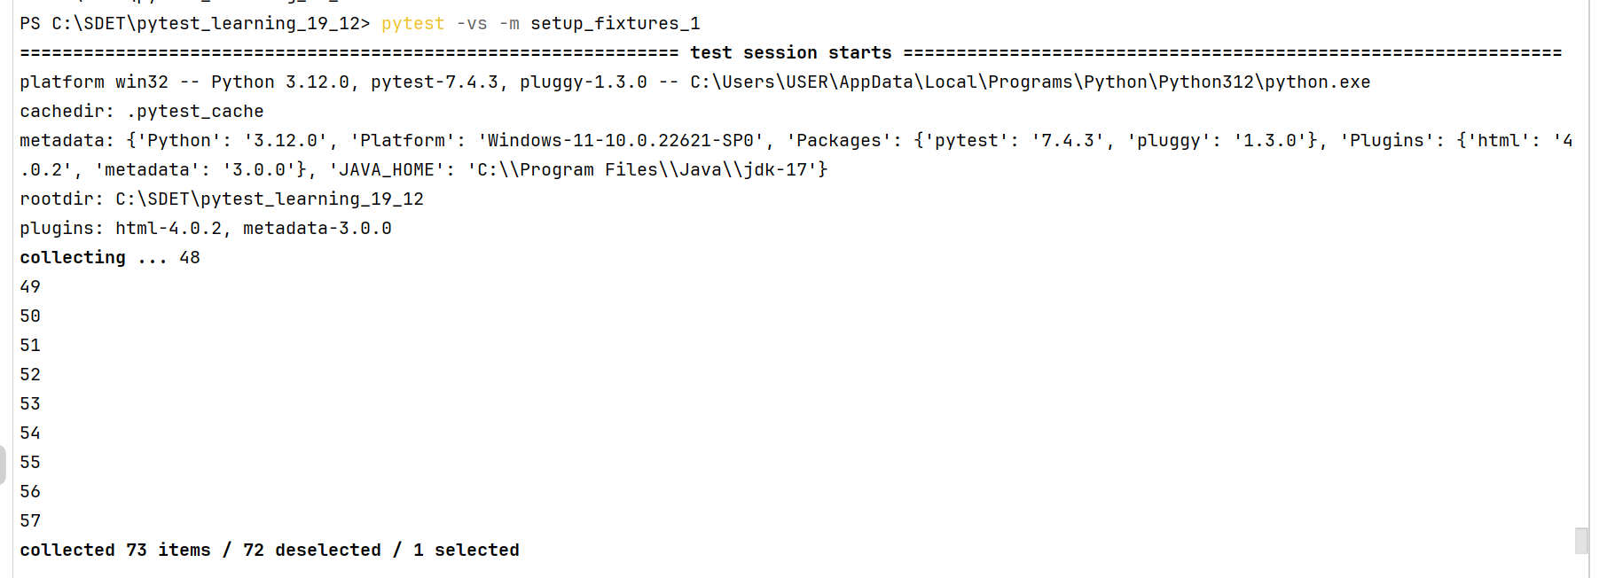

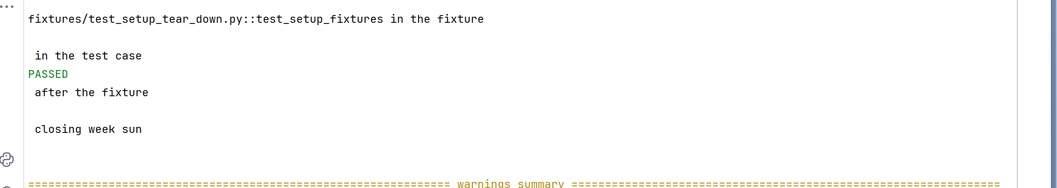

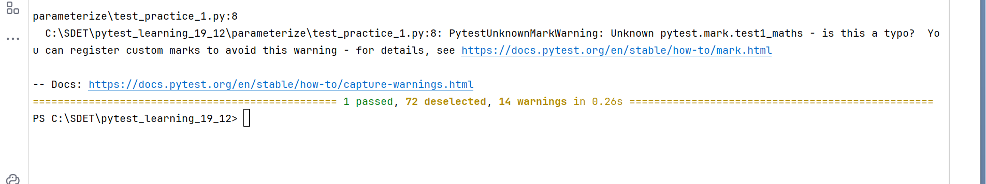

Using multiple fixtures in test:

Example:

import pytest  
list1 = ['mon', 'tue', 'wed']  
list2 = ['thur', 'fri', 'sat']  
  
@pytest.fixture  
def setup_weeks_01():  
 print("in the fixture")  
 wk1 = list1.copy()  
 yield wk1  
 wk1.pop()  
 print("\n after the fixture")  
 print("\n closing week sun")  
  
  
@pytest.fixture  
def setup_02():  
 print("in fixture2")  
 wk2 = list2.copy()  
 wk2.append("new_week_day")  
 yield wk2  
 print("\n after the fixture2")  
 wk2.pop()  
  
@pytest.mark.setup_fixtures_1  
@pytest.mark.usefixtures("setup_weeks_01")  
def test_setup_fixtures(setup_weeks_01):  
 print("\n in the test case")  
 setup_weeks_01.append('sun')  
 setup_weeks_01.extend(list2)  
 assert setup_weeks_01 == ['mon', 'tue', 'wed','sun','thur', 'fri', 'sat']  
  
  
  
@pytest.mark.fixture_method2  
@pytest.mark.usefixtures("setup_weeks_01", "setup_02")  
def test_length_validation(setup_weeks_01, setup_02):  
 assert len(setup_02) != len(setup_weeks_01)

Example2: on files

import pytest  
  
@pytest.fixture  
def file_setup():  
 with open("file1.txt", 'w') as file1:  
 file1.write("This is python language")  
 with open("file1.txt", 'r') as file12:  
 yield file12  
 print("file closed")  
  
@pytest.mark.usefixtures("file_setup")  
def test_file_ops1(file_setup):  
 assert file_setup.readline() == 'This is python language'

**Sharing fixtures:**

We can share the fixtures to the test functions using the special plugin called conftest.py.

Conftest.py will shares the fixtures across the multiple tests. We can have single conftest.py in centralized directory for all test to access the fixtures. Also can have other conftest.py files in subdirectories.

**Note:** conftest.py file should not imported by the test files. It will auto detects by pytest and implicitly runs every fixture written in conftest.py

Example:

Conftest.py file:

import pytest  
  
  
*#creating global variables in pytest which will be avialable for all fixtures & tests*def pytest_configure():  
 pytest.string1 = 'its beautiful day'  
 pytest.list1 = ['Iam', 'Mohana kasi', 'python', 'language']  
  
@pytest.fixture  
def string_setup():  
 string_ = pytest.string1[::]  
 string_.upper()  
 yield string_  
  
@pytest.fixture  
def list_setup():  
 list_ = pytest.list1.copy()  
 yield list_[::-1]

test file:

import pytest  
  
@pytest.mark.conf_class_ops  
@pytest.mark.usefixtures("string_setup", "list_setup")  
class Test_conftest_ops:  
  
 def test_string_ops(self, string_setup):  
 string_setup.replace('day', 'month')  
 print(string_setup)  
  
 def test_list_ops(self,list_setup):  
 list_setup.remove('python')  
 print(list_setup)

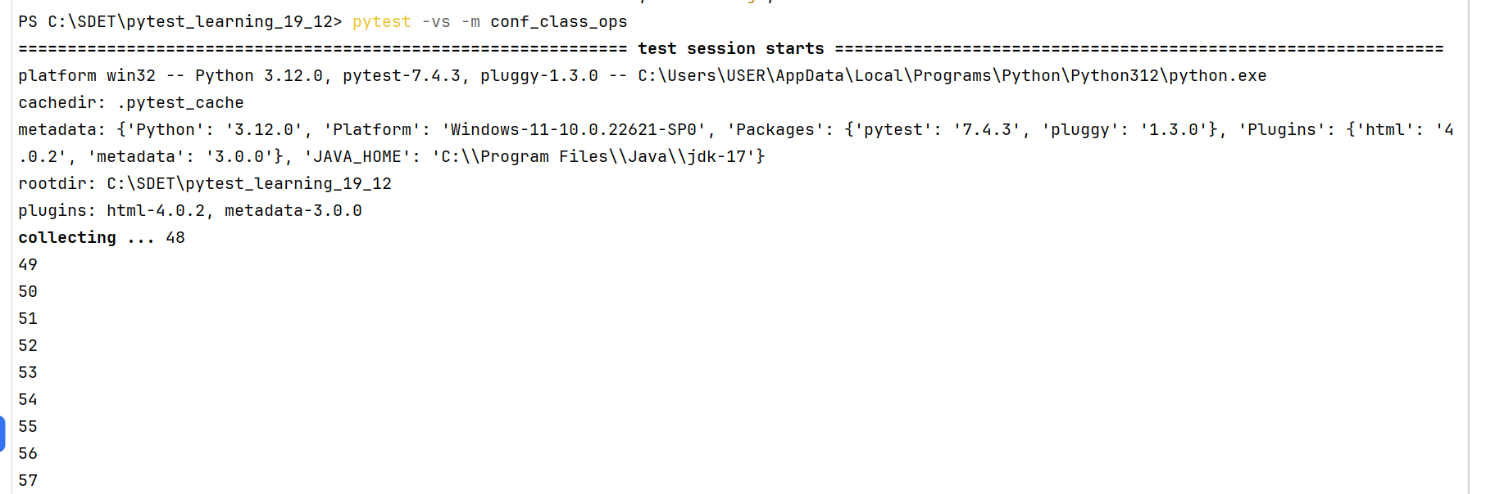

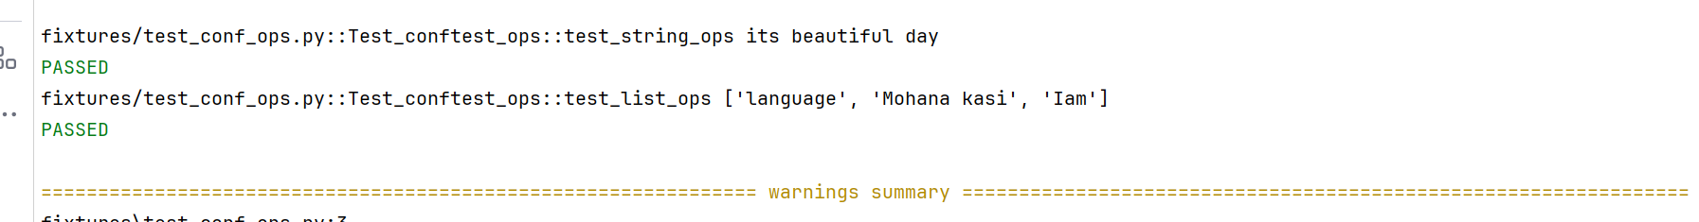

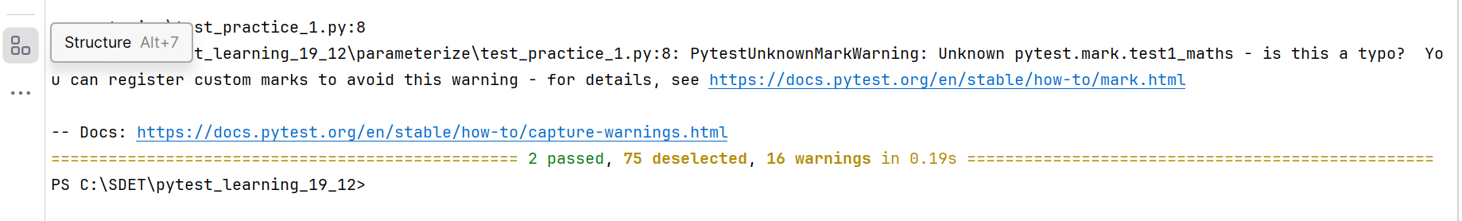

**Having multiple conftest files in project:**

We should not have multiple conftest files in the centralized directory. But we can have one more conftest file in sub directory.

So, in the same directory we should not have multiple conftest files, in sub directory we can have one another conftest file

Example:

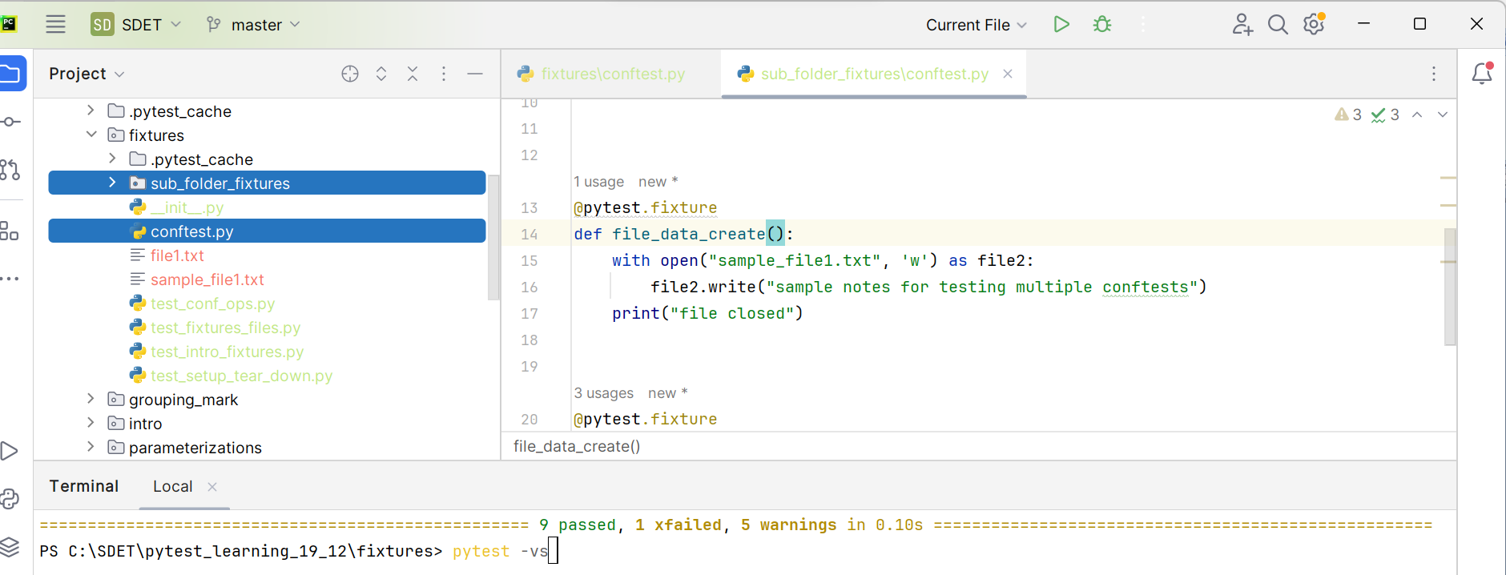

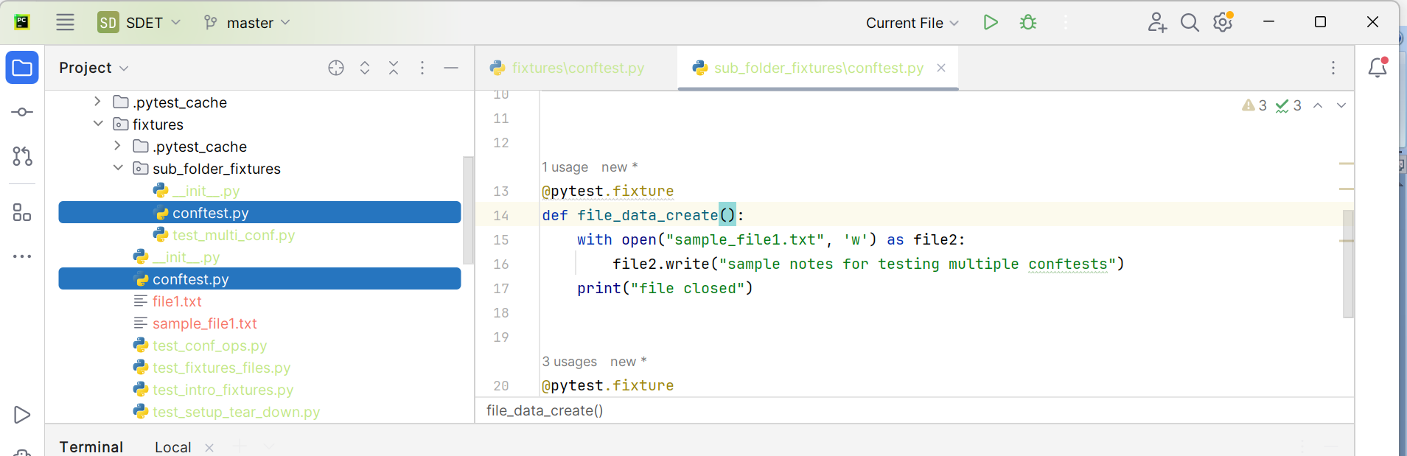

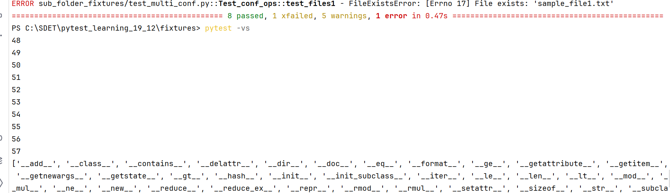

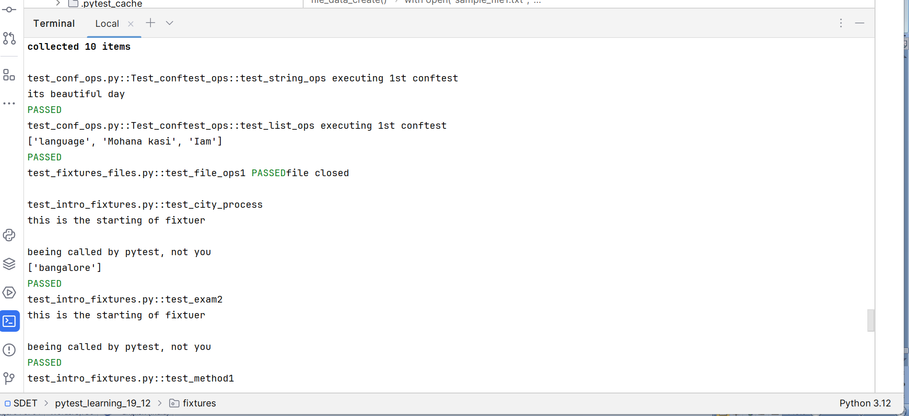

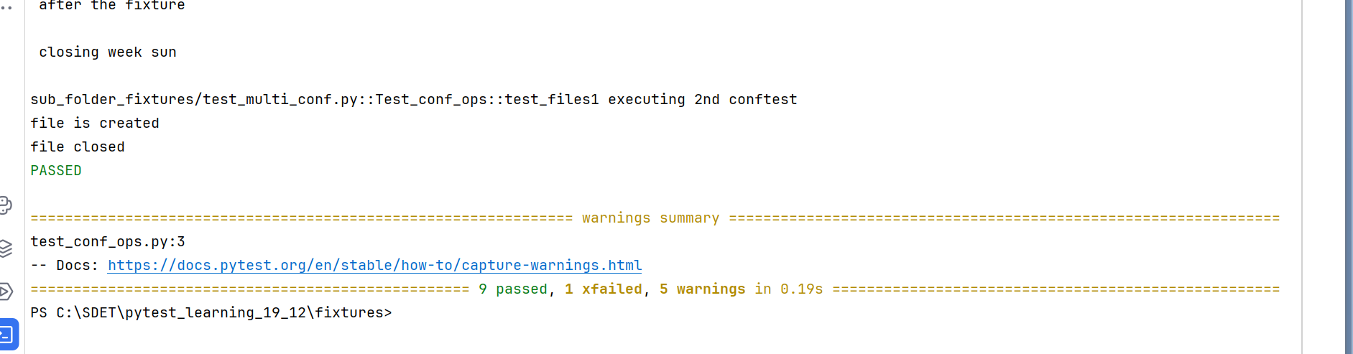

**Flow of fixtures:**

If you are running pytest command in terminal without specifying the test file, by default pytest will search for test_module.py file and if its founds it will search inside that folder for any class with Test_ or any function with test_. If it founds class with Test_, again inside class it will search for methods starts with test_ and executes those.

If you created conftest.py with few fixtures in your test suite, and if you are not using the fixtures in any of the test method/function/class that fixture will not be callable by pytest and it will not executes.

So ultimately if you running pytest command in terminal, first it will got test files/methods in those if created fixtures are used, then pytest will navigates to conftest file and runs that fixtures and again its navigates back to test file and search for another test method and executes it.

**Test_file.py🡪 test_class/test_function 🡪 [if fixtures are used in test file] conftest.py(fixtures)🡪test file**

**Conclusion:** conftest.py will not executes first, and all the functions in the conftest.py will not executes. conftest.py will default callable by pytest until the fixtures are used in test file. So, only fixtures in the conftest.py will implicitly callable by pytest until you using those in test methods**.**

**Scope of fixtures:**

**If you created a fixture with scope=”class”** 🡪 here fixture will executes once per class that too before the class

If your class having multiple test methods in the class, if you are using that fixture more than one time, even though you used it it will not work for 2nd method, bcoz it will works for one time for one class.

**If you created a fixture with scope= “function”** 🡪 here fixture will run once per once function/method

If you are using this fixture in every test method inside a class, then it will run every time before the every test method. Bcoz you are given scope as function.

When you used module as scope for a test it will tear down after all methods executed in that file.

Example:

**Conftest_file:**

import pytest  
  
def pytest_configure():  
 pytest.dict_ = {'name': "mohana kasi", 'age':27}  
  
  
@pytest.fixture(scope="module")  
def dict_fetch():  
 print("in conftest module_fixture1")  
 yield pytest.dict_  
 print("closing of module ficture")  
  
@pytest.fixture(scope="function")  
def second_fixture():  
 print("second fixture executed")

**test_file:**

import pytest  
pytestmark = [pytest.mark.module_fixtures_check]  
  
@pytest.mark.usefixtures("dict_fetch")  
def test_check_module_fixture(dict_fetch):  
 print(dict_fetch['name'])  
 print("temp check")  
  
  
@pytest.mark.usefixtures("second_fixture")  
def test_check_module_fixture2(second_fixture):  
 print("temp check 2nd fixture")

Execution: 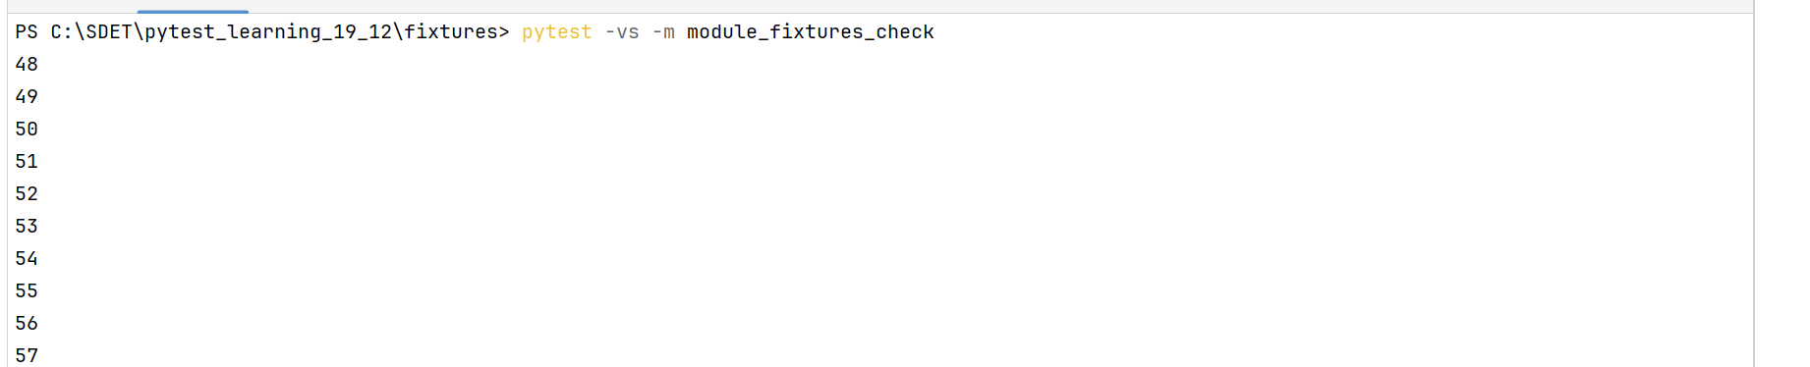

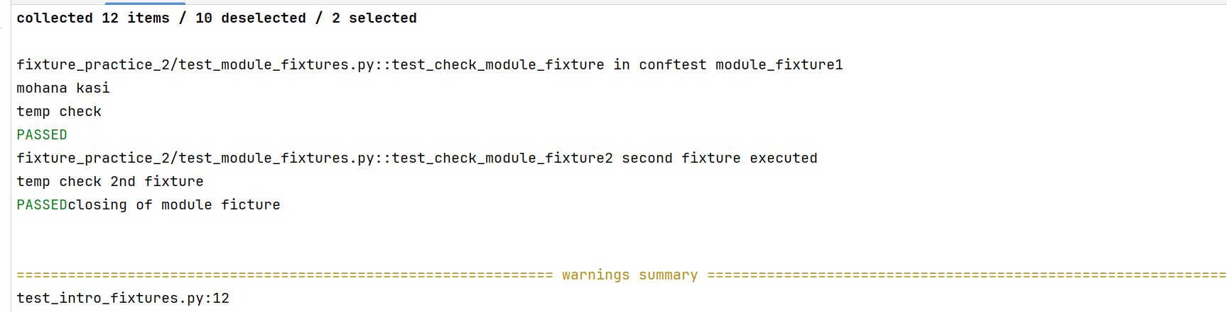

**request: built-in fixture parameter**

Some times fixtures can seek the data or some validations like scope of the fixture, and passing the parameters to the fixture we will use request parameter in the fixture as a parameter. Request is a built in fixture parameter in the pytest.

Conftest.py:

@pytest.fixture()  
def request_fixture_practice(request):  
 print(f"\n scope of this fixture is {request.scope}")  
 print(f"\n name of this function is {request.function.__name__}")  
 print(f"\n {request.module.__name__}") *#gives the packages names which fixture is in*

Test_file.py:

@pytest.mark.request_practice  
def test_check_request(request_fixture_practice):  
 print("fixture ")

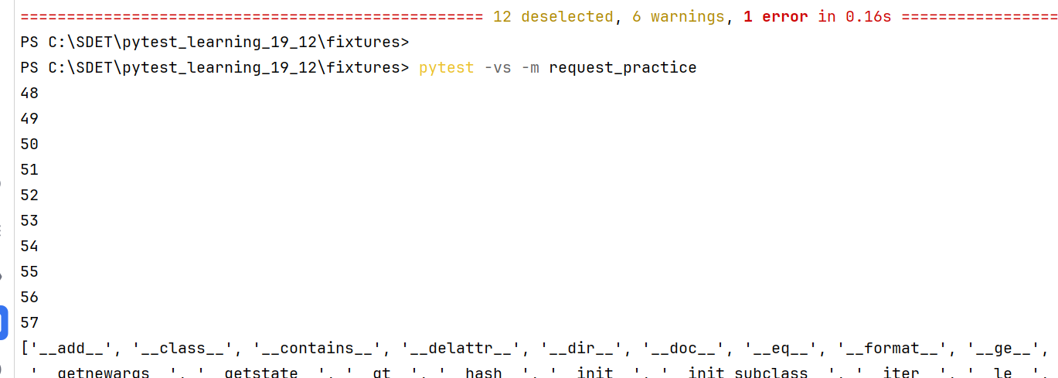

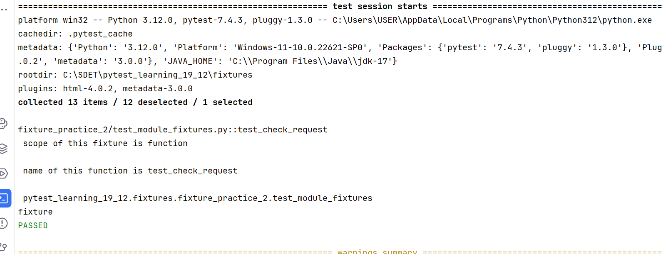

**Taking parameters in fixtures:**

We can pass some variables to the fixtures using a default variable in fixtures called params. By using this fixed variable name you can pass the data to it as a single data or a collection of data. For example if you are giving a list of data, the fixture will run for multiple times with each time with particular data in the list like a for loop. You can access the data using request parameter.

Syntax: @pytest.fixture(params=[data]) #scope optional

Note: only collections/iterables are accepted for params variable, single data types not allowed

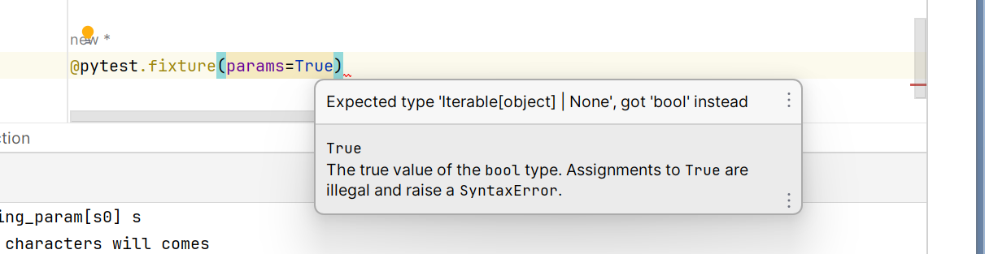

Examples: with the list

**Declaring parameters but not utilising it:**

Conftest.py:

@pytest.fixture(params=["kasi", 'Mohana']) *#here fixture will run for total length of params list*def params_check(request):  
 print("parameters are not using")

Test_file.py:

@pytest.mark.practice_params  
def test_prameters_check(params_check):  
 print("these are the prameters")

Output:

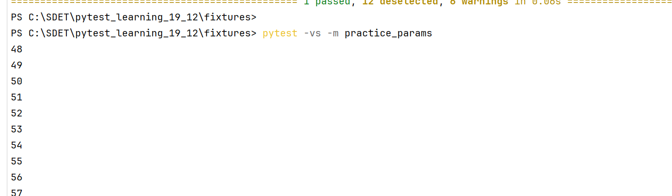

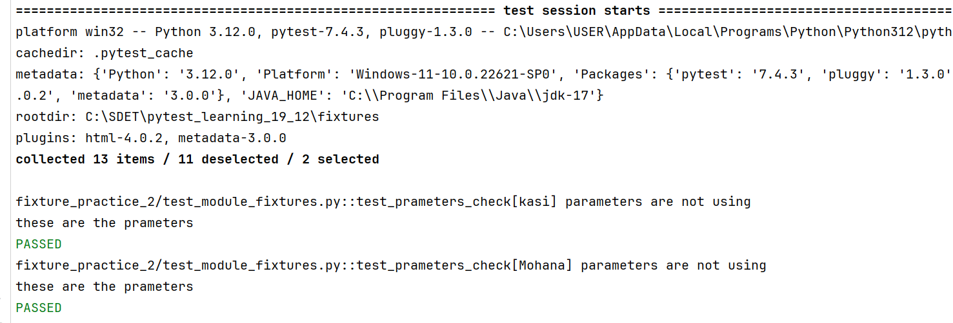

* here even though you are not using the parameters declared, the fixture is running for the total items length in the params list
* means in the above params list two items are there, the fixture ran for two times, even test also ran along with

**Example:2 condition checking with list items**

Conftest.py:

@pytest.fixture(params=["kasi", 'Mohana', 1008]) *#here fixture will run for total length of params list*def params_check_list_2(request):  
 if request.param == 'kasi' and isinstance(request.param, str):  
 print("kasi found")  
 else:  
 pass

Test_file.py:

@pytest.mark.practice_params  
def test_prameters_check(params_check_list_2):  
 print("these are the prameters")

Output:

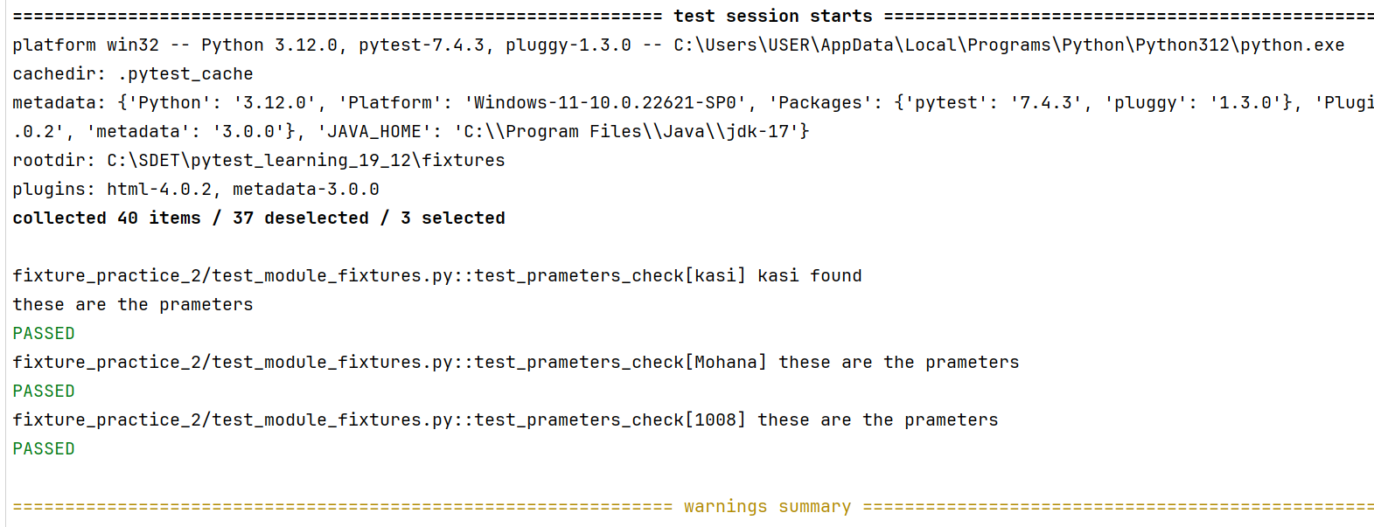

**Example3: with dict:**

Conftest.py:

@pytest.fixture(params={'name': 'kasi', 'age':27})  
def prams_with_dict(request): *#eachtime key will pass to request parameter* print(request.param)

@pytest.mark.fixture_with_dict_param  
def test_dict_ficture(prams_with_dict):  
 print("dict also possible as parameter in fictures")

Output:

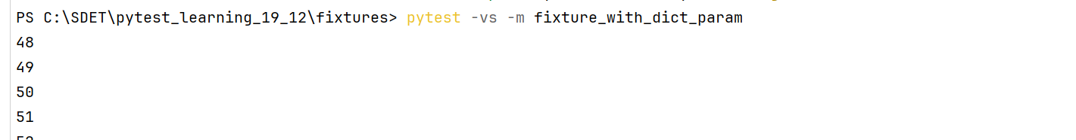

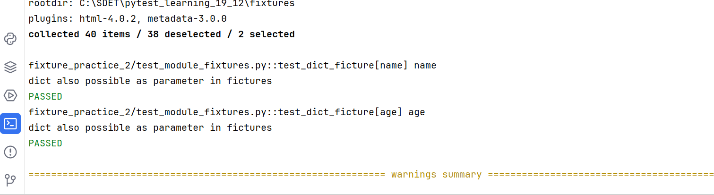

**Example4: With string:**

@pytest.fixture(params="this is kasi from python")  
def prams_with_string(request): *#eachtime key will pass to request parameter* print(request.param)

@pytest.mark.fixture_stirng_param  
def test_string_param(prams_with_string):  
 print("string also possible in fixture params but each time characters will comes")

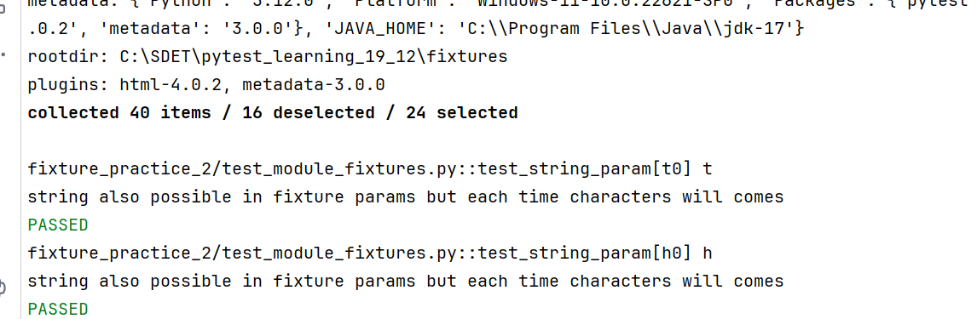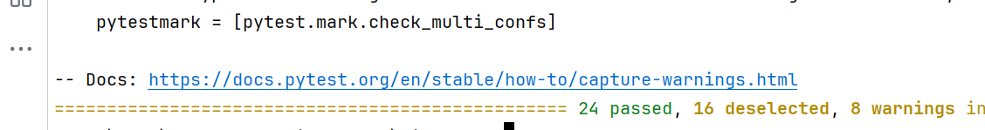

**Factories as fixture:**

When the test function needed to check any logic for multiple times, we will use this factories as fixture concept. Here we will write the logic function in fixture and Instead of returning data directly, the fixture returns a function name which generates the data. This function can be called multiple times in the test function. Its like reusable thing, the function can reused multiple times in the test

Example:

@pytest.fixture()   
def factories_fixture():  
 def data_type_check(name):  
 if name == 'string':  
 return "sample string"  
 elif name == 'list':  
 return [1,2,3,4]  
 else:  
 print("not a proper data type")  
 return data_type_check

@pytest.mark.practice_factiries_fixture  
def test_factory_fixture_check(factories_fixture): #here the fixture name will have the funciton  
 assert type(factories_fixture('string')) == str   
 assert type(factories_fixture('list')) == list

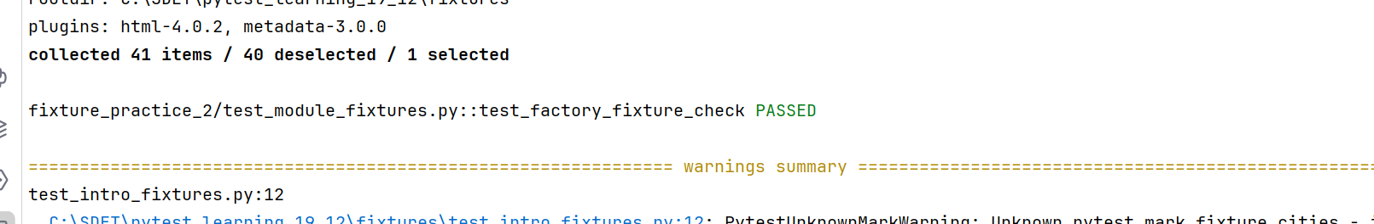

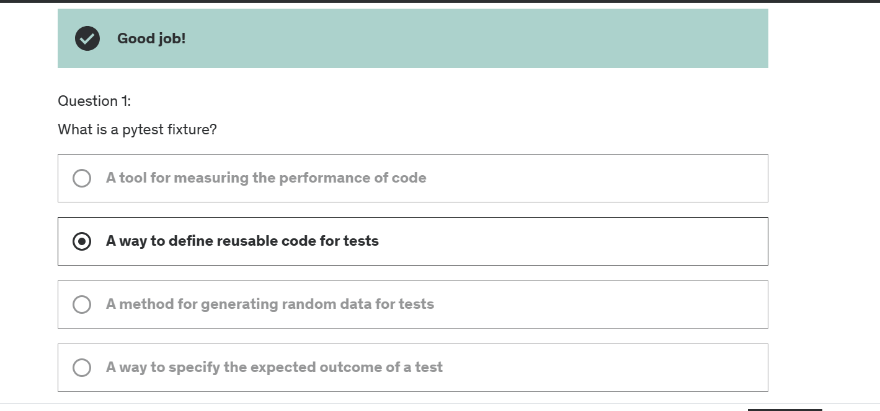

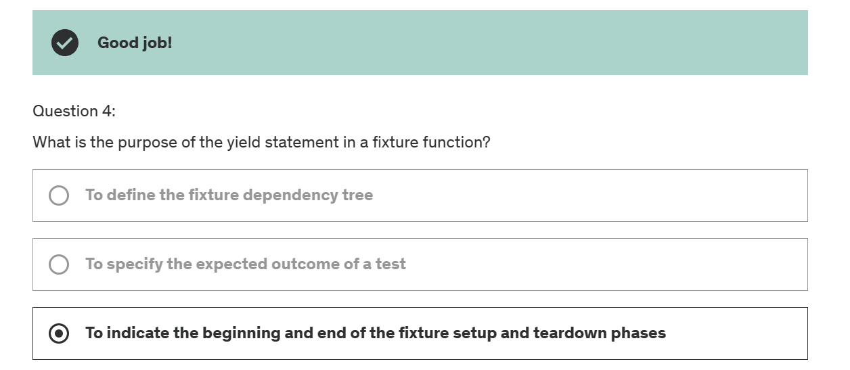

Using fixtures as parametrization:

@pytest.fixture(params=[(3,4), (5,6)])  
def fixture_parametrization(request):  
 return request.param

@pytest.mark.practice_fixture_parametrization  
def test_fixtures_params(fixture_parametrization):  
 assert type(fixture_parametrization) in [tuple, list]

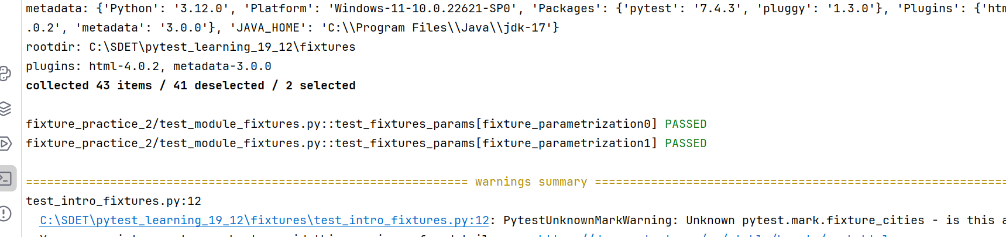

Here for every time fixture running its giving some randam ids in console, to give particular id we use fixed parameter called ids

Example:

@pytest.fixture(params=[(3,4), [5,6]], ids=['tuple', 'list'])  
def fixture_parametrization(request):  
 return request.param

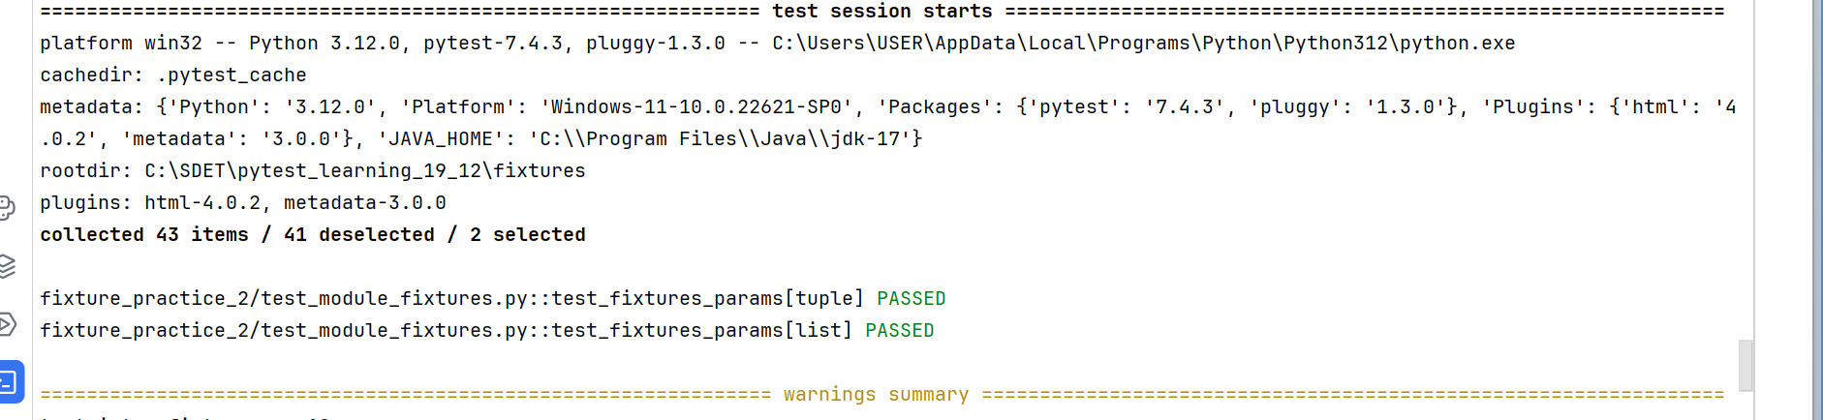

Example2:

@pytest.fixture(params=[(3,4), [5,6]], ids=['tuple', 'list'])  
def fixture_parametrization(request):  
 return request.param  
  
@pytest.fixture(params=["access", "slice"])  
def fixture_params02(request):  
 return request.param

@pytest.mark.practice_fixture_parametrization  
def test_fixtures_params(fixture_parametrization):  
 assert (type(fixture_parametrization)) in [tuple, list]

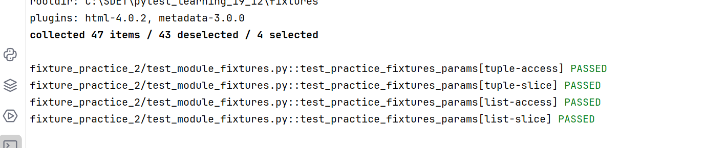

**Fixture scopes:**

Fixture are created when first requested by test, and are destroyed based on their scopes

Function: the default scope, the fixture is destroyed at the end of the test.

Class: the fixture is destroyed during teardown of the last test in the class

Module: the fixture is destroyed during teardown of the last test in the module

Package: the fixture is destroyed during teardown of last test in that package

Session: the fixture is destroyed at the end of the test session

test